Key Question 1. Is a four-drug regimen more effective than a three-drug regimen as induction therapy in transplant-eligible multiple myeloma

Table 1. Summary of Findings table
Outcomes | Illustrative comparative risks* (95% CI) |  | Relative effect  (95% CI) | No of Participants  (studies) | Quality of the evidence  (GRADE) | Comments
Outcomes | Assumed  risk | Corresponding  risk
PFS | 236 per 1000 | 144 per 1000  (123 to 172) | HR 0.58  (0.49 to 0.70) | 1658  (2 studies) | ⊕⊕⊕⊝  moderate
PR | 899 per 1000 | 935 per 1000  (908 to 953) | RR 1.04  (1.01 to 1.06) | 2599  (5 studies) | ⊕⊕⊕⊝  moderate
≥ VGPR | 740 per 1000 | 836 per 1000  (799 to 866) | RR 1.13  (1.08 to 1.17) | 2599  (5 studies) | ⊕⊕⊕⊝  moderate
MRD (10⁻⁵) | 400 per 1000 | 585 per 1000  (536 to 637) | RR 1.46  (1.34 to 1.59) | 2318  (5 studies) | ⊕⊕⊕⊕  high
ANEMIA | 61 per 1000 | 81 per 1000  (56 to 116) | RR 1.32  (0.92 to 1.90) | 1725  (4 studies) | ⊕⊕⊕⊝  moderate
DIARRHEA | 22 per 1000 | 41 per 1000  (18 to 93) | RR 1.85  (0.82 to 4.16) | 969  (2 studies) | ⊕⊕⊕⊝  moderate
INFECTION  (ZOSTER) | 95 per 1000 | 123 per 1000  (85 to 179) | RR 1.30  (0.90 to 1.89) | 969  (2 studies) | ⊕⊕⊕⊝  moderate
LYMPHOPENIA | 155 per 1000 | 197 per 1000  (165 to 238) | RR 1.27  (1.06 to 1.53) | 2031  (4 studies) | ⊕⊕⊕⊝  moderate
NEUROPATHY | 68 per 1000 | 65 per 1000  (49 to 86) | RR 0.96  (0.72 to 1.28) | 2799  (5 studies) | ⊕⊕⊕⊝  moderate
NEUTROPENIA | 148 per 1000 | 237 per 1000  (203 to 277) | RR 1.60  (1.37 to 1.87) | 2799  (5 studies) | ⊕⊕⊕⊝  moderate
THROMBOCYTOPENIA | 57 per 1000 | 98 per 1000  (74 to 129) | RR 1.71  (1.29 to 2.26) | 2680  (5 studies) | ⊕⊕⊕⊝  moderate
*The basis for the assumed risk (e.g. the median control group risk across studies) is provided in footnotes. The corresponding risk (and its 95% confidence interval) is based on the assumed risk in the comparison group and the relative effect of the intervention (and its 95% CI).
CI, confidence interval; RR, risk ratio; HR, hazard ratio; PFS progression free survival, PR, partial response; VGPR, very good partial response; MRD, minimal residual disease.

Figure 1. Results of meta-analysis

A) Progression free survival
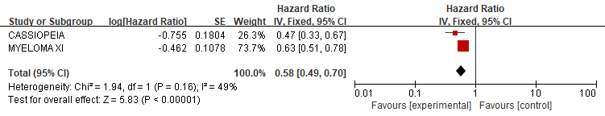

B) Partial response
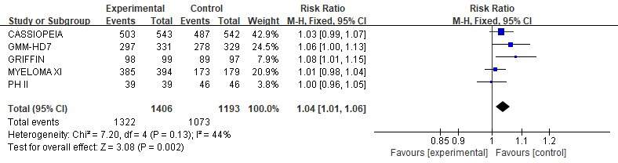

C) Very good partial response
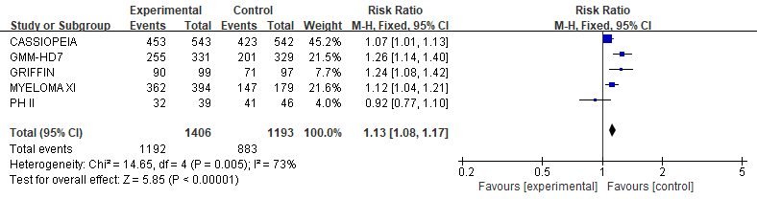

D) Minimal residual disease
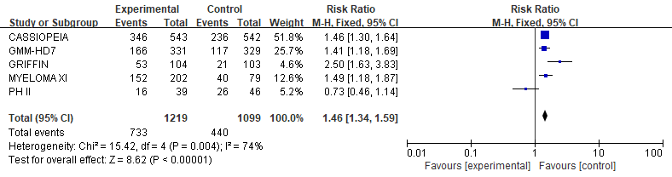
E) Anemia
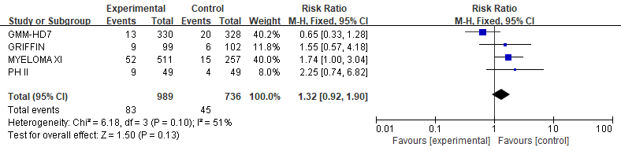

F) Diarrhea
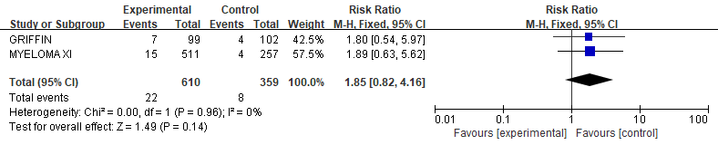

G) Infection
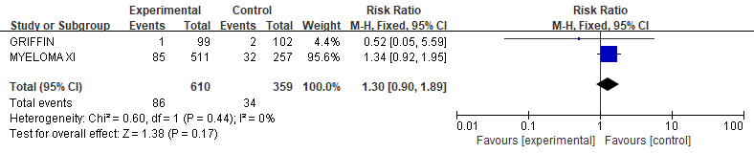

H) Lymphopenia
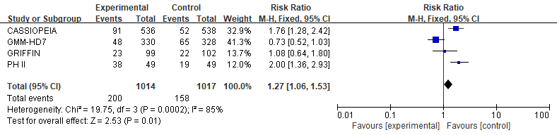

I) Neuropathy
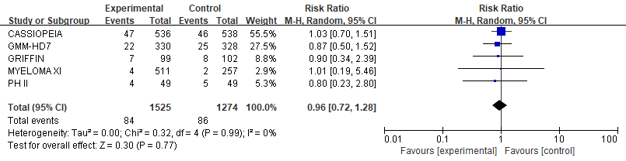

J) Neutropenia
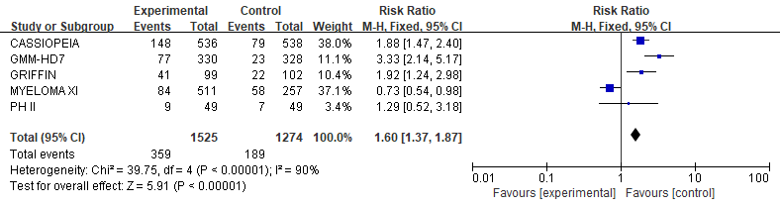

K) Thrombocytopenia
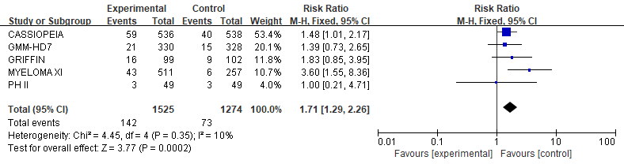

Key Question 2. Is continuous therapy superior to a fixed duration of induction therapy in newly diagnosed transplant-ineligible multiple myeloma?

Table 2. Summary of Findings table
Outcomes | Illustrative comparative risks* (95% CI) |  | Relative effect  (95% CI) | No of Participants  (studies) | Quality of the evidence  (GRADE) | Comments
Outcomes | Assumed risk | Corresponding risk
progression or death | 830 per 1000 | 695 per 1000  (642 to 744) | HR 0.67  (0.58 to 0.77) | 1381  (2 studies) | ⊕⊕⊕⊝  moderate
OS | 352 per 1000 | 346 per 1000  (305 to 998) | HR 0.98  (0.84 to 15) | 1381  (2 studies) | ⊕⊕⊝⊝  low
CR | 118 per 1000 | 139 per 1000  (106 to 184) | RR 1.18  (0.90 to 1.56) | 1381  (2 studies) | ⊕⊕⊝⊝  low
ORR | 722 per 1000 | 758 per 1000  (707 to 801) | RR 1.05  (0.98 to 1.11) | 1381  (2 studies) | ⊕⊕⊝⊝  low
VGPR or CR | 405 per 1000 | 413 per 1000  (364 to 466) | RR 1.02  (0.90 to 1.15) | 1381  (2 studies) | ⊕⊕⊝⊝  low
neutropenia_Gr3,4 | 416 per 1000 | 437 per 1000  (396 to 483) | RR 1.05  (0.95 to 1.16) | 1381  (2 studies) | ⊕⊕⊝⊝  low
anemia_Gr3,4 | 186 per 1000 | 199 per 1000  (162 to 247) | RR 1.07  (0.87 to 1.33) | 1381  (2 studies) | ⊕⊕⊝⊝  low
thrombocytopenia_Gr3,4 | 173 per 1000 | 166 per 1000  (135 to 204) | RR 0.96  (0.78 to 1.18) | 1381  (2 studies) | ⊕⊕⊝⊝  low
febrile neutropenia_Gr3,4 | 26 per 1000 | 66 per 1000  (21 to 205) | RR 2.52  (0.81 to 7.85) | 305  (1 study) | ⊕⊝⊝⊝  very low
infection_Gr3,4 | 203 per 1000 | 246 per 1000  (203 to 299) | RR 1.21  (1.00 to 1.47) | 1381  (2 studies) | ⊕⊕⊝⊝  low
DVT_Gr3,4 | 39 per 1000 | 13 per 1000  (3 to 64) | RR 0.34  (0.07 to 1.64) | 305  (1 study) | ⊕⊝⊝⊝  very low
*The basis for the assumed risk (e.g. the median control group risk across studies) is provided in footnotes. The corresponding risk (and its 95% confidence interval) is based on the assumed risk in the comparison group and the relative effect of the intervention (and its 95% CI).
CI, confidence interval; RR, risk ratio; HR, hazard ratio; OS, overall survival; CR, complete response; ORR, overall response rate; VGPR, very good partioal response; Gr, grade; DVT, deep vein thrombosis

Figure 2. Results of meta-analysis

A) A meta-analysis of survival rates based on the continuous therapy
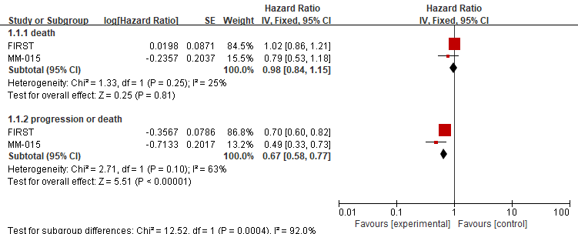

B) A meta-analysis of response rates based on the continuous therapy
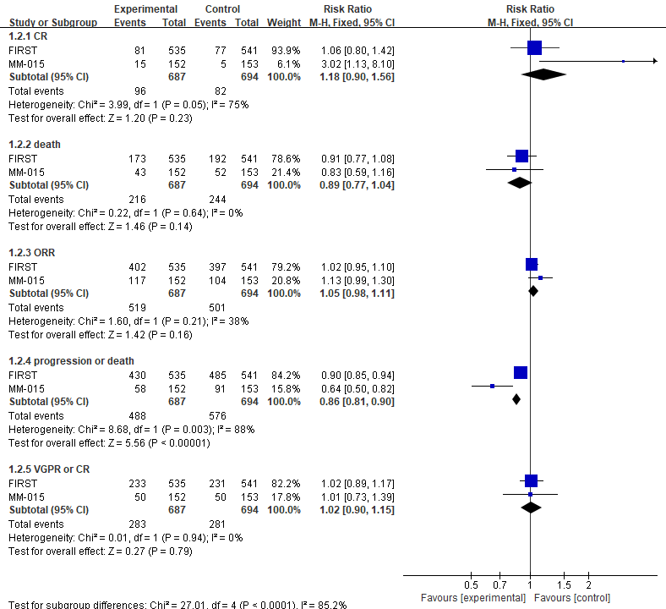

C) A meta-analysis of progression-free survival based on the continuous therapy over different time points
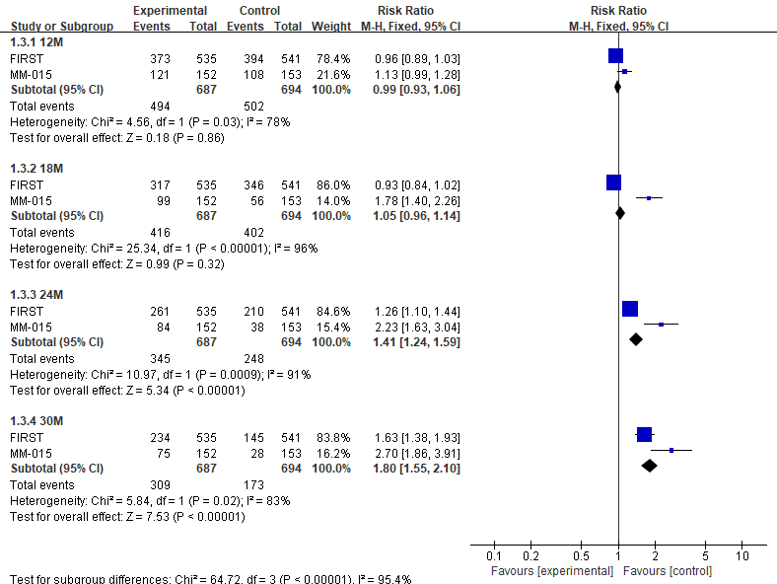

D) A meta-analysis of overall survival based on the continuous therapy over different time points
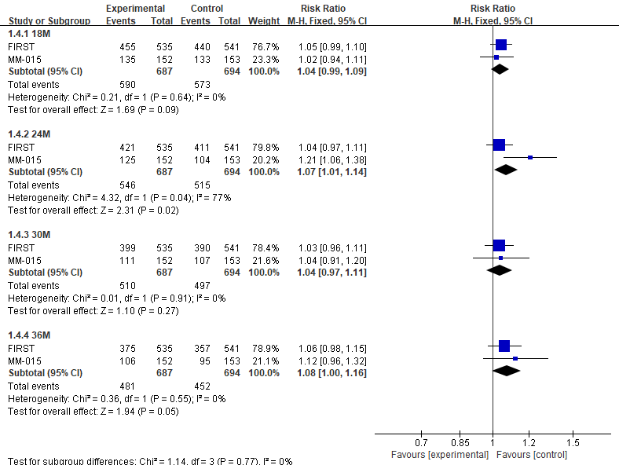(
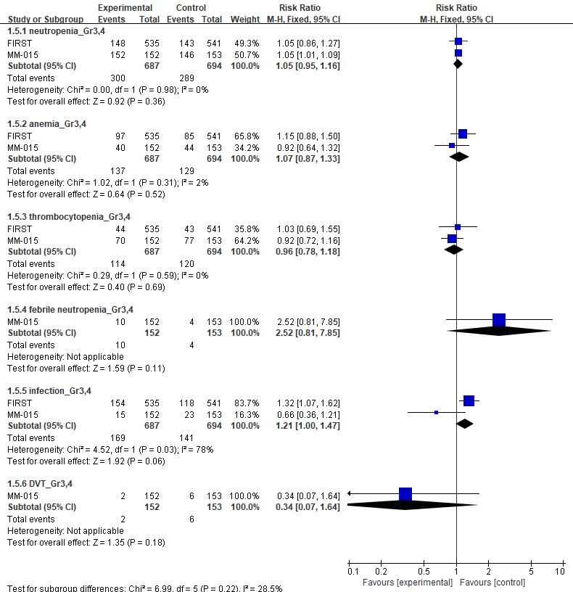
E) A meta-analysis of adverse events based on the continuous therapy

Key Question 3. Is upfront autologous stem cell transplantation more effective than delayed autologous stem cell transplantation in transplant-eligible multiple myeloma?

Table 3. Summary of Findings table
Outcomes | Illustrative comparative risks* (95% CI) |  | Relative effect  (95% CI) | No of Participants  (studies) | SoE (GRADE)
Outcomes | Assumed risk | Corresponding  risk | Relative effect  (95% CI) | No of Participants  (studies) | SoE (GRADE)
OS FU: 5 yrs | 181  per 1000 | 134 per 1000  (66 to 264) | HR 0.72  (0.34 to 1.53) | 3,044 (2 studies) | ⊕⊝⊝⊝ Very low
PFS FU: 5 yrs | 790  per 1000 | 722 per 1000  (505 to 903) | HR 0.82  (0.45 to 1.49) | 3044 (2 studies) | ⊕⊝⊝⊝ Very low
*The basis for the assumed risk (e.g. the median control group risk across studies) is provided in footnotes. The corresponding risk (and its 95% confidence interval) is based on the assumed risk in the comparison group and the relative effect of the intervention (and its 95% CI).
OS, overall survival; PFS, progression-free survival; FU, follow-up; CI, confidence interval; HR, hazard ratio

Figure3. Result of meta-analysis
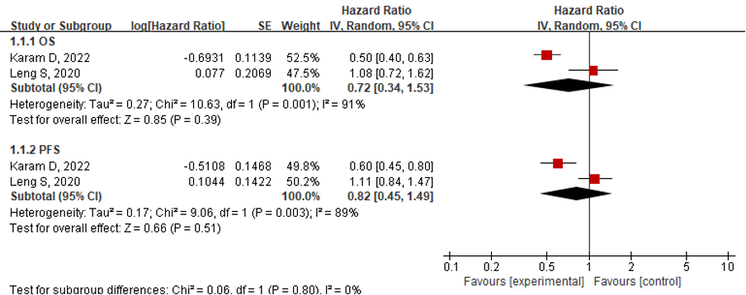
Key Question 4. Dose tandem transplantation improve overall survival compared with a single autologous stem cell transplantation?

Table 4. Summary of Findings table
Outcomes | Illustrative comparative risks*  (95% CI) |  | Relative effect  (95% CI) | No of Participants  (studies) | Quality of the evidence  (GRADE) | Comments
Outcomes | Assumed  risk | Corresponding  risk
OS | 556 per 1000 | 589 per 1000  (506 to 678) | RR 1.06  (0.91 to 1.22) | 1913  (3 studies) | ⊕⊝⊝⊝  very low
RFS | 421 per 1000 | 509 per 1000  (446 to 581) | RR 1.21  (1.06 to 1.38) | 1322  (2 studies) | ⊕⊕⊝⊝  low
CR+VGPR | 364 per 1000 | 437 per 1000  (386 to 491) | RR 1.20  (1.06 to 1.35) | 1494  (3 studies) | ⊕⊕⊝⊝  low
EFS | 262 per 1000 | 383 per 1000  (310 to 472) | RR 1.46  (1.18 to 1.8) | 720  (2 studies) | ⊕⊕⊕⊝  moderate
treatment related deaths | 36 per 1000 | 50 per 1000  (25 to 101) | RR 1.40  (0.69 to 2.81) | 720  (2 studies) | ⊕⊕⊝⊝  low
mucositis(Gr3/4) | 245 per 1000 | 277 per 1000  (194 to 402) | RR 1.13  (0.79 to 1.64) | 321  (1 study) | ⊕⊕⊝⊝  low
infection(Gr3/4) | 209 per 1000 | 240 per 1000  (161 to 361) | RR 1.15  (0.77 to 1.73) | 321  (1 study) | ⊕⊕⊝⊝  low
≥Gr3 non-hematologic toxicities | 504 per 1000 | 509 per 1000  (438 to 584) | RR 1.01  (0.87 to 1.16) | 761  (2 studies) | ⊕⊕⊝⊝  low
Secondary malignancies | 43 per 1000 | 57 per 1000  (27 to 123) | RR 1.33  (0.62 to 2.87) | 501  (1 study) | ⊕⊕⊝⊝  low
PFS(High risk)  Follow-up: 5 years | 256 per 1000 | 356 per 1000  (241 to 523) | RR 1.39  (0.94 to 2.04) | 228  (2 studies) | ⊕⊝⊝⊝  very low
17p deletion 5yrs PFS | 91 per 1000 | 23 per 1000  (9 to 62) | HR 0.24  (0.09 to 0.67) | 40  (1 study) | ⊕⊝⊝⊝  very low
17p deletion 5yrs OS | 318 per 1000 | 109 per 1000  (34 to 334) | HR 0.30  (0.09 to 1.06) | 40  (1 study) | ⊕⊝⊝⊝  very low
*The basis for the assumed risk (e.g. the median control group risk across studies) is provided in footnotes. The corresponding risk (and its 95% confidence interval) is based on the assumed risk in the comparison group and the relative effect of the intervention (and its 95% CI).
CI, confidence interval; RR, risk ratio; HR, hazard ratio; OS, overall survival; RFS, relapse free survival; CR, complete response; VGPR, very good partial response; EFS, event free survival; Gr, grade; PFS, progression free survival

Figure 4. Results of meta-analysis

A) A meta-analysis of response rate and survival rates
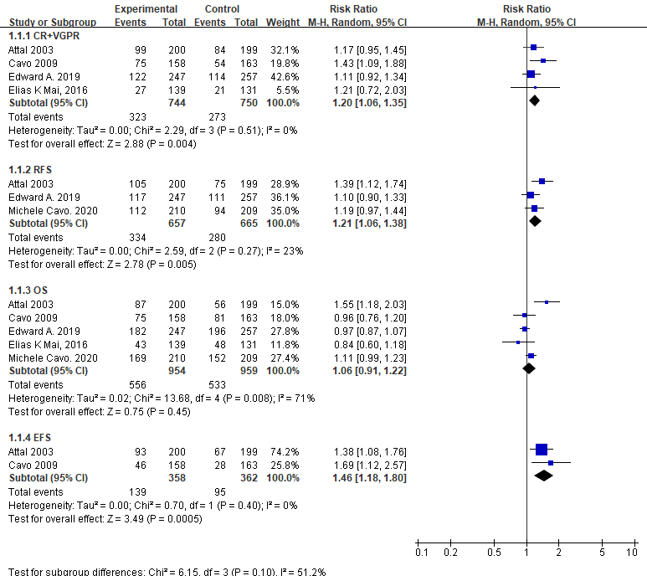

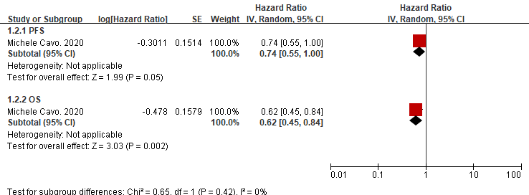
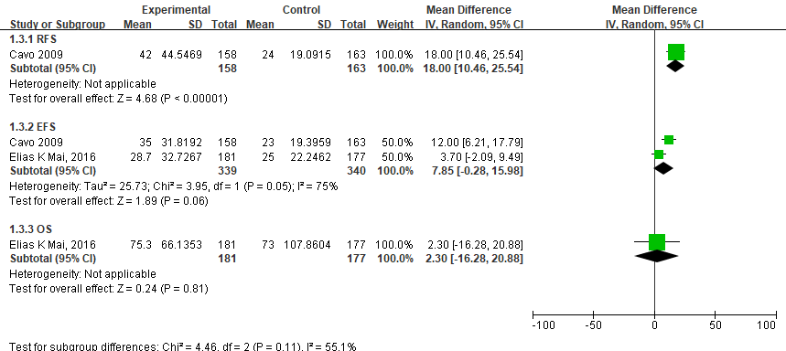

B) A meta-analysis of survival rates in high-risk patients

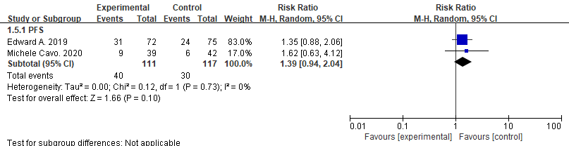

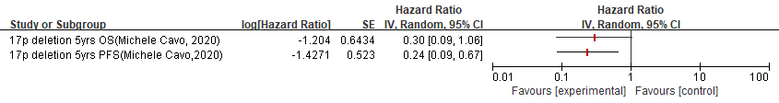

C) A meta-analysis of adverse events
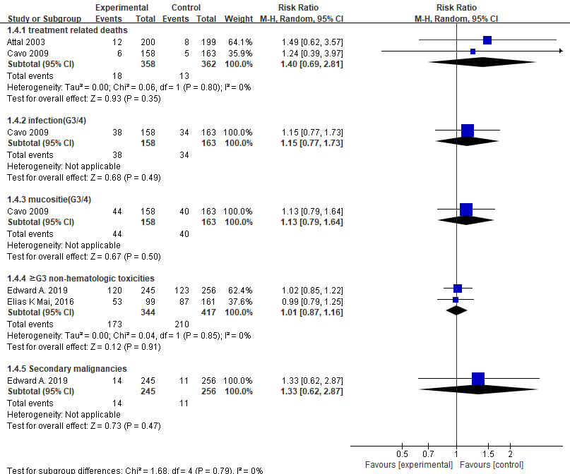

Key Question 5. Does maintenance therapy after autologous stem cell transplantation improve survival in patients with multiple myeloma?

Table 5. Summary of Findings table
Outcomes | Illustrative comparative risks* (95% CI) |  | Relative effect  (95% CI) | No of Participants  (studies) | Quality of the evidence  (GRADE) | Comments
Outcomes | Assumed risk | Corresponding risk
OS | 236 per 1000 | 179 per 1000  (152 to 209) | HR 0.73  (0.61 to 0.87) | 2445  (4 studies) | ⊕⊕⊕⊝  moderate
PFS | 509 per 1000 | 324 per 1000  (300 to 352) | HR 0.55  (0.50 to 0.61) | 3982  (6 studies) | ⊕⊕⊕⊕  high
Febrile neutropenia | 1 per 1000 | 5 per 1000  (1 to 47) | RR 3.95  (0.44 to 35.12) | 1492  (2 studies) | ⊕⊕⊝⊝  low
Grade 3/4  neutropenia | 148 per 1000 | 271 per 1000  (168 to 442) | RR 1.83  (1.13 to 2.98) | 2605  (4 studies) | ⊕⊕⊕⊕  high
Grade 3/4  thrombocytopenia | 28 per 1000 | 71 per 1000  (48 to 103) | RR 2.56  (1.75 to 3.75) | 2605  (4 studies) | ⊕⊕⊕⊝  moderate
Infection | 49 per 1000 | 91 per 1000  (59 to 139) | RR 1.86  (1.22 to 2.85) | 2145  (3 studies) | ⊕⊕⊕⊝  moderate
Second primary cancer | 32 per 1000 | 63 per 1000  (43 to 91) | RR 1.94  (1.34 to 2.81) | 2605  (4 studies) | ⊕⊕⊕⊝  moderate
*The basis for the assumed risk (e.g. the median control group risk across studies) is provided in footnotes. The corresponding risk (and its 95% confidence interval) is based on the assumed risk in the comparison group and the relative effect of the intervention (and its 95% CI).
CI, confidence interval; RR, risk ratio; HR, hazard ratio; OS, overall survival; PFS, progression-free survival

Figure 5. Results of meta-analysis

A) A meta-analysis of progression-free survival
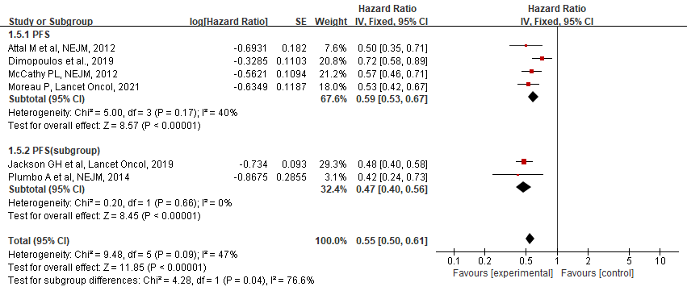

B) A meta-analysis of overall survival
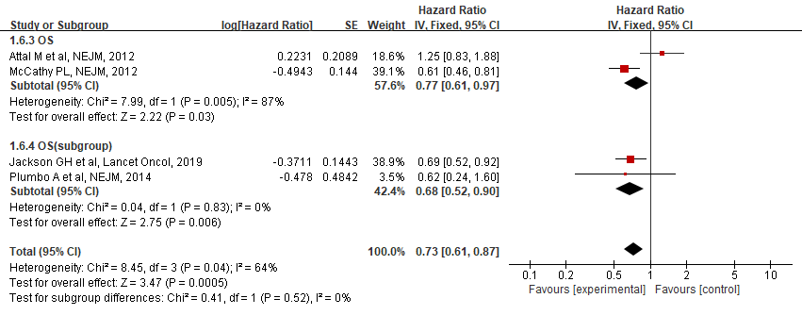

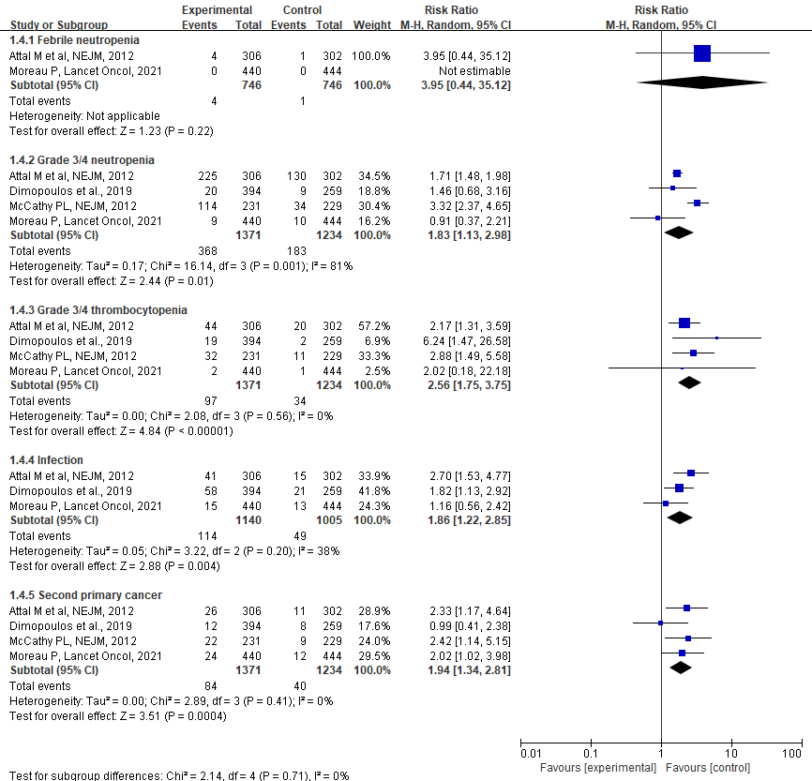
C) A meta-analysis of adverse events

Key Question 6. In relapsed multiple myeloma, does treatment at the time of biochemical relapse improve survival compared to treatment at the time of symptomatic relapse?

Table 6. Summary of Findings table
Biochemical compared to Clinical for
Patient or population: patients with
Settings:
Intervention: Biochemical
Comparison: Clinical
Outcomes | Illustrative comparative risks* (95% CI) |  | Relative effect  (95% CI) | No of Participants  (studies) | Quality of the evidence  (GRADE) | Comments
Outcomes | Assumed risk | Corresponding risk
 | Clinical | Biochemical
PFS | 247 per 1000 | 145 per 1000  (142 to 180) | HR 0.55  (0.54 to 0.70) | 2808  (4 studies) | ⊕⊝⊝⊝  very low
OS | 648 per 1000 | 355 per 1000  (197 to 487) | HR 0.42  (0.21 to 0.64) | 3272  (6 studies) | ⊕⊝⊝⊝  very low
*The basis for the assumed risk (e.g. the median control group risk across studies) is provided in footnotes. The corresponding risk (and its 95% confidence interval) is based on the assumed risk in the comparison group and the relative effect of the intervention (and its 95% CI).
CI, confidence interval; HR, hazard ratio; PFS, progression-free survival; OS, overall survival

Figure 6. Result of meta-analysis

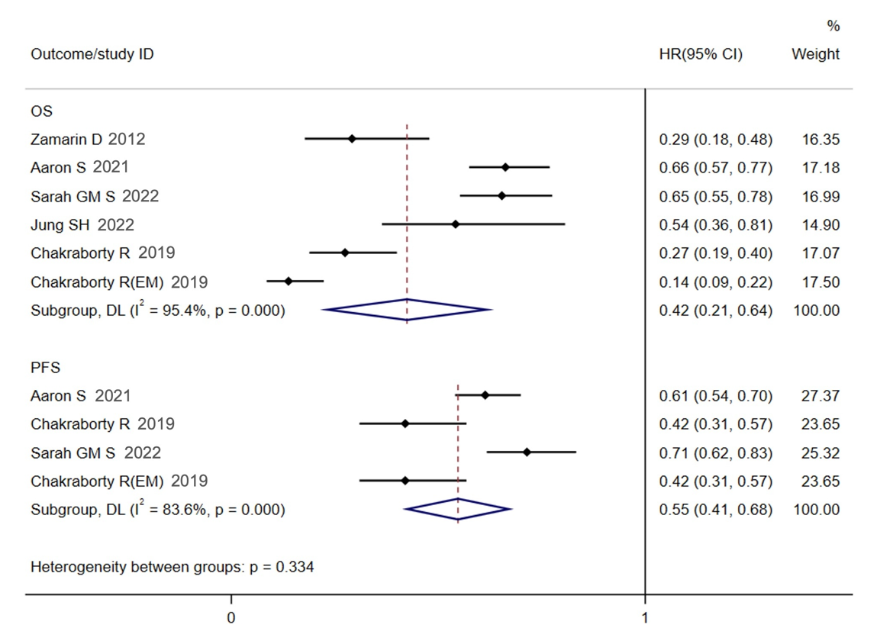
Key Question 7. Is it effective to retreatment with previously effective agents in relapsed
multiple myeloma?

Table 7. Summary of Findings table
Outcomes | Illustrative comparative risks* (95% CI) |  | Relative effect  (95% CI) | No of Participants  (studies) | Quality of the evidence  (GRADE) | Comments
Outcomes | Control proportion | Test proportion
ORR | 0.60(0.53-0.67) | 0.57(0.42-0.71) | Not estimable | 506  (10 studies) | ⊕⊝⊝⊝  very low
CR | 0.12(0.10-0.15) | 0.09(0.04-0.15) | Not estimable | 410  (9 studies) | ⊕⊝⊝⊝  very low
VGPR | 0.25(0.20-0.30) | 0.06(0.02-0.11) | Not estimable | 378  (8 studies) | ⊕⊝⊝⊝  very low
PR | 0.28(0.22-0.35) | 0.37(0.26-0.47) | Not estimable | 410  (9 studies) | ⊕⊝⊝⊝  very low
median PFS | - | 6.32(4.57-8.07) | Not estimable | 198  (4 studies) | ⊕⊝⊝⊝  very low
median OS | - | 14.35(8.82-19.88) | Not estimable | 233  (4 studies) | ⊕⊝⊝⊝  very low
Neutropenia | 0.23(0.17-0.28) | 0.05(-0.01-0.11) | Not estimable | 267  (3 studies) | ⊕⊝⊝⊝  very low
Anemia | 0.17(0.15-0.19) | 0.04(0.01-0.08) | Not estimable | 361  (4 studies) | ⊕⊝⊝⊝  very low
Infection | 0.11(0.07-0.15) | 0.01(-0.01-0.02) | Not estimable | 137  (2 studies) | ⊕⊝⊝⊝  very low
Neutropathy | 0.04(0.03-0.05) | 0.04(-0.01-0.08) | Not estimable | 276  (4 studies) | ⊕⊝⊝⊝  very low
Pneumonia | 0.10(0.09-0.11) | 0.05(0.02-0.08) | Not estimable | 226  (2 studies) | ⊕⊝⊝⊝  very low
Thrombocytopenia | 0.21(0.17-0.24) | 0.15(0.03-0.27) | Not estimable | 361  (4 studies) | ⊕⊝⊝⊝  very low
Upper respiratory infection | 0.01(0.01-0.01) | 0.01 | Not estimable | 96  (1 studies) | ⊕⊝⊝⊝  very low
HTN | 0.05(0.03-0.06) | 0.31 | Not estimable | 13  (1 studies) | ⊕⊝⊝⊝  very low
*The basis for the assumed risk (e.g. the median control group risk across studies) is provided in footnotes. The corresponding risk (and its 95% confidence interval) is based on the assumed risk in the comparison group and the relative effect of the intervention (and its 95% CI).
CI, confidence interval; RR, risk ratio; ORR, overall response rate; CR, complete response; VGPR, very good partial response; PR, partial response; PFS, progression-free survival; OS, overall survival; HTN, hypertension

Figure 7. Results of meta-analysis

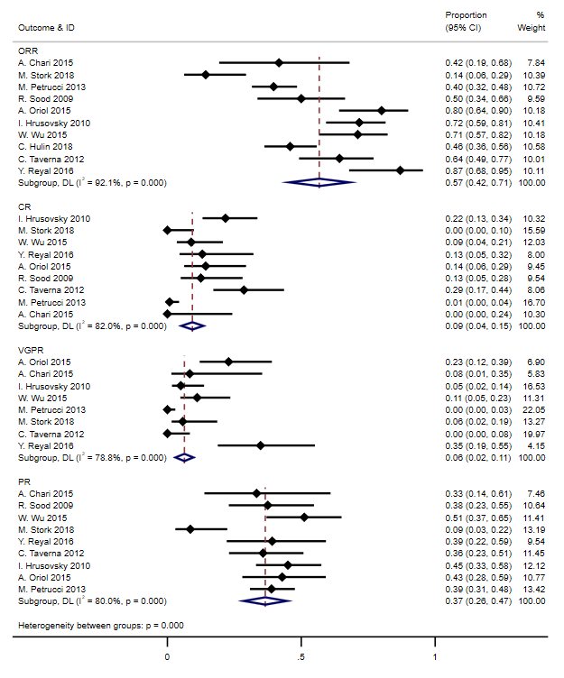
A) Response rates when treated with previous treatment.

B) Response rates when treated with agents other than those used in previous treatment

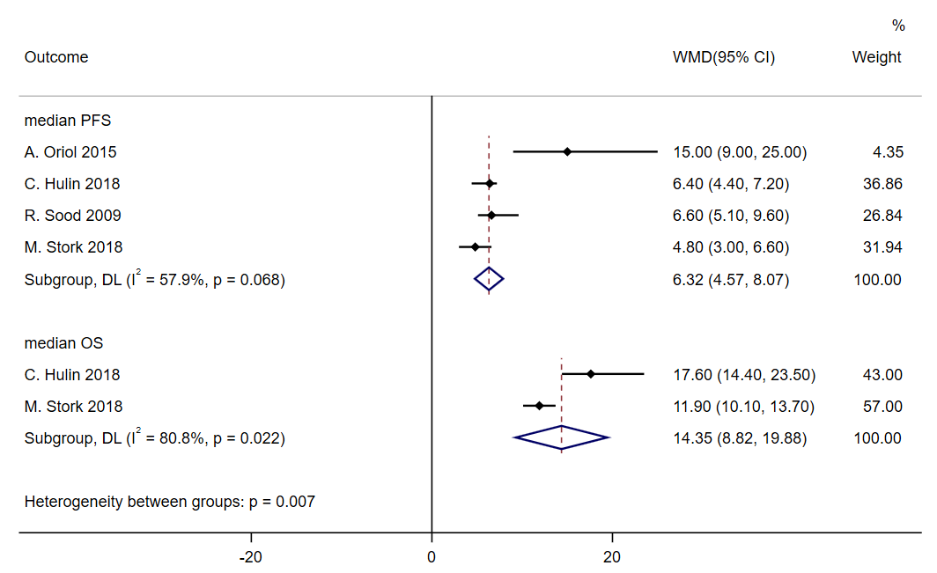
C) Survival rates when treated with previous treatment.

D) Response rates in resue of bortezomib
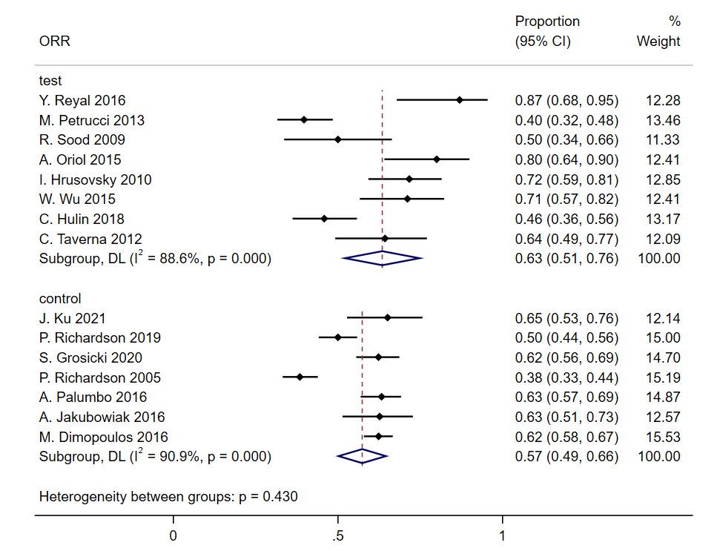

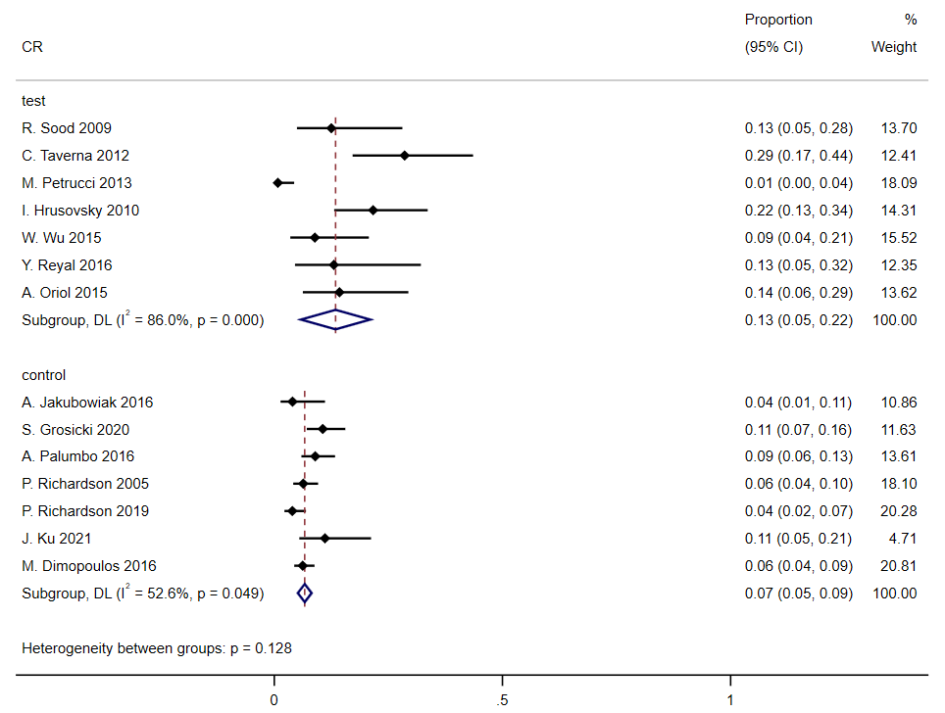

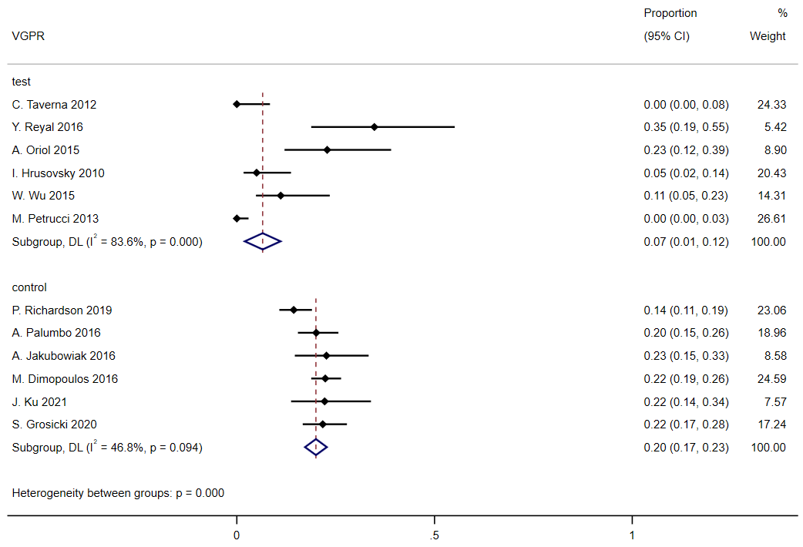

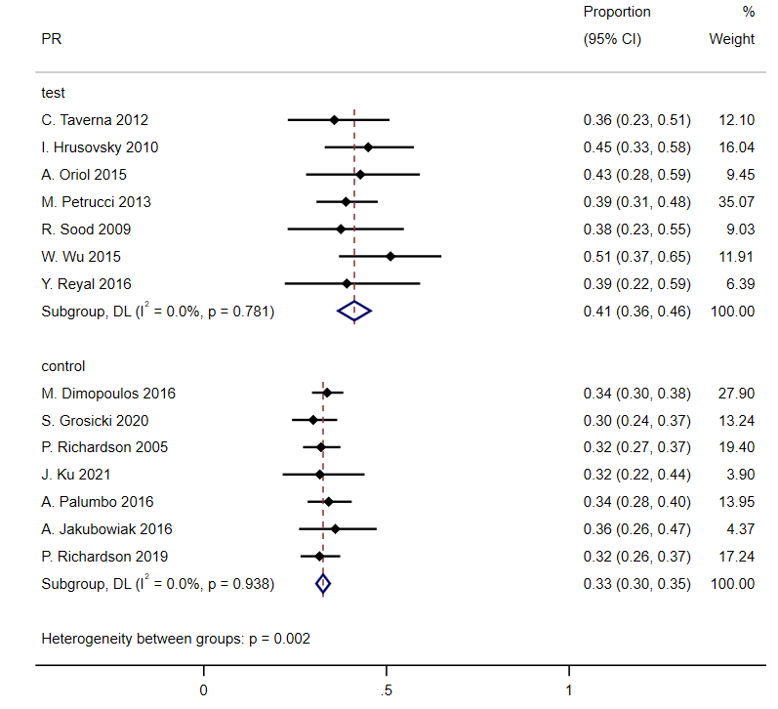

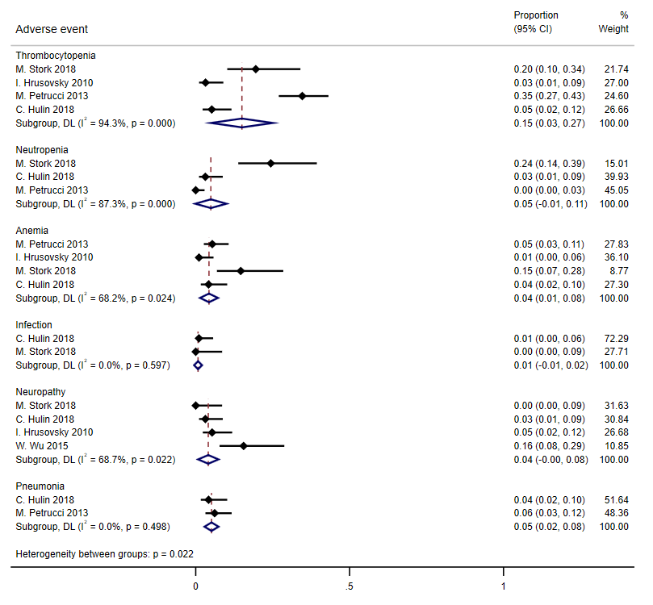
E) A meta-analysis of adverse events

Key Question 8. Is the use of antibiotics or antivirals for infection prevention useful during initial induction therapy for newly diagnosed multiple myeloma?

Table 8. Summary of Findings table

A) Prophylactic antibiotic
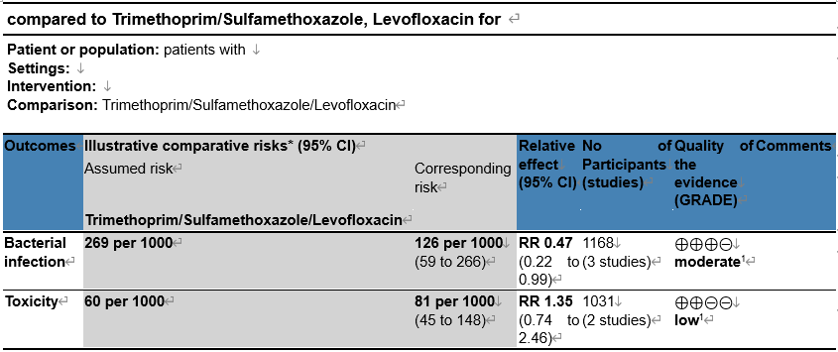

B) Prophylactic antiviral agent
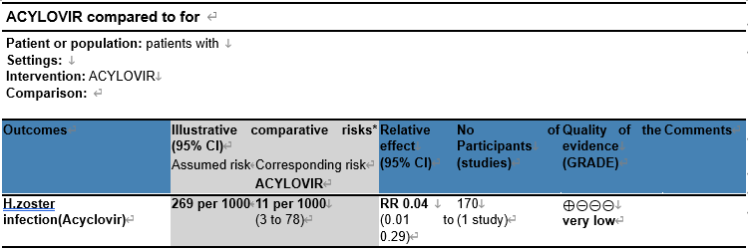

Figure 8-1. Results of meta anaylsis of prophylactic antibiotic

A) A meta-analysis of efficacy of prophylactic antibiotics
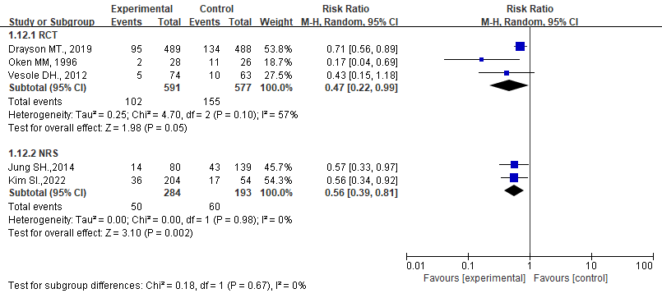

B) A meta-analysis of adverse events
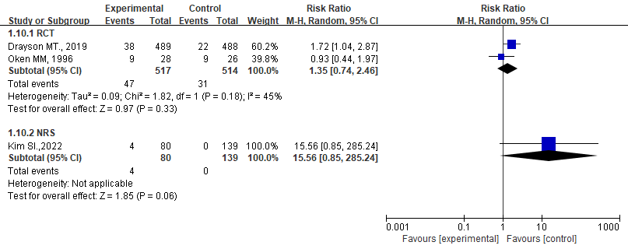

Figure 8-2. A meta-analysis of efficacy of prophylactic antiviral agent

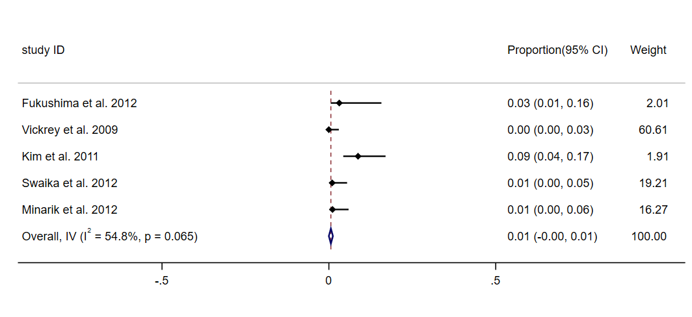
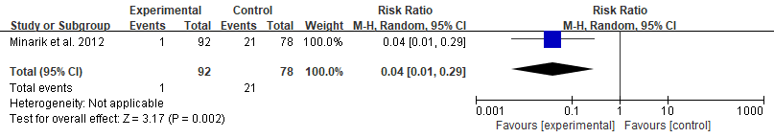

Key Question 9. Is the use of bone resorption inhibitors effective in multiple myeloma?

Table 9. Table of Findings table

(A) Comparison of pamidronate or zoledronate with placebo or no treatment
Outcomes | Illustrative comparative risks* (95% CI) |  | Relative effect  (95% CI) | No of Participants  (studies) | Quality of the evidence  (GRADE) | Comments
Outcomes | Assumed risk | Corresponding  risk
OS | 410 per 1000 | 286 per 1000  (236 to 330) | HR 0.64  (0.51 to 0.76) | 1479  (8 studies) | ⊕⊕⊕⊝  moderate
PFS | 477 per 1000 | 335 per 1000  (272 to 393) | HR 0.63  (0.49 to 0.77) | 982  (6 studies) | ⊕⊕⊕⊝  moderate
Skeletal-related events (SREs) | 320 per 1000 | 228 per 1000  (198 to 263) | HR 0.67  (0.57 to 0.79) | 1661  (7 studies) | ⊕⊕⊕⊝  moderate
Osteonecrosis of Jaw (ONJ) | 0 per 1000 | 4 per 1000 (0 to 10) | RR 4.61 (0.99 to 21.35) | 1284 (6 studies) | ⊕⊕⊝⊝  low
Gastrointestinal toxicity Grade III or IV | 99 per 1000 | 8 per 1000  (89 to 184) | RR 1.30  (0.90 to 1.87) | 879  (3 studies) | ⊕⊕⊝⊝  low
*The basis for the assumed risk (e.g. the median control group risk across studies) is provided in footnotes. The corresponding risk (and its 95% confidence interval) is based on the assumed risk in the comparison group and the relative effect of the intervention (and its 95% CI).
CI, confidence interval; RR, risk ratio; HR, hazard ratio; OS, overall survival; PFS, progression free survival;

(B) Comparison of Denosumab and Zoledronate
Outcomes | Illustrative comparative risks*  (95% CI) |  | Relative effect  (95% CI) | No of Participants  (studies) | Quality of the evidence  (GRADE) | Comments
Outcomes | Assumed risk | Corresponding risk
 | Zoledronate | Denosumab
SRE_s | 446 per 1000 | 439 per 1000  (395 to 490) | HR 0.98  (0.85 to 1.14) | 1718  (1 study) | ⊕⊕⊝⊝  low
OS | 150 per 1000 | 136 per 1000  (108 to 172) | HR 0.90  (0.70 to 1.16) | 1718  (1 study) | ⊕⊕⊝⊝  low
PFS | 305 per 1000 | 258 per 1000  (219 to 303) | HR 0.82  (0.68 to 0.99) | 1711  (1 study) | ⊕⊕⊝⊝  low
ONJ | 28 per 1000 | 41 per 1000  (25 to 69) | RR 1.46  (0.88 to 2.44) | 1702  (1 study) | ⊕⊕⊝⊝  low
drug related  adverse events  Grade III or IV | 58 per 1000 | 52 per 1000  (35 to 77) | RR 0.90  (0.61 to 1.34) | 1702  (1 study) | ⊕⊕⊝⊝  low
Hypocalcemia | 124 per 1000 | 169 per 1000  (134 to 214) | RR 1.36  (1.08 to 1.72) | 1702  (1 study) | ⊕⊕⊝⊝  low
Renal dysfunction | 46 per 1000 | 37 per 1000  (23 to 58) | RR 0.80  (0.50 to 1.26) | 1702  (1 study) | ⊕⊕⊝⊝  low
*The basis for the assumed risk (e.g. the median control group risk across studies) is provided in footnotes. The correspo nding risk (and its 95% confidence interval) is based on the assumed risk in the comparison group and the relative effect of the intervention (and its 95% CI).
CI, confidence interval; RR, risk ratio; HR: hazard ratio;
Figure 9. Results of meta-analysis

A) Skeletal-related events
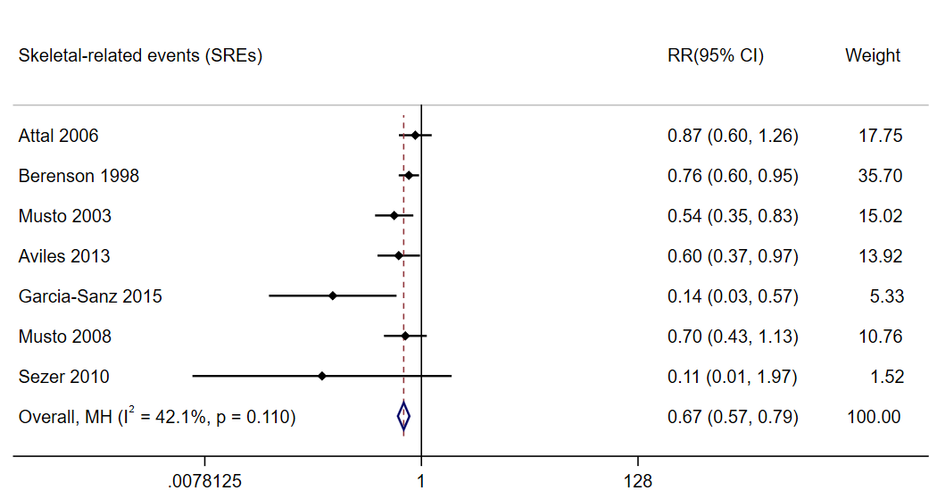

B) Survival
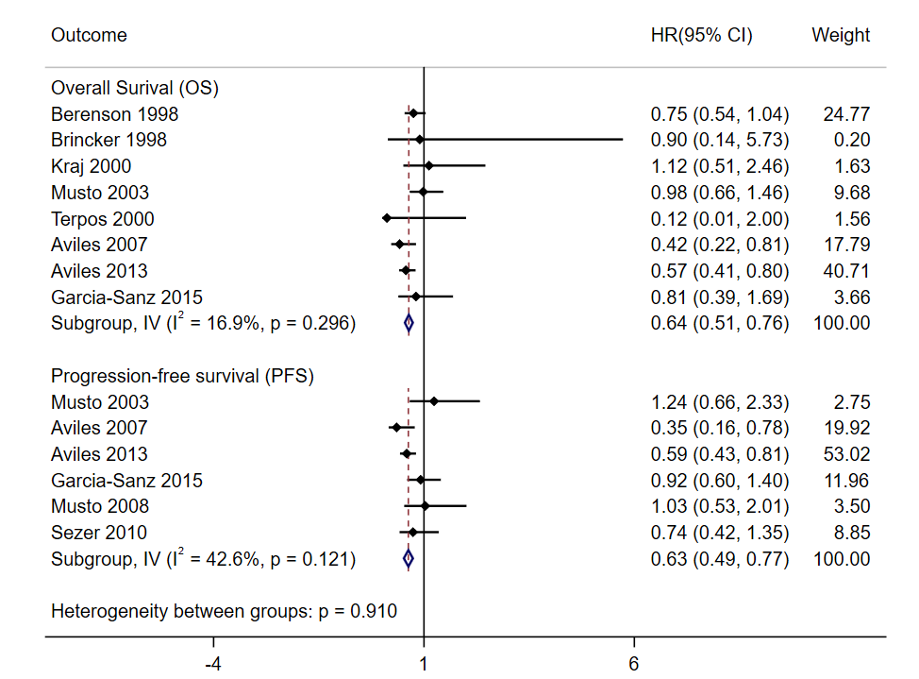
C) Comparison of denosumab and zoledronate
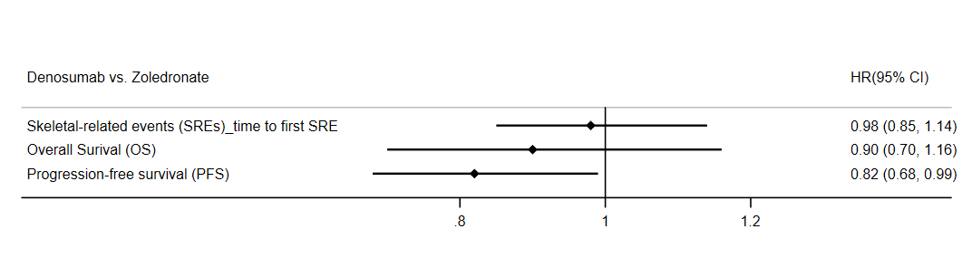

D) Gatrointestinal toxicity Grade III or IV
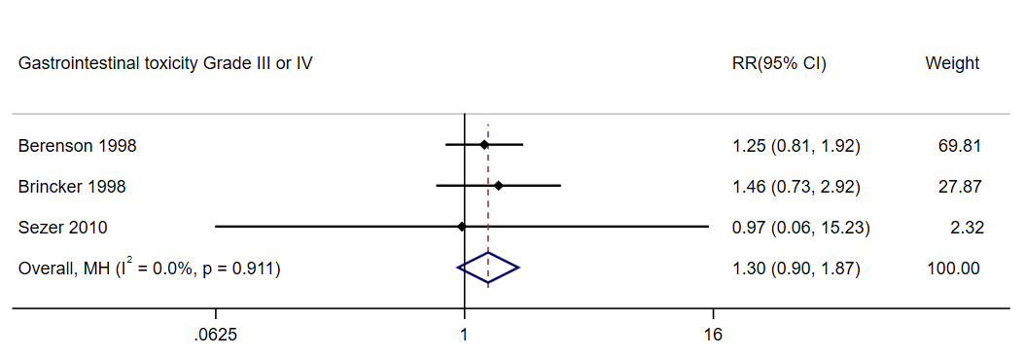

E) Incidence of osteonecrosis of jaw
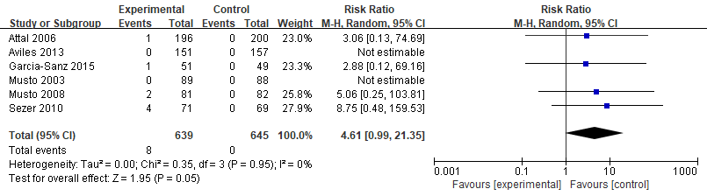

F) Adverse events of denosumab and zoledronate
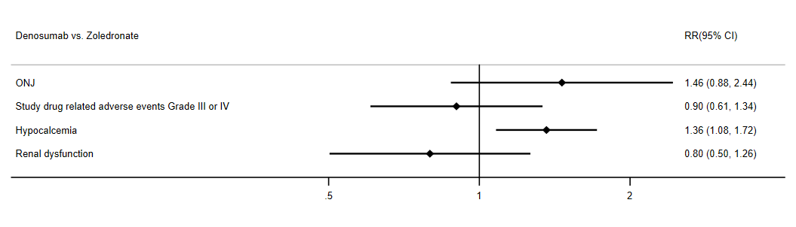
Key Question 10. Is FDG PET/CT or MRI useful for prognosis prediction in newly diagnosed multiple myeloma?
Tablke 10-1 Summary of clinical studies
A) Clinical studies of FDG PET/CT
Study | Year | Country | Design | Population | Median age (y) | Median f/u (m) | PET/CT parameters | Outcomes
Zamagni (90) | 2015 | Italy | Retro | 282 | 59 | 67 | FL | PFS, OS
McDonald (91) | 2017 | USA | Retro | 192 | NA | 101.52 | FL | PFS, OS
Davies (92) | 2018 | USA | Retro | 596 | 60.6 | 61.2 | FL | PFS, OS
Jung (93) | 2019 | Korea | Retro | 167 | 67 | 24.4 | FL | PFS, OS
Moon (94) | 2018 | Korea | Retro | 76 | 60.5 | 27.6 | FL | PFS, OS
Aljama (95) | 2018 | USA | Retro | 313 | 66 | 67 | FL | PFS, OS
Abe (96) | 2019 | Japan | Retro | 163 | 74.1 | 27.5 | FL | PFS, OS
Cho (97) | 2022 | Korea | Retro | 210 | 67 | 18.5 | FL | PFS, OS
Cho (98) | 2021 | Korea | Retro | 380 | 66 | 26 | FL | PFS, OS
Sachpekidis (99) | 2021 | Germany | Retro | 47 | 59.9 | 85.1 | FL | PFS
Rasche (100) | 2018 | USA | - | 404 | NA | 62.4 | FL | PFS
Fonti (101) | 2015 | Italy | Retro | 27 | 62 | 66 | FL | PFS

B) Clinical studies of MRI
Study | Year | Country | Design | Population | Median age (y) | Median f/u (m) | MRI parameters | Outcomes
Lee (102) | 2022 | Korea | Retro | 214 | 67 | 37.9 | Diffuse | PFS, OS
Zhang (103) | 2021 | China | Pros | 102 | 60 | 50.2 | Diffuse | PFS, OS
Mai (104) | 2015 | Germany | Retro | 161 | 58 | 64 | Diffuse, FL | PFS, OS
Song (105) | 2015 | Korea | Retro | 168 | 69 | 34.1 | Diffuse | PFS, OS
Song (106) | 2014 | Korea | Retro | 79 | 53.5 | 46.1 | Diffuse | PFS, OS
Rasche (100) | 2018 | USA | - | 404 | > 65 (35%) | 62.4 | FL | PFS, OS
Bartel (107) | 2009 | Italy | - | 239 | > 65 (28%) | 43 | FL | PFS, OS
Walker (108) | 2007 | USA | - | 420 | NA | 55 | FL | OS
Moulopoulos (109) | 2005 | Greece | Retro | 142 | ≥65, (30%) | NA | Diffuse | OS
Moulopoulos (110) | 2012 | Greece | Retro | 134 | 67 | NA | Diffuse | OS

Table 10-2. Summary of Findings table
A) Comparison of survival based on FDG PET/CT and MRI
Outcomes | Illustrative comparative risks* (95% CI) |  | Relative effect  (95% CI) | No of Participants  (studies) | Quality of the evidence  (GRADE) | Comments
Outcomes | Assumed risk | Corresponding risk
PET/CT(PFS) | 553 per 1000 | 830 per 1000  (646 to 919) | HR 2.20  (1.29 to 3.12) | 1142  (5 studies) | ⊕⊝⊝⊝  very low
PET/CT(OS) | 298 per 1000 | 501 per 1000  (320 to 633) | HR 1.96  (1.09 to 2.83) | 762  (4 studies) | ⊕⊝⊝⊝  very low
MRI(PFS)_Diffuse | 440 per 1000 | 730 per 1000  (648 to 792) | HR 2.26  (1.80 to 2.71) | 622  (4 studies) | ⊕⊝⊝⊝  very low
MRI(PFS) _High FL | 373 per 1000 | 489 per 1000  (143 to 696) | HR 1.44  (0.33 to 2.55) | 565  (2 studies) | ⊕⊝⊝⊝  very low
MRI(OS)_Diffuse | 374 per 1000 | 653 per 1000  (569 to 718) | HR 2.26  (1.80 to 2.71) | 677  (4 studies) | ⊕⊝⊝⊝  very low
MRI(OS) _High FL | 236 per 1000 | 324 per 1000  (34 to 525) | HR 1.45  (0.13 to 2.76) | 565  (2 studies) | ⊕⊝⊝⊝  very low
*The basis for the assumed risk (e.g. the median control group risk across studies) is provided in footnotes. The corresponding risk (and its 95% confidence interval) is based on the assumed risk in the comparison group and the relative effect of the intervention (and its 95% CI).
CI, confidence interval; H, hazard ratio; PFS, progression-free survival; OS, overall survival; FL, focal lesion

B) Sensitivity and Specificity of FDG PET/CT and MRI from the perspective of PFS
Should PET/CT vs. MRI be used to diagnose PFS in [health problem and/or population]?
Patient or population: [health problem and/or population]
Setting:
New test: MRI |Cut-off value:
Pooled sensitivity PET/CT:0.56 (95% CI: 0.52 to 0.59)|Pooled specificity PET/CT:0.64 (95% CI: 0.60 to 0.68)
Pooled sensitivity MRI:0.83 (95% CI: 0.78 to 0.87)|Pooled specificity MRI:0.39 (95% CI: 0.31 to 0.46)
Test result | Number of results per 1,000 patients tested (95% CI) |  |  |  | Number of participants  (studies) | Certainty of the Evidence (GRADE)
Test result | Prevalence40%  Typically seen in |  | Prevalence50%  Typically seen in |  | Number of participants  (studies) | Certainty of the Evidence (GRADE)
Test result | PET/CT | MRI | PET/CT | MRI | Number of participants  (studies) | Certainty of the Evidence (GRADE)
True positives | 224 (208 to 236) | 332 (312 to 348) | 280 (260 to 295) | 415 (390 to 435) | PET/CT  2499  (10)  MRI  724(5) | ⨁⨁◯◯  Low
True positives | 108 fewer TP in PET/CT |  | 135 fewer TP in PET/CT |  | PET/CT  2499  (10)  MRI  724(5) | ⨁⨁◯◯  Low
False negatives | 176 (164 to 192) | 68 (52 to 88) | 220 (205 to 240) | 85 (65 to 110) | PET/CT  2499  (10)  MRI  724(5) | ⨁⨁◯◯  Low
False negatives | 108 more FN in PET/CT |  | 135 more FN in PET/CT |  | PET/CT  2499  (10)  MRI  724(5) | ⨁⨁◯◯  Low
True negatives | 384 (360 to 408) | 234 (186 to 276) | 320 (300 to 340) | 195 (155 to 230) | PET/CT  2499  (10)  MRI  724(5) | ⨁◯◯◯  Very low
True negatives | 150 more TN in PET/CT |  | 125 more TN in PET/CT |  | PET/CT  2499  (10)  MRI  724(5) | ⨁◯◯◯  Very low
False positives | 216 (192 to 240) | 366 (324 to 414) | 180 (160 to 200) | 305 (270 to 345) | PET/CT  2499  (10)  MRI  724(5) | ⨁◯◯◯  Very low
False positives | 150 fewer FP in PET/CT |  | 125 fewer FP in PET/CT |  | PET/CT  2499  (10)  MRI  724(5) | ⨁◯◯◯  Very low
CI: confidence interval

C) Sensitivity and Specificity of FDG PET/CT and MRI from the perspective of OS
Should PET/CT vs. MRI be used to diagnose OS in [health problem and/or population]?
Patient or population: [health problem and/or population]
Setting:
New test: MRI |Cut-off value:
Pooled sensitivity PET/CT:0.62 (95% CI: 0.57 to 0.67)|Pooled specificity PET/CT:0.63 (95% CI: 0.57 to 0.68)
Pooled sensitivity MRI:0.78 (95% CI: 0.65 to 0.88)|Pooled specificity MRI:0.42 (95% CI: 0.26 to 0.60)
Test result | Number of results per 1,000 patients tested (95% CI) |  |  |  | Number of participants  (studies) | Certainty of the Evidence (GRADE)
Test result | Prevalence30%  Typically seen in |  | Prevalence40%  Typically seen in |  | Number of participants  (studies) | Certainty of the Evidence (GRADE)
Test result | PET/CT | MRI | PET/CT | MRI | Number of participants  (studies) | Certainty of the Evidence (GRADE)
True positives | 186 (171 to 201) | 234 (195 to 264) | 248 (228 to 268) | 312 (260 to 352) | PET/CT  2021  (7)  MRI  995(7) | ⨁◯◯◯  Very low
True positives | 48 fewer TP in PET/CT |  | 64 fewer TP in PET/CT |  | PET/CT  2021  (7)  MRI  995(7) | ⨁◯◯◯  Very low
False negatives | 114 (99 to 129) | 66 (36 to 105) | 152 (132 to 172) | 88 (48 to 140) | PET/CT  2021  (7)  MRI  995(7) | ⨁◯◯◯  Very low
False negatives | 48 more FN in PET/CT |  | 64 more FN in PET/CT |  | PET/CT  2021  (7)  MRI  995(7) | ⨁◯◯◯  Very low
True negatives | 441 (399 to 476) | 294 (182 to 420) | 378 (342 to 408) | 252 (156 to 360) | PET/CT  2021  (7)  MRI  995(7) | ⨁◯◯◯  Very low
True negatives | 147 more TN in PET/CT |  | 126 more TN in PET/CT |  | PET/CT  2021  (7)  MRI  995(7) | ⨁◯◯◯  Very low
False positives | 259 (224 to 301) | 406 (280 to 518) | 222 (192 to 258) | 348 (240 to 444) | PET/CT  2021  (7)  MRI  995(7) | ⨁◯◯◯  Very low
False positives | 147 fewer FP in PET/CT |  | 126 fewer FP in PET/CT |  | PET/CT  2021  (7)  MRI  995(7) | ⨁◯◯◯  Very low
CI: confidence interval

Figure 10. Results of meta-analysis

A) Progression-free survival
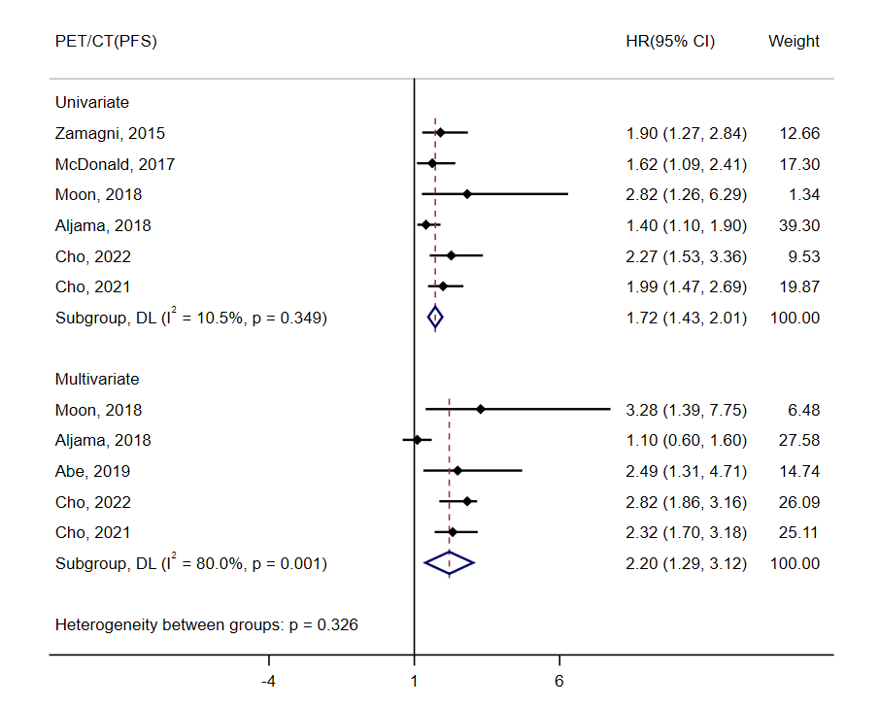
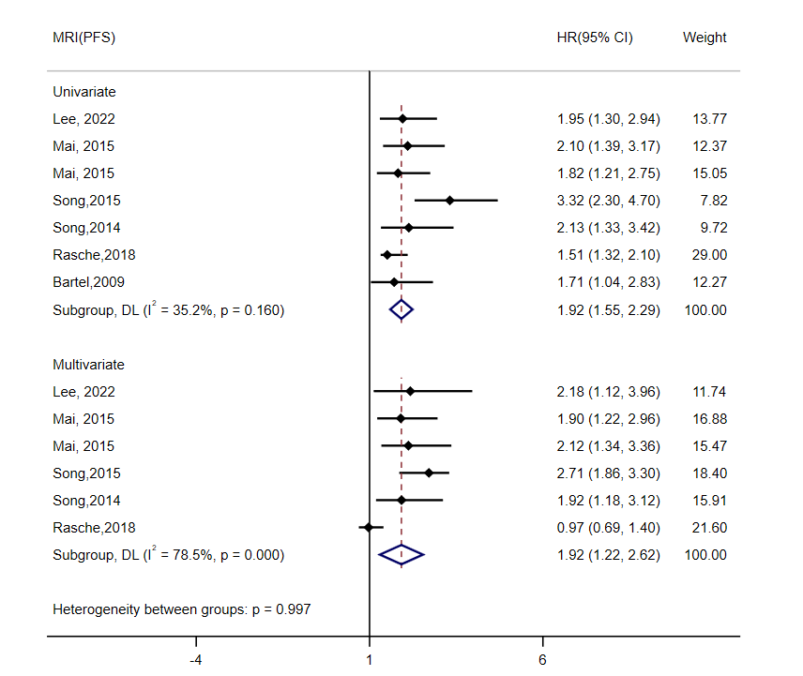
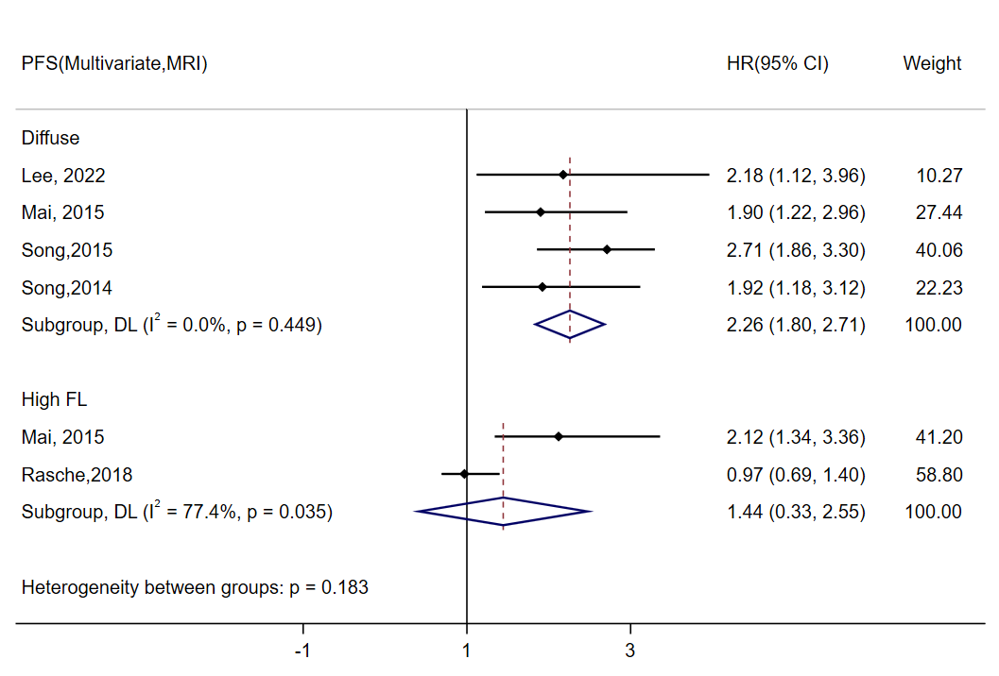

B) Overall survival
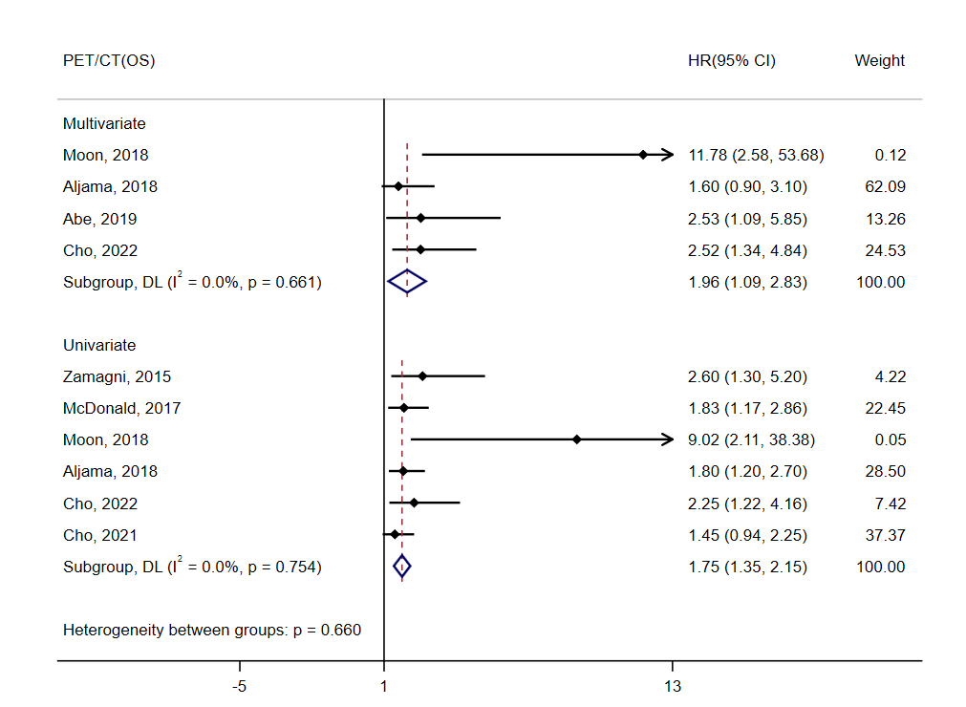
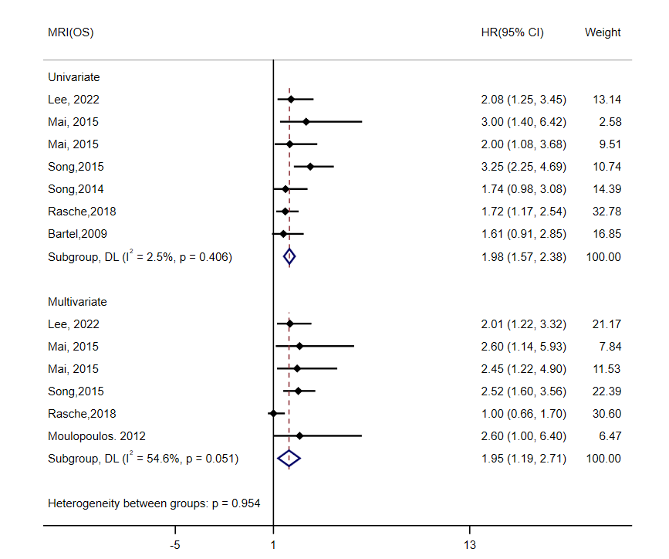
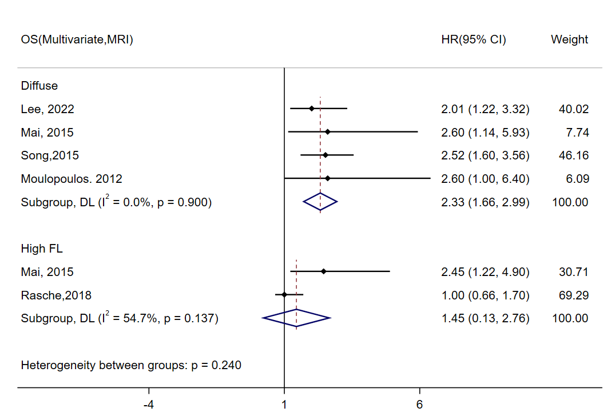

Key Question 11. Is assessment of minimal residual disease useful in newly diagnosed multiple myeloma patients?

Table 11. Summary of Findings table

MM MRD for
Patient or population: patients with newly diagnosed multiple myeloma
Settings: MM treatment- chemotherapy and autologous hematopoietic stem cell transplantation
Intervention: MM MRD method - multicolor flow cytometry /next-generation flow cytometry or
next-generation sequencing
Outcomes | Illustrative comparative risks* (95% CI) |  | Relative effect  (95% CI) | No of Participants  (studies) | Quality of the evidence  (GRADE) | Comments
Outcomes | Assumed risk | Corresponding risk
 | Control | MMMRD
OS | 286 per 1000 | 114 per 1000  (96 to 135) | HR 0.36  (0.3 to 0.43) | 3973  (14 studies) | ⊕⊝⊝⊝  very low
PFS | 416 per 1000 | 140 per 1000  (116 to 163) | HR 0.28  (0.23 to 0.33) | 9421  (29 studies) | ⊕⊝⊝⊝  very low
*The basis for the assumed risk (e.g. the median control group risk across studies) is provided in footnotes. The corresponding risk (and its 95% confidence interval) is based on the assumed risk in the comparison group and the relative effect of the intervention (and its 95% CI).
CI, Confidence interval; HR, Hazard ratio; MM, multiple myeloma; MRD, minimal residual disease; OS, overall survival; PFS, progression-free survival.

Figure 11. Results of meta-analysis

A) Meta-analysis of progression-free survival according to MRD negativity
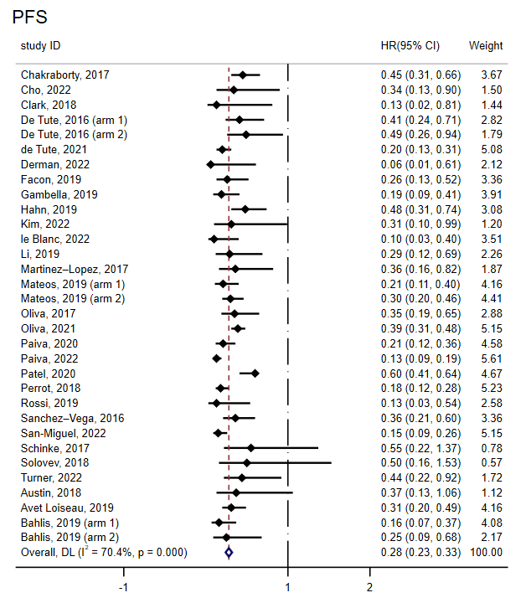
B) Meta-analysis of progression-free survival according to MRD negativity; Sensitivity thresholds of 10⁻⁴(10⁻⁴ to 10⁻⁵) or 10⁻⁵(under 10⁻⁵)
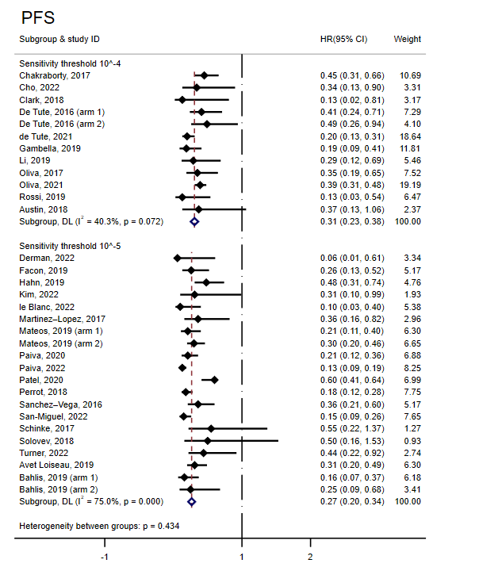
*10⁻⁴ means 10⁻⁴ to 10⁻⁵ sensitivity; 10⁻⁵ means under 10⁻⁵ sensitivity

C) Meta-analysis of progression-free survival according to MRD negativity after ASCT or chemotherapy

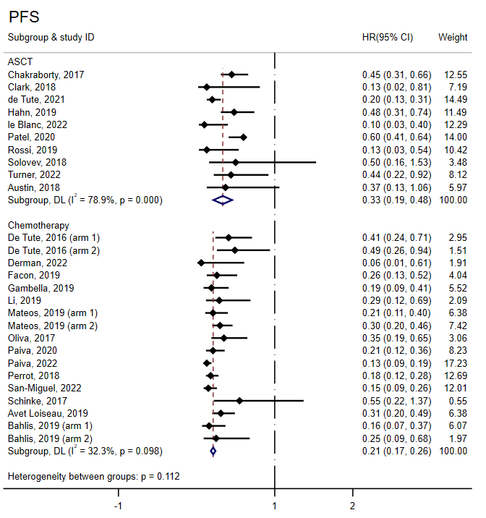
*ASCT, autologous hematopoietic stem cell transplantation

D) Meta-analysis of progression-free survival according to MRD negativity at different time points after treatment (under 6 months, 6-12 months, and over 12 months)

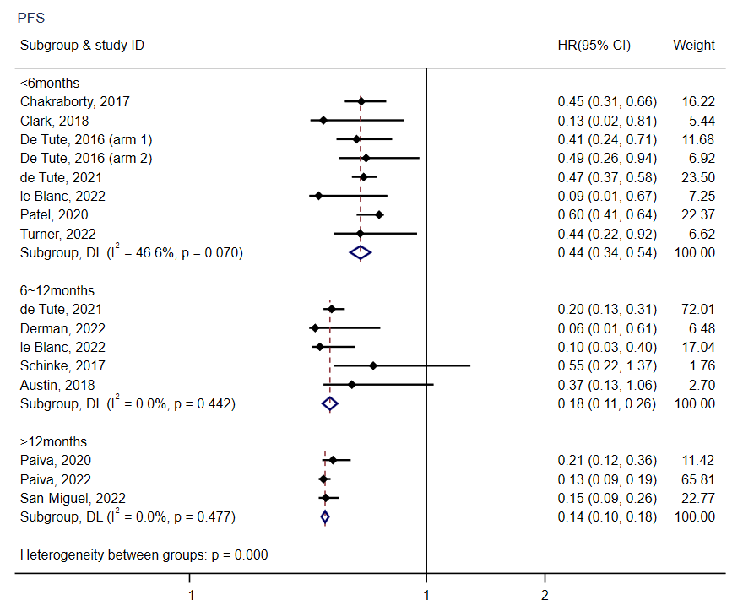

E) Meta-analysis of overall survival according to MRD negativity
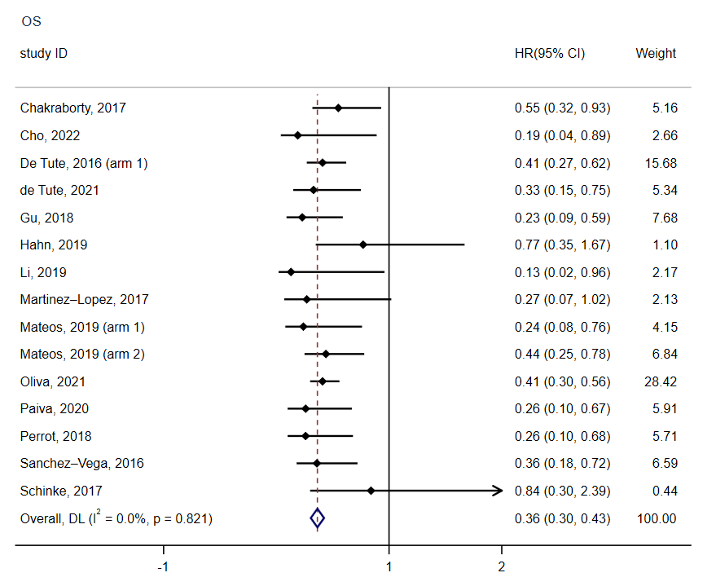

F) Meta-analysis of overall survival according to MRD negativity; Sensitivity thresholds of 10⁻⁴ or 10⁻⁵

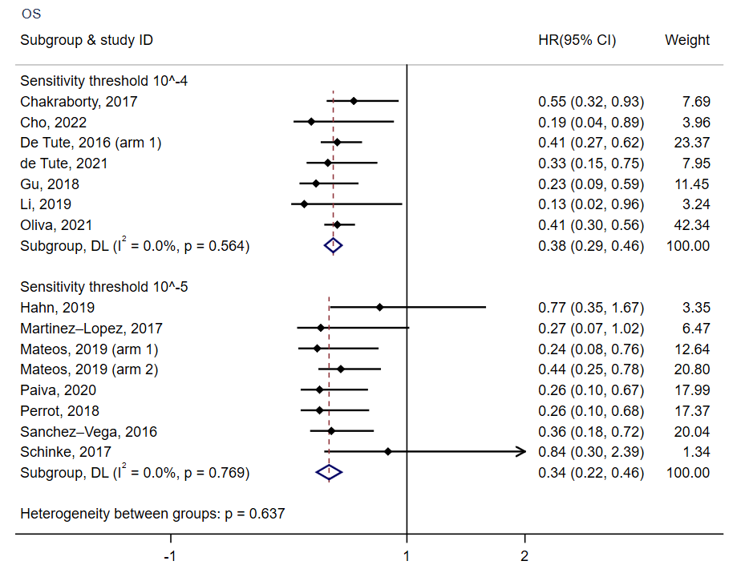
*10⁻⁴ means 10⁻⁴ to 10⁻⁵ sensitivity; 10⁻⁵ means under 10⁻⁵ sensitivity

G) Meta-analysis of overall survival according to MRD negativity after ASCT or chemotherapy
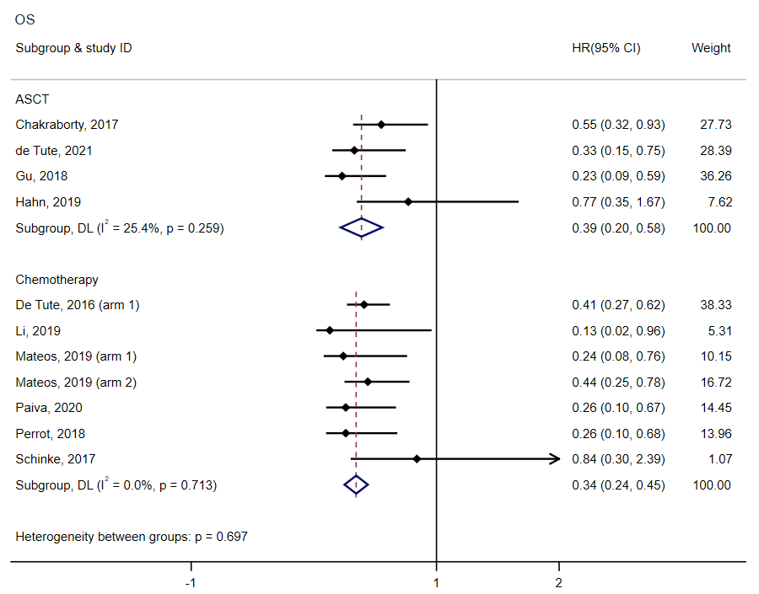
*ASCT, autologous hematopoietic stem cell transplantation

H) Meta-analysis of overall survival according to MRD negativity at different time points after treatment (under 6 months, 6-12 months, and over 12 months)
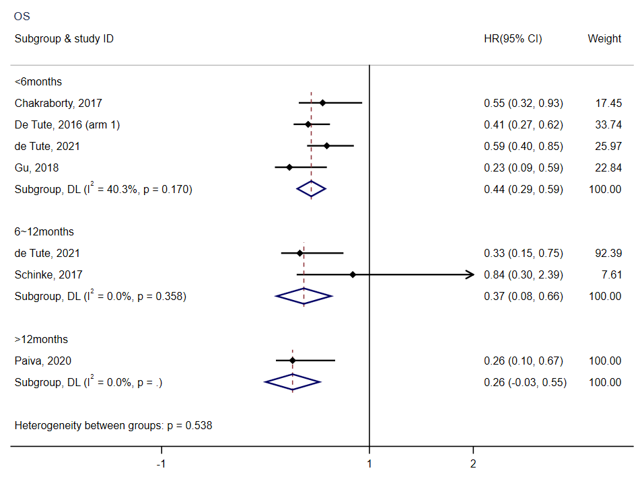
.

Key Question 12. Is it useful to start treatment immediately in patients with high-risk smoldering multiple myeloma?

Table 12. Summary of Findings table
Outcomes | Illustrative comparative risks*  (95% CI) |  | Relative effect  (95% CI) | No of Participants  (studies) | Quality of the evidence  (GRADE) | Comments
Outcomes | Assumed risk | Corresponding risk
PFS | 558 per 1000 | 224 per 1000  (171 to 284) | HR 0.31  (0.23 to 0.41) | 378  (3 studies) | ⊕⊕⊕⊝  moderate
OS | 613 per 1000 | 418 per 1000  (276 to 598) | HR 0.57  (0.34 to 0.96) | 119  (1 study) | ⊕⊕⊝⊝  low
AE | 141 per 1000 | 494 per 1000  (56 to 1000) | RR 3.51  (0.40 to 30.45) | 303  (2 studies) | ⊕⊕⊝⊝  low
*The basis for the assumed risk (e.g. the median control group risk across studies) is provided in footnotes. The corresponding risk (and its 95% confidence interval) is based on the assumed risk in the comparison group and the relative effect of the intervention (and its 95% CI).
CI, Confidence interval; RR, Risk ratio; HR, Hazard ratio; PFS, progression-free survival; OS, overall survival; AE, adverse event

Figure 12. Results of meta-analysis

A) Survival
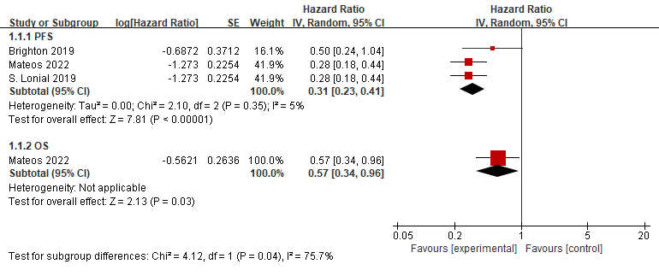

B) Adverse events
