Supplementary Table 1. Patient characteristics including the Unrelated groups.
 |  | Unrelated 09-13 (n=51) | Unrelated 14-18 (n=36) | UCB  (n=24) |  | HRD (n=41) | p value
Median age, Years (IQR) |  | 11.3 (5.4–14.8) | 8.6 (3.0–12.7) | 2.4 (1.4–6.1) | 11.3 (5.8–14.2) |  | <0.001
Sex, No. (%) |  |  |  |  |  |  | 0.121
 | Male | 26 (51.0%) | 22 (61.1%) | 8 (33.3%) | 24 (58.5%)
 | Female | 25 (49.0%) | 14 (38.9%) | 16 (66.7%) | 17 (41.5%)
Median BSA, m² (IQR) |  | 1.20 (0.74–1.51) | 1.0 (0.64–1.37) | 0.55 (0.48–0.80) | 1.11 (0.67–1.54) |  | <0.001
Median Body weight, kg (IQR) |  | 38.0 (18.2–51.3) | 28.8 (15.5–45.3) | 12.23 (9.8–21.1) | 31.2 (15.7–50.6) |  | <0.001
Diagnosis, No. (%) |  |  |  |  |  |  | 0.172
 | Acute lymphoblastic leukemia | 22 (43.1%) | 19 (52.8%) | 10 (41.7%) | 16 (39.0%)
 | Acute myeloid leukemia | 23 (45.1%) | 8 (22.2%) | 10 (41.7%) | 14 (34.1%)
 | Myelodysplastic syndrome† | 1 (2.0%) | 0 (0.0%) | 0 (0.0%) | 3 (7.3%)
 | Malignant lymphoma | 2 (3.9%) | 6 (16.7%) | 0 (0.0%) | 6 (14.6%)
 | Others* | 3 (5.9%) | 3 (8.3%) | 4 (16.7%) | 2 (4.9%)
Conditioning regimen |  |  |  |  |  |  | <0.001
 | Bu+Flu | 15 (29.4%) | 4 (11.1%) | 8 (33.3%) | 0 (0.0%)
 | Bu+Flu+VP | 34 (66.7%) | 32 (88.9%) | 14 (58.3%) | 0 (0.0%)
 | Bu+Flu+Mel | 2 (3.9%) | 0 (0.0%) | 2 (8.3%) | 0 (0.0%)
 | Bu+Flu+Cy | 0 (0.0%) | 0 (0.0%) | 0 (0.0%) | 41 (100.0%)
Status |  |  |  |  |  |  | 0.715
 | CR1 | 36 (70.6%) | 29 (80.6%) | 17 (70.8%) | 29 (70.7%)
 | ≥CR2 or persistence | 15 (29.4%) | 7 (19.4%) | 7 (29.2%) | 12 (29.3%)
Infused busulfan AUC, mg x h/L (IQR) |  | 75.4 (74.2–76.9) | 74.1 (73.3–75.5) | 73.7 (72.0–75.2) | 74.5 (74.0–76.0) |  | 0.01
Median follow-up years (IQR) |  | 11.1 (5.5-13.0) | 7.3 (5.7-9.1) | 10.9 (0.4-14.1) | 7.0 (4.4-8.7) |  | 0.006
UCB, umbilical cord blood; HRD, haploidentical related donor; IQR, interquartile range; No., Number; BSA, body surface area; Bu, busulfan; Flu, fludarabine; VP, etoposide; Mel, melphalan; Cy, cyclophosphamide; CR, complete remission; and AUC, area under the curve
† 1 Myelodysplastic syndrome with excess blasts in Unrelated A group, 2 therapy-related myelodysplastic syndromes, and 1 myelodysplastic syndrome, with excess blasts in the HRD group.
* 2 Mixed-phenotype acute leukemia and 1 NK cell leukemia each in the Unrelated A and B groups, 2 Juvenile myelomonocytic leukemia, 1 Mixed-phenotype acute leukemia, and 1 Malignant histiocytosis in the UCB group, and 2 Mixed phenotype acute leukemia in the HRD group.

Supplemantary Figure
The 5-year EFS (A) and OS (B) rates for all groups, including the unrelated donor groups, are presented.

1A

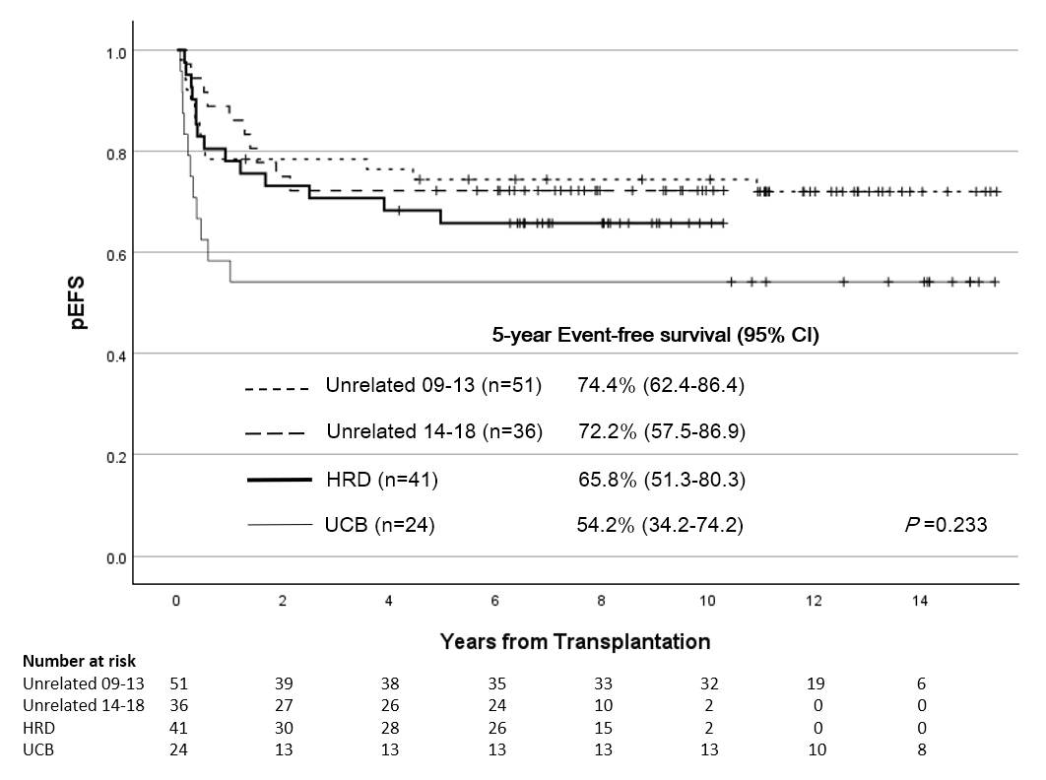

Supplemantary Figure 1B
