Supplement

|  |  |  |
| --- | --- | --- |
| C:\Users\lenovo\AppData\Local\Temp\Rar$DIa18668.5158\Sensitivity_plot (12).png  **A** | C:\Users\lenovo\AppData\Local\Temp\Rar$DIa18668.124\Sensitivity_plot (13).png  **B** | C:\Users\lenovo\AppData\Local\Temp\Rar$DIa18668.12245\Sensitivity_plot (14).png  **C** |
| C:\Users\lenovo\AppData\Local\Temp\Rar$DIa18668.26360\Sensitivity_plot (15).png  **D** | C:\Users\lenovo\AppData\Local\Temp\Rar$DIa18668.35139\Sensitivity_plot (16).png  **E** | Figure S1: Sensitivity plot of the T3801C polymorphism under different models.  A : allele contrst model, B : recessive model, C : dominant model, D : homozygous model, E : heterozygous model. |

|  |  |  |
| --- | --- | --- |
| C:\Users\lenovo\AppData\Local\Temp\Rar$DIa13680.15705\Sensitivity_plot (HTZ.png  **A** | C:\Users\lenovo\AppData\Local\Temp\Rar$DIa13680.25714\Sensitivity_plot Allele contrast.png  **B** | C:\Users\lenovo\AppData\Local\Temp\Rar$DIa13680.36050\Sensitivity_plot dominant.png  Figure S2: Sensitivity plot of the A2455G polymorphism under different models.  A : Allele contrast model, B : recessive model, C : dominant model, D : homozygous model, E : heterozygous model.  **C** |
| C:\Users\lenovo\AppData\Local\Temp\Rar$DIa13680.49227\Sensitivity_plot HMZ.png  **D** | C:\Users\lenovo\AppData\Local\Temp\Rar$DIa13680.9260\Sensitivity_plot Recessive.png  **E** |  |

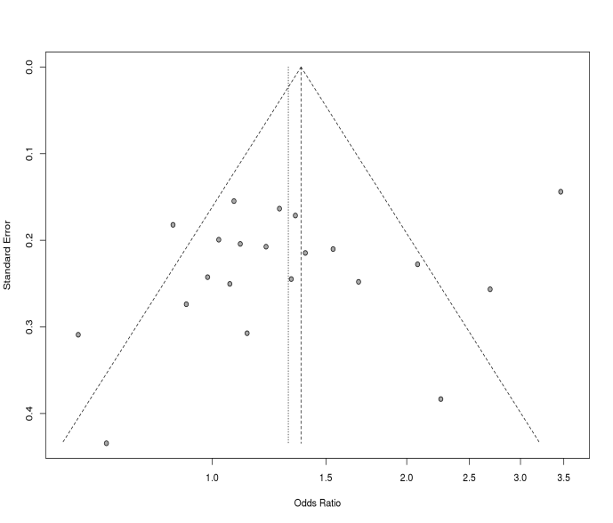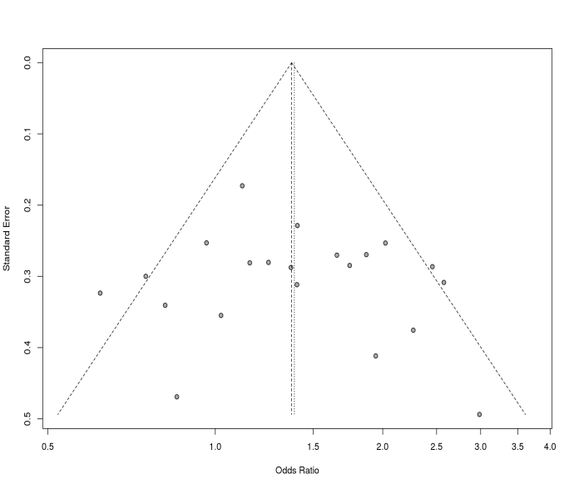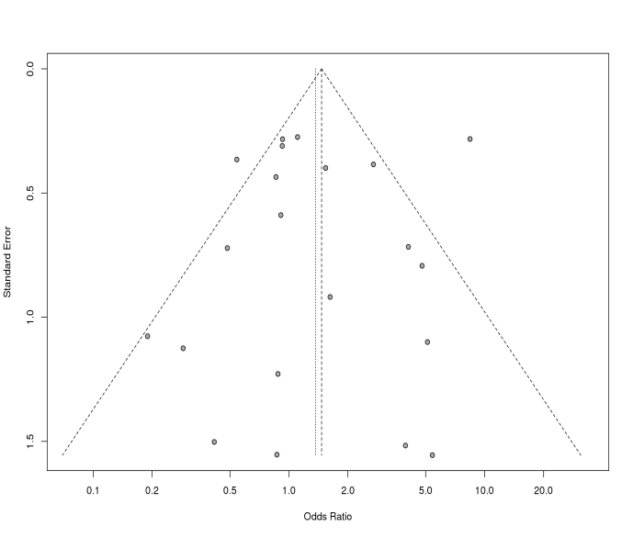

**C**

**A**

**B**

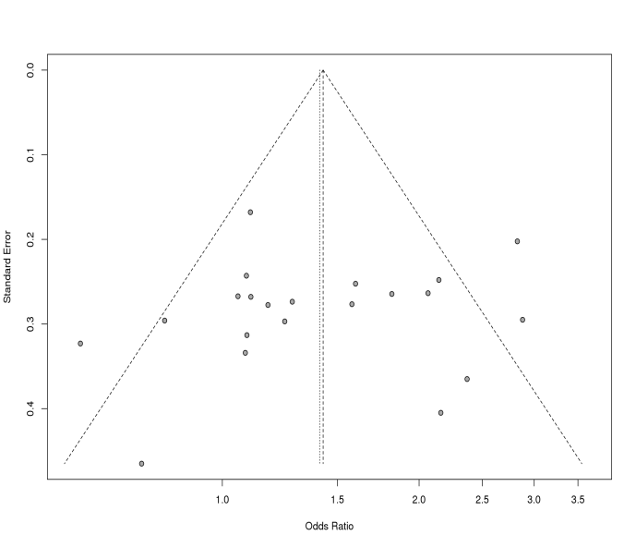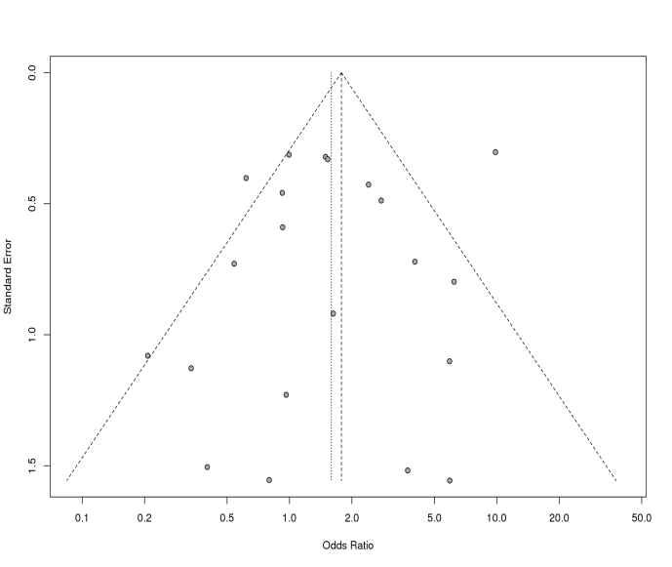

**E**

**D**

**Figure S3: Funnel plots for different models of T3801C polymorphism**

A : Allele contrast model ; B : Recessive model ; C : Dominant model ; D : Homozygous model ; E : Heterozygous model

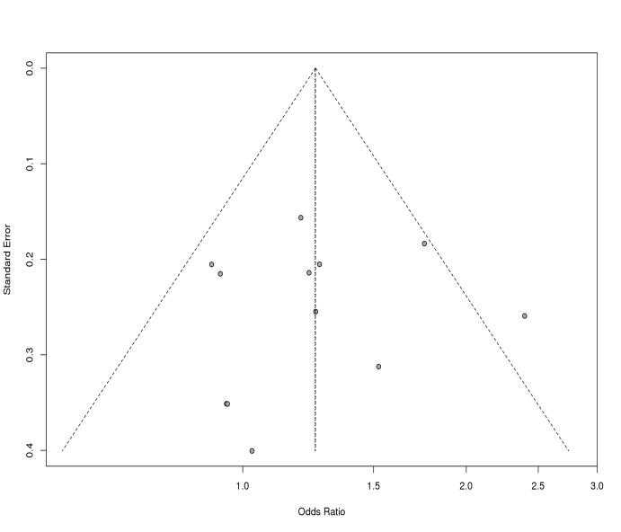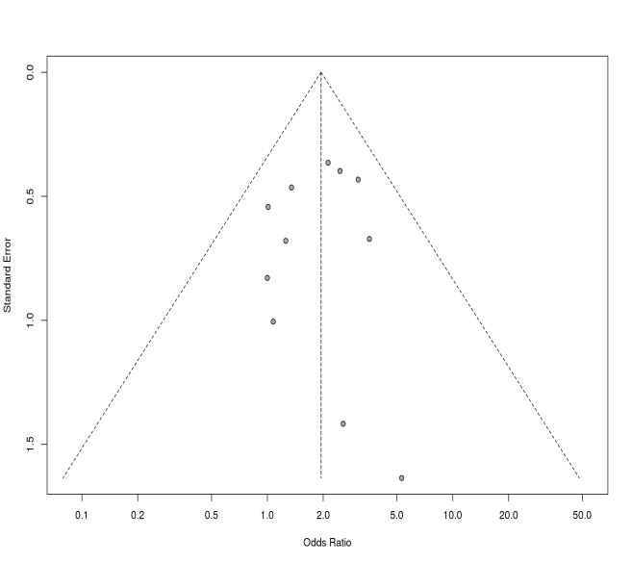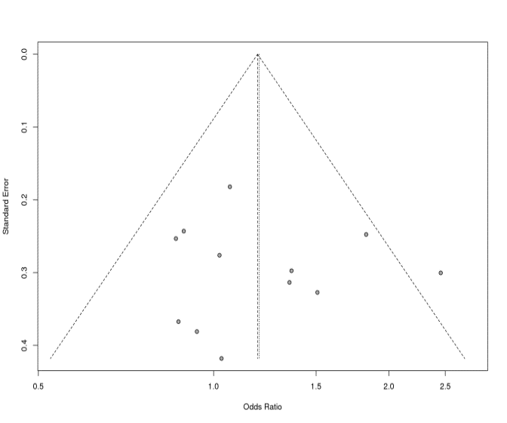

**Figure S4: Funnel plots for different models of A2455G polymorphism**

A : Allele contrast model ; B : Recessive model ; C : Dominant model ; D : Homozygous model ; E : Heterozygous model

**C**

**B**

**A**

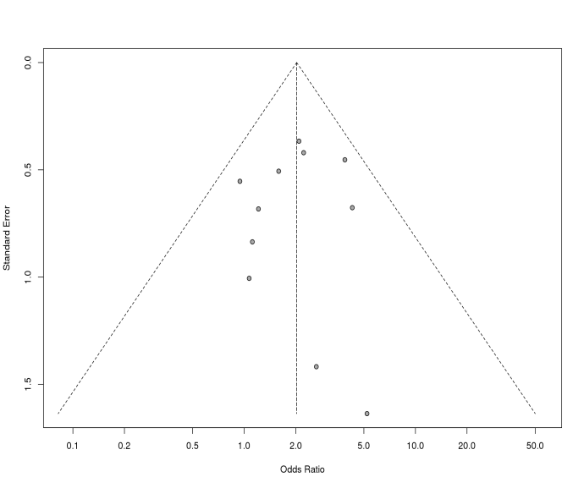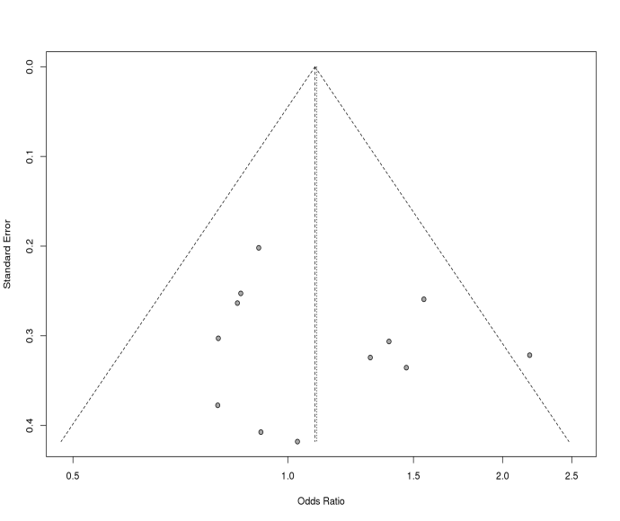

**E**

**D**