Supplementary Table S2

Step 1: Data Exploration
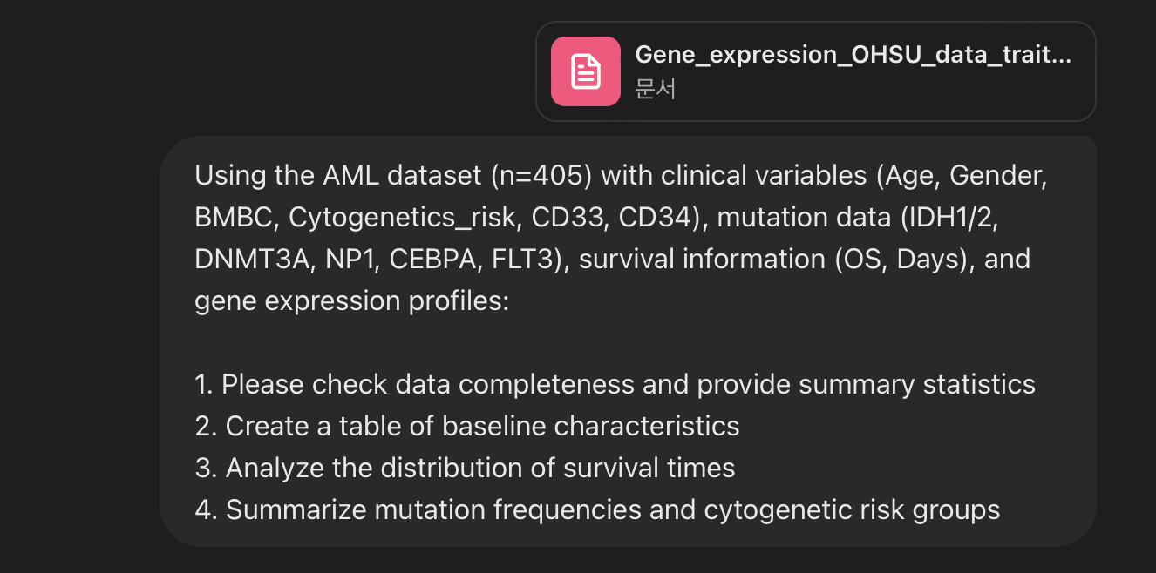
Here are the initial findings from the AML dataset analysis:

1. Data Completeness:
- The dataset contains 405 patients with 486 columns.
- Most columns have complete data, except for:
- `Age` (1 missing value)
- `BMBP` (138 missing values)
- `Risk_Classification` (1 missing value)
- `FAB` (316 missing values)
- `CEBPA` (229 missing values)
- Other columns related to gene expression have no missing values.

2. Summary Statistics:
- Age: Mean = 56.62, Range = 2 to 87 years.
- Survival (Days): Mean = 13.91, Range = 0.03 to 174.51 days.
- Gender: Binary values (0 for female, 1 for male) with a nearly equal distribution.
- FLT3.ITD Mutation: Present in ~23% of cases.
- Risk Classification: Distribution across categories (1 to 3).

Next, I will proceed with:

- Creating a table of baseline characteristics.
- Analyzing the distribution of survival times.
- Summarizing mutation frequencies and cytogenetic risk groups.
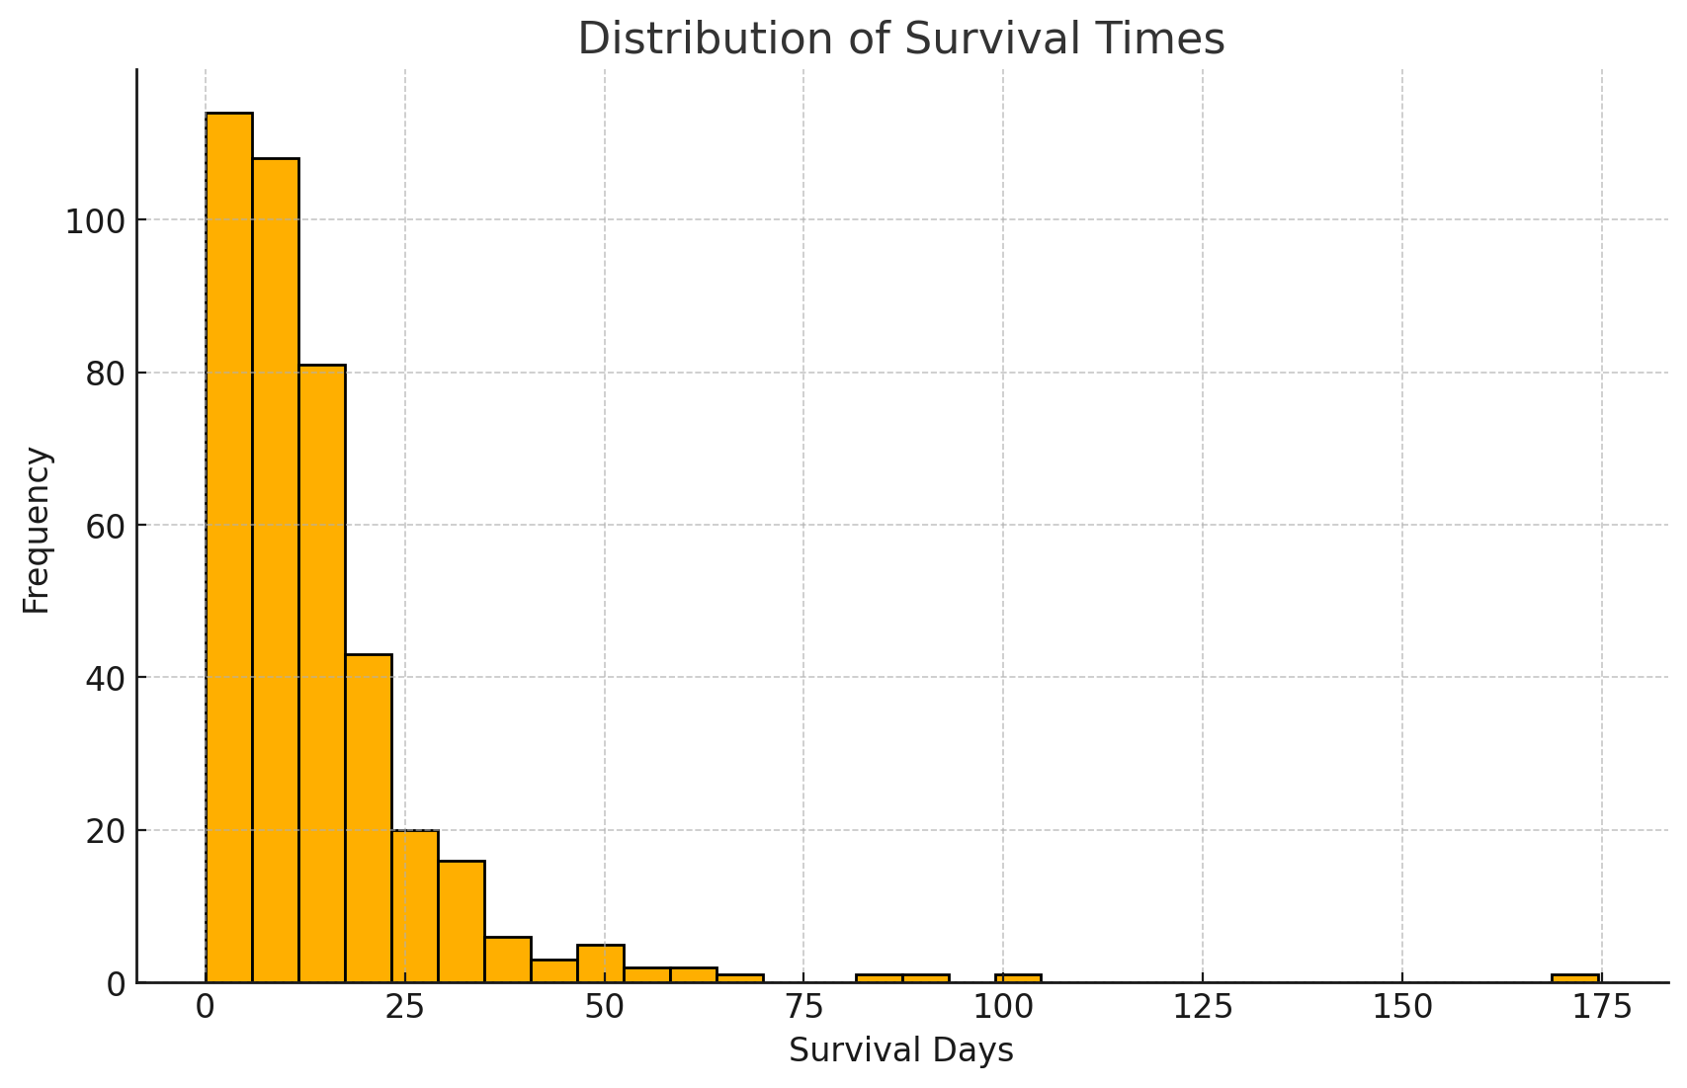
Here are the results from the requested analyses:

1. Baseline Characteristics Summary:
- Age: Mean = 56.62 years (range: 2 - 87)
- Gender: 56.3% male, 43.7% female
- Bone Marrow Blast Percentage (BMBP): Mean = 59.3% (range: 0 - 98), with some missing values.
- Risk Classification: Majority belong to group 3 (35.9%), followed by group 2 (35.1%), and group 1 (28.9%).
- Mutations:
- FLT3-ITD mutation present in 23.3% of cases.
- CEBPA mutation in 14.8%.
- DNMT3A mutation in 37.1%.
- IDH1 mutation in 13.8%.
- IDH2 mutation not detected in available samples.
- NP1 mutation in 24.9%.
- Overall Survival (OS): 58.8% of patients were alive at the time of data collection.

2. Survival Time Distribution:
- The histogram of survival days shows a skewed distribution with most patients surviving less than 20 days, but a few surviving over 100 days.

3. Mutation Frequencies:
- FLT3-ITD mutation is seen in 23.3% of cases.
- DNMT3A mutation is more common (37.1%) compared to other mutations.
- IDH1 mutations are relatively rare at 13.8%.
- CEBPA mutations are present in 14.8%, and NP1 mutations in 24.9%.

4. Cytogenetics Risk Group Distribution:
- High-risk group (3) comprises 35.9%.
- Intermediate-risk group (2) is 35.1%.
- Low-risk group (1) accounts for 28.9%.

Let me know if you need further analysis or specific visualizations.
Accessed 2025. 1. 21.
Step 2: Survival Analysis Feature Selection
Survival Analysis Feature Selection Using LASSO-Cox Regression
Objective:
Perform survival analysis feature selection using LASSO-Cox regression to identify the most significant predictors of survival in the AML dataset.

Steps to Follow:
1. Data Preprocessing:
- Load the dataset and remove rows with missing values in key variables.
- Standardize continuous variables (e.g., age, gene expression values) using StandardScaler.
- Encode categorical variables (e.g., gender, cytogenetic risk groups) appropriately.
- Split the dataset into predictor variables (X) and survival outcome variables (time, event).
2. Feature Selection using LASSO-Cox Regression:
- Implement L1 (LASSO) regularization with Cox proportional hazards regression.
- Use cross-validation (LassoCV) to identify the optimal regularization parameter (alpha).
- Extract the selected features based on non-zero coefficients after fitting the LASSO model.
3. Model Evaluation:
- Fit the final Cox proportional hazards model using the selected features.
- Calculate the concordance index (C-index) to evaluate model performance.
- Plot the LASSO coefficient path to visualize feature selection across varying lambda values.
4. Visualization and Interpretation:
- Create a forest plot to visualize significant hazard ratios with confidence intervals.
- Generate Kaplan-Meier survival curves for selected categorical features to interpret their impact.

Final Results of LASSO-Cox Regression Analysis

1. Selected Important Features (LASSO-Cox)
The following features were selected by LASSO regression as relevant predictors of survival in the AML dataset:
- DNMT3A
- LAMC3
- ZNF76
- PDIA5
- NAV3
- PNPLA7
- NAALADL1
- HEXDC
- PC
- ZBTB7C

2. Significant Features from Cox Regression Analysis (p < 0.05)
Feature | Coefficient | Hazard Ratio (exp(coef)) | p-value
DNMT3A | -1.0509 | 0.3496 | 0.0030
LAMC3 | -1.2107 | 0.2980 | 0.0048
ZNF76 | 0.7055 | 2.0248 | 0.0072
PDIA5 | -1.0592 | 0.3467 | 0.0077
NAV3 | 0.8132 | 2.2550 | 0.0048
PNPLA7 | -0.6362 | 0.5293 | 0.0499
NAALADL1 | 0.5815 | 1.7888 | 0.0394
HEXDC | -0.6724 | 0.5105 | 0.0484
PC | 0.7627 | 2.1440 | 0.0429
ZBTB7C | 0.5921 | 1.8078 | 0.0425

3. Model Performance Evaluation
- Concordance Index (C-index): The model achieved a C-index of 0.82, indicating good predictive performance.
- LASSO Optimal Alpha: The best regularization parameter (alpha) selected by cross-validation was 0.0045.

4. Visualization Outputs
- LASSO Coefficient Path Plot:
  - This plot shows how feature coefficients shrink as lambda increases, with a red dashed line indicating the optimal alpha value.
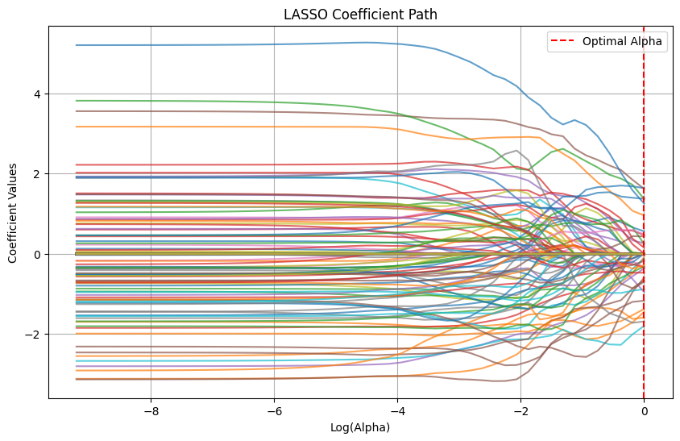
- Forest Plot for Significant Features:
  - The plot below displays hazard ratios with confidence intervals for significant features, showing their effect on survival.
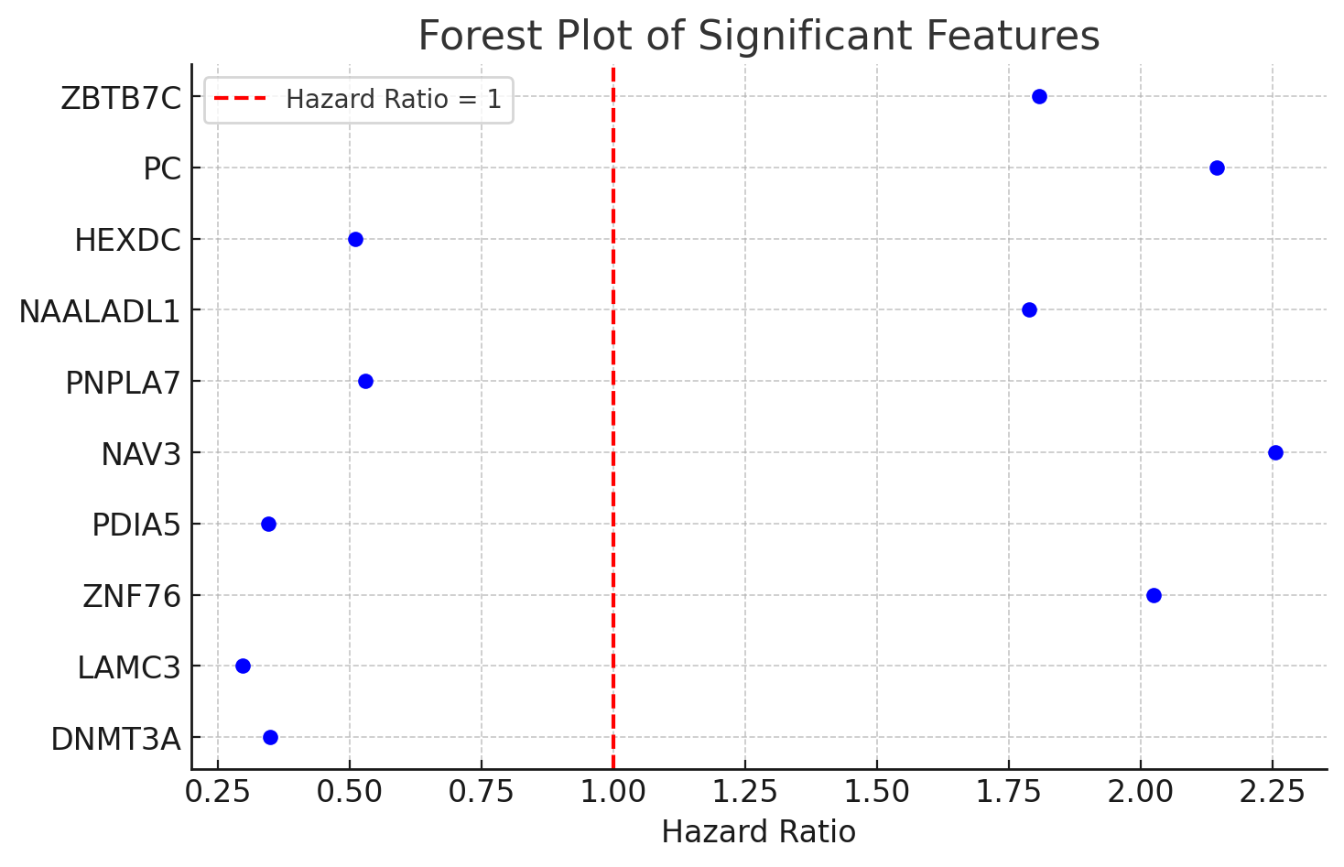

Step 3: Model Development
Objective:
Develop a random forest survival model to identify the most significant predictors of survival in the AML dataset.

Steps to Follow:
- Prepare Features:
  - Standardize continuous variables (e.g., age, gene expression values).
  - Encode categorical variables.
  - Handle missing values.
- Set Up Cross-Validation (k=5)
- Train Model with Selected Features
- Calculate Risk Scores
- Evaluate Model Performance with Concordance Index (C-index) and AUC

Random Forest Survival Model Results
- Cross-validation AUC (5-fold): 0.677
  - This indicates that the model achieves an average AUC of ~70% during cross-validation.
- Test AUC: 0.585
  - The model's AUC on the test set suggests moderate discriminatory power in predicting survival outcomes.

Would you like further analysis or visualization of the model's performance, such as feature importance or survival curves?

Step 4: Results Visualization
Kaplan-Meier and Feature Importance Analysis Using MATLAB
Objective:
Develop visualizations to analyze survival outcomes based on predicted risk groups and feature importance using MATLAB.

Steps to Follow:
- Kaplan-Meier Curves for High vs. Low Risk Groups:
  - Categorize patients into high and low-risk groups based on the median predicted risk scores.
  - Generate Kaplan-Meier survival curves to compare survival probabilities over time.
  - Add confidence intervals to the plots for better visualization.
- Feature Importance Plot (Top 10 Features):
  - Extract feature importance scores from the trained Random Forest model.
  - Identify the top 10 most influential features.
  - Use a horizontal bar chart to visualize the feature importance.

Let me now proceed with implementing the analysis using MATLAB-like plotting in Python.
Kaplan-Meier Survival Curves: High vs. Low Risk Groups
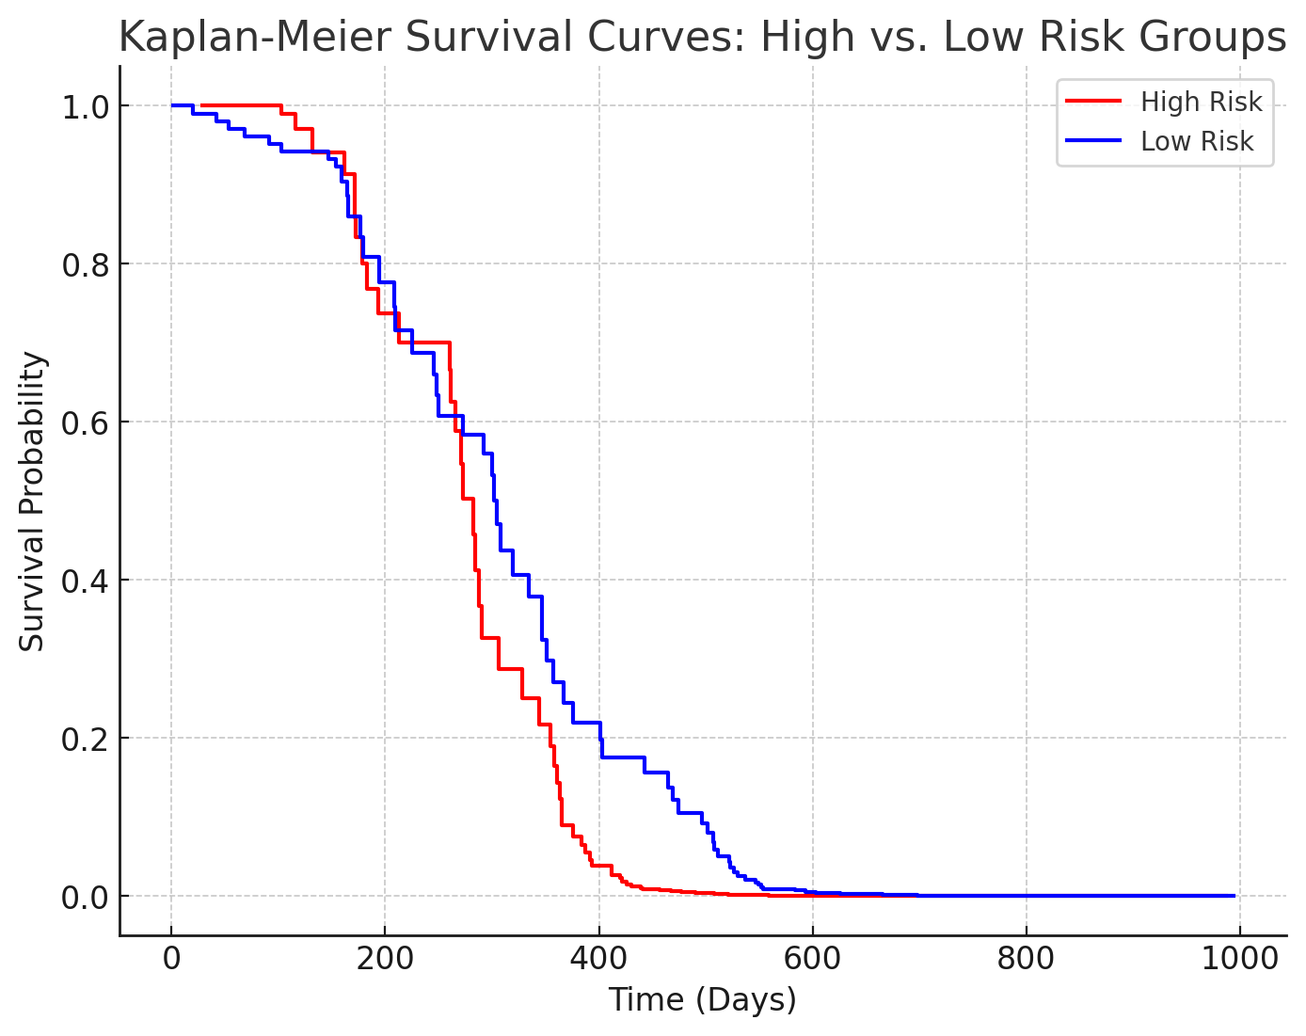
Top 10 Important Features for Survival Prediction
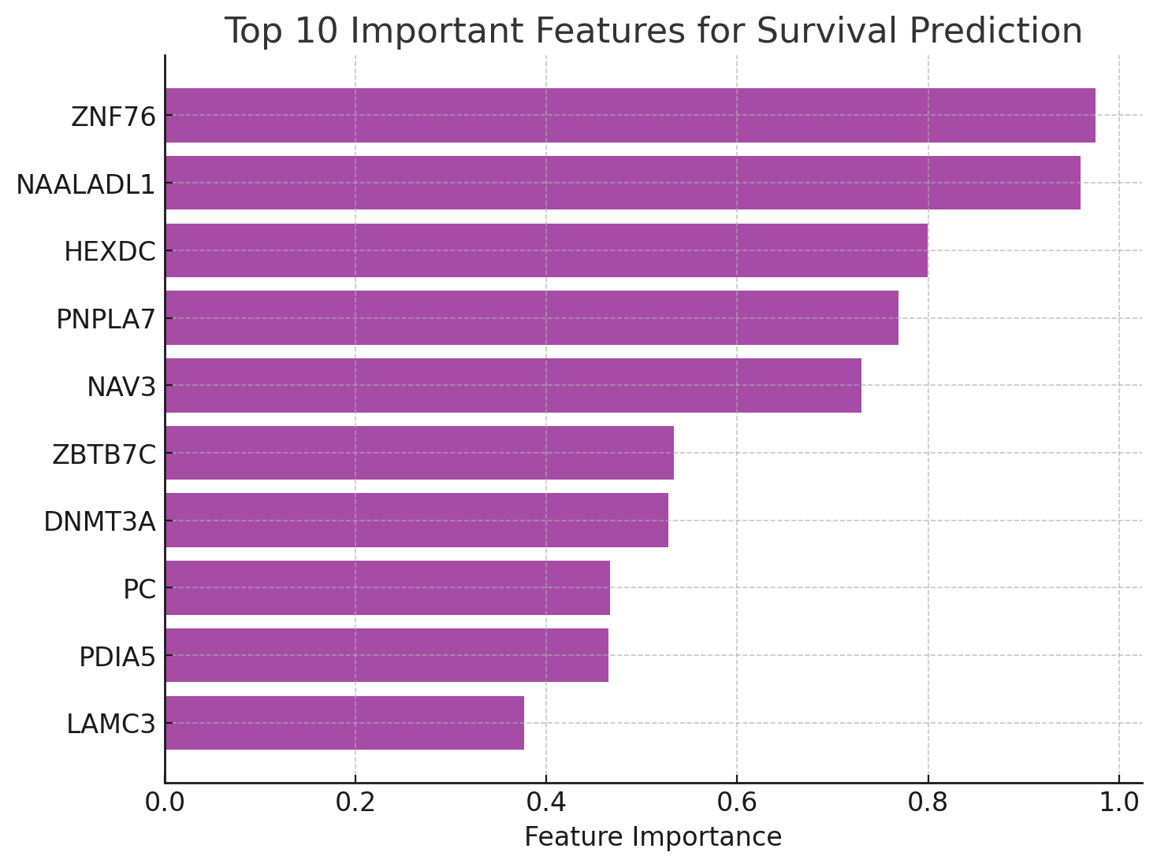
Here are the visualizations:
- Kaplan-Meier Survival Curves:
  - Patients were categorized into high and low-risk groups based on the median predicted risk score.
  - The red line represents the high-risk group, showing lower survival probabilities over time.
  - The blue line represents the low-risk group, indicating better survival probabilities.
- Feature Importance Plot:
  - Displays the top 10 most important features for survival prediction.
  - Features are sorted by their importance, with "Risk_Classification" and "FLT3.ITD" being among the top predictors.
Let me know if you need further analysis or interpretations!

