Supplemental Data Table S1. Positive rates of T-cell response assays and S antibody assays according to subgroups
Assay |  | ChAdOx1/BNT162b2 group (N = 29) | BNT162b2 group (N = 27) | BI group*  (N = 33) | Total  (N = 89) | P†
In-house ELISPOT | SW | 48.0% | 80.8% | 93.8% | 75.9% | 0.014
 | SO | 84.0% | 84.6% | 100% | 90.4% | NS
 | NW | 0.0% | 7.7% | 75.0% | 29.9% | NS
 | NO | 0.0% | 7.7% | 62.5% | 25.3% | NS
T-SPOT.COVID | Panel A | 62.1% | 59.3% | 87.9% | 70.8% | NS
 | Panel B | 0.0% | 0.0% | 51.5% | 19.1% | NS
QuantiFERON IGRA | Ag1 | 64.3% | 42.3% | 84.8% | 65.5% | NS
 | Ag2 | 71.4% | 65.4% | 97.0% | 79.3% | NS
 | Total (Ag1 and Ag2) | 71.4% | 65.4% | 97.0% | 79.3% | NS
Euroimmun IGRA |  | 96.3% | 96.2% | 100% | 97.7% | NS
Abbott IgG II Quant |  | 100% | 100% | 100% | 100% | NA
Elecsys Anti-S |  | 100% | 100% | 100% | 100% | NA
*Significantly higher positive rates in the BI group than in the noninfected group except for Euroimmun IGRA (P value not shown).
†Chi-square or Fisher’s exact test (ChAdOx1/BNT162b2 group vs. BNT162b2 group).
Abbreviations: S, spike; BI, breakthrough infection; NS, not significant; NA, not applicable; SW, S protein of wild-type virus; SO, S protein of the Omicron variant; NW, nucleocapsid protein of wild-type virus; NO, nucleocapsid protein of the Omicron variant; IGRA, interferon-gamma release assay.
Supplemental Data Table S2. Correlations among T-cell response assays and S antibody assays in the BI and noninfected groups
Assay |  | In-house ELISPOT |  |  |  |  | T-SPOT.COVID |  |  | QuantiFERON IGRA |  | Euroimmun IGRA | Abbott IgG II Quant
 |  | SW | SO | NW | NO |  | A | B |  | Ag1 | Ag2
In-house ELISPOT | SO | 0.46**
 |  | 0.51***
 | NW | 0.52** | 0.54**
 |  | –0.09 | 0.07
 | NO | 0.45** | 0.50** | 0.84***
 |  | –0.05 | 0.11 | 0.53***
T-SPOT.COVID | A | 0.52** | 0.76*** | 0.61*** | 0.50**
 |  | 0.34* | 0.46** | –0.16 | 0.02
 | B | 0.49** | 0.34 | 0.78*** | 0.69*** |  | 0.45**
 |  | 0.02 | –0.02 | –0.04 | 0.18 |  | 0.06
QuantiFERON IGRA | Ag1 | 0.06 | 0.28 | 0.06 | 0.07 |  | 0.27 | –0.06
 |  | 0.32* | 0.31* | 0.09 | 0.16 |  | 0.46*** | –0.09
 | Ag2 | 0.08 | 0.20 | –0.07 | –0.08 |  | 0.24 | –0.12 |  | 0.91***
 |  | 0.24 | 0.23 | 0.06 | 0.05 |  | 0.34* | –0.16 |  | 0.85***
Euroimmun IGRA | S1 | 0.28 | 0.32 | 0.36* | 0.27 |  | 0.45** | 0.16 |  | 0.72** | 0.62***
 |  | 0.27 | 0.23 | 0.01 | 0.14 |  | 0.47*** | -0.16 |  | 0.75*** | 0.60***
Abbott IgG II Quant |  | 0.16 | 0.15 | 0.34 | 0.20 |  | 0.32 | 0.47** |  | 0.04 | 0.02 | 0.17
 |  | 0.36** | 0.08 | –0.07 | –0.02 |  | 0.12 | –0.12 |  | 0.13 | 0.17 | 0.18
Elecsys Anti-S |  | 0.23 | 0.08 | 0.17 | 0.25 |  | 0.15 | 0.33 |  | –0.03 | –0.03 | 0.14 | 0.73***
 |  | 0.38** | 0.12 | –0.09 | 0.04 |  | 0.34* | –0.07 |  | 0.31* | 0.18 | 0.30* | 0.79***
Each cell presents the correlation coefficient (ρ) and associated P value obtained using Spearman’s correlation test. *P < 0.05; **P < 0.01; ***P < 0.001. 1st line: BI group (N = 33), 2nd line: noninfected group (N = 56). Significantly strong correlation (ρ ≥ 0.6) is shown in bold.
Abbreviations: S, spike; NS, not significant; NA, not applicable; SW, S protein of wild-type virus; SO, S protein of the Omicron variant; NW, nucleocapsid protein of wild-type virus; NO, nucleocapsid protein of the Omicron variant; IGRA, interferon-gamma release assay.
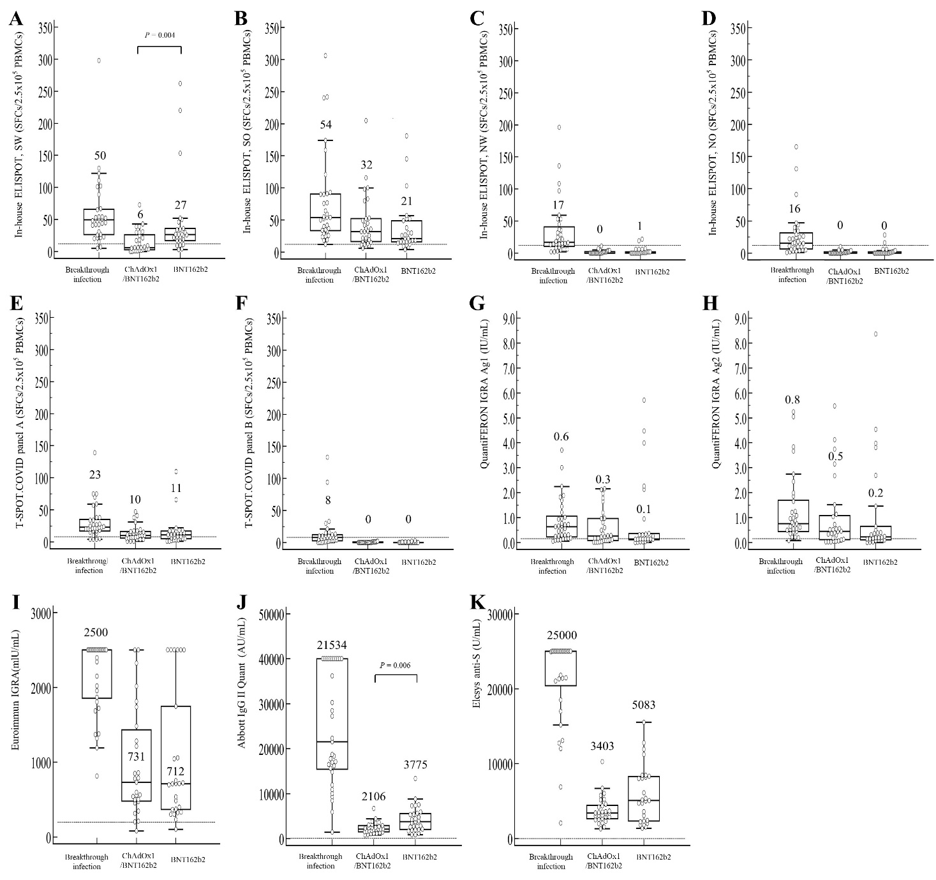
Supplemental Data Figure S1. Differences in T-cell responses and S antibody titers between the BI and noninfected groups (A) In-house ELISPOT, SW, (B) SO, (C) NW, (D) NO, (E) T-SPOT.COVID panel A, (F) T-SPOT.COVID panel B, (G) QuantiFERON IGRA Ag1, (H) QuantiFERON IGRA Ag2, (I) Euroimmun IGRA, (J) Abbott IgG II Quant, and (K) Elecsys Anti-S. The median value is shown above each box-and-whisker plot. For differences between the ChAdOx1/BNT162b2 and BNT162b2 groups, P-values obtained using the Mann–Whitney U test below 0.05 are presented. The T-cell responses obtained using in-house ELISPOT targeting SW and the antibody titers obtained using Abbott IgG II Quant were significantly higher in the BNT162b2 group than in the ChAdOx1/BNT162b2 group (P = 0.004 and 0.006, respectively), and the T-cell responses or the antibody titers obtained using the other assays did not significantly differ between the two groups.
Abbreviations: S, spike; SFCs, spot-forming cells; PBMCs, peripheral blood mononuclear cells; SW, S protein of wild-type virus; SO, S protein of the Omicron variant; NW, nucleocapsid protein of wild-type virus; NO, nucleocapsid protein of the Omicron variant.

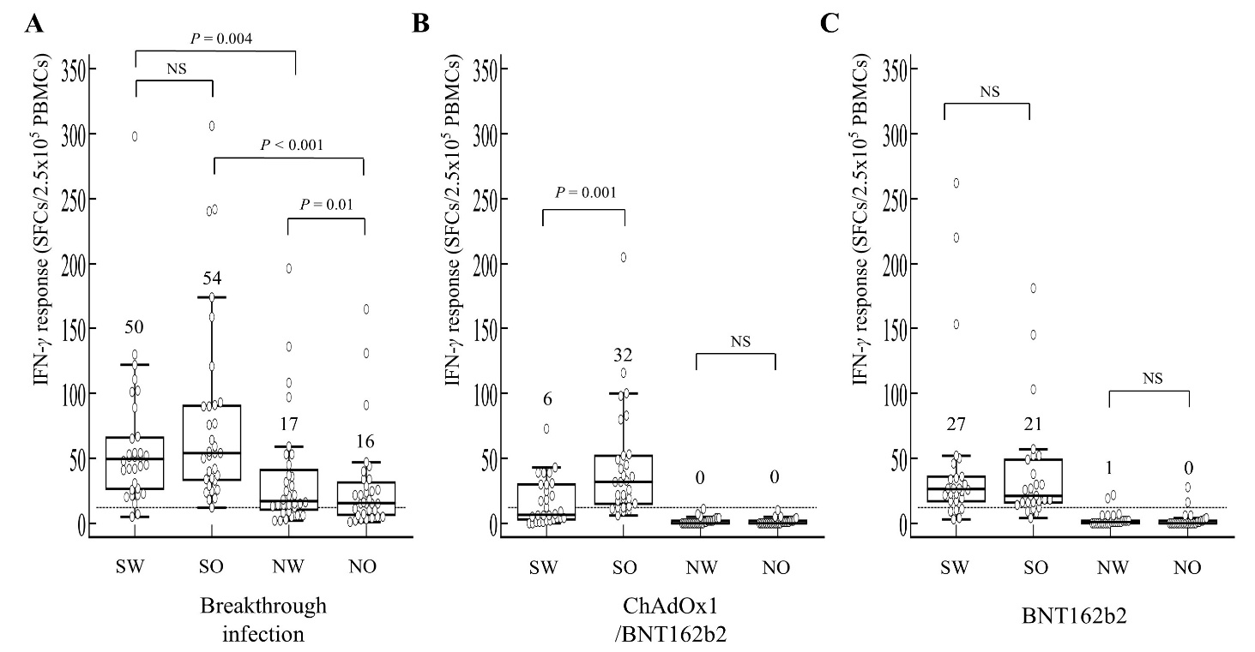
Supplemental Data Figure S2. Comparison of T-cell responses to each stimulating peptide pool (SW; SO; NW; NO) of the in-house ELISPOT assay. (A) BI group (N = 33), (B) ChAdOx1/BNT162b2 group (N = 29), (C) and BNT162b2 group (N = 27). The median value is shown above each box-and-whisker plot. P-values obtained using the Wilcoxon signed-rank test below 0.05 are presented. The IFN-γ ELISPOT response to SW was lower than that to SO (P = 0.001) in the ChAdOx1/BNT162b2 group, but this difference was not observed in the BI or BNT162b2 groups.
Abbreviations: SFCs, spot-forming cells; PBMCs, peripheral blood mononuclear cells; SW, spike protein of wild-type virus; SO, spike protein of the Omicron variant; NW, nucleocapsid protein of wild-type virus; NO, nucleocapsid protein of the Omicron variant; NS, not significant.

