Supple 5. Photographic documentation of extravasation case
Extravasation
Reporter : ________________
- Date of Request: ______________________ Department: ___________ Physician: ___________
- IV device-related information
    - IV device insertion date/time: ____/____/____ _ _ _: _ _ _
    - IV device inserted by: ____________
    - IV device type
Peripheral intravenous catheter ( G) Non-tunnel ( ) Tunnel ( ) Implanted port PICC
- Extravasation drug-related information
    - Drug names/dosage: ___________/________
    - Vesicant drug: Yes No
    - Drug administered on: ____/___/____ (administered by:_______________)
    - Chemo_regimen: ___________________
    - Administration path: IV push Piggyback IM Flush only other_____________
    - Blood backflow confirmed during administration: Yes No
    - Patient’s symptoms and expression during administration: ________________________________
- Extravasation site assessment
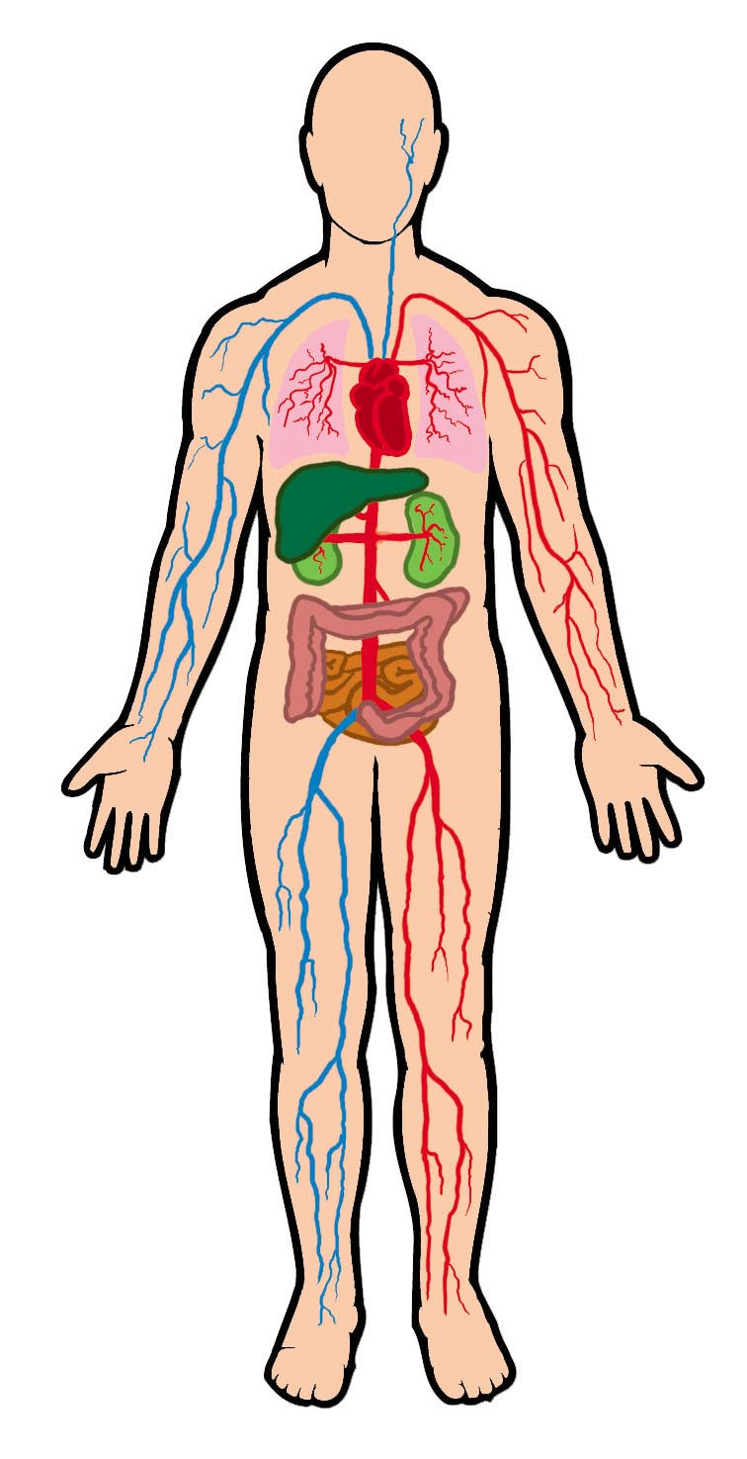
    - Assessed on: _________(year) _____(month) ______(day) (D_____)
    - Extravasation site
Rt Lt
Upper extremity Lower extremity
Internal External
Details: _______________________
    - Description of extravasation site’s condition (skin condition, size, etc.)

< Details >
_____________________________________________
- Therapeutic interventions
  - Administration of antidote: Yes _____________ No
  - Intervention contents: _____________________________________________________________
  - Medical photography: Yes No
  - Results: Resolved after emergency treatment Resolved after single medication Skin graft required F/U Loss
- Follow-up
Date | / / | / / | / / | / / | / / | / / | / /
Extravasation occurred on | D( ) | D( ) | D( ) | D( ) | D( ) | D( ) | D( )
Color
Integrity
Skin temp.
Edema
Mobility
Pain
Fever
Comment

Date | / / | / / | / / | / / | / / | / / | / /
Extravasation occurred on | D( ) | D( ) | D( ) | D( ) | D( ) | D( ) | D( )
Color
Integrity
Skin temp.
Edema
Mobility
Pain
Fever
Comment
<Extravasation Assessment Tool>
Score  Evaluation items | 0 |  | 1 | 2 | 3 | 4
Color | Normal |  | Pink | Red | Blanched | Blackened
Integrity | Unbroken |  | Blistered | Superficial skin loss | Tissue loss, exposing subcutaneous tissue | Tissue loss, exposing muscle, /bone with a deep crater or necrosis
Skin temp. | Normal |  | Warm | Hot
Edema | Absent |  | Non-pitting | Pitting
Mobility | Full |  | Slightly limited | Very limited | Immobile
Pain | Rate on 0-10 scale
Fever | Normal | Elevated (highest value during 24 hours)

