Supplementary Fig. 1. Flow diagram of Preferred Reporting Items for Systematic Reviews and Meta-Analyses (PRISMA)

A. Preoperative workup

A1. Which test is helpful to evaluate the extent of the primary tumor in patients with locally invasive DTC for surgery?

A2. What is the role of preoperative workup in patients with thyroid cancer with neck metastasis?

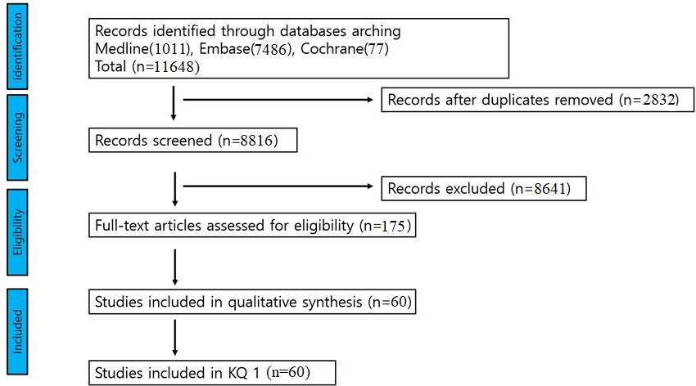

B. Surgical extent of thyroidectomy

B1. What is the appropriate surgical extent of thyroidectomy in T3/T4 thyroid cancer?

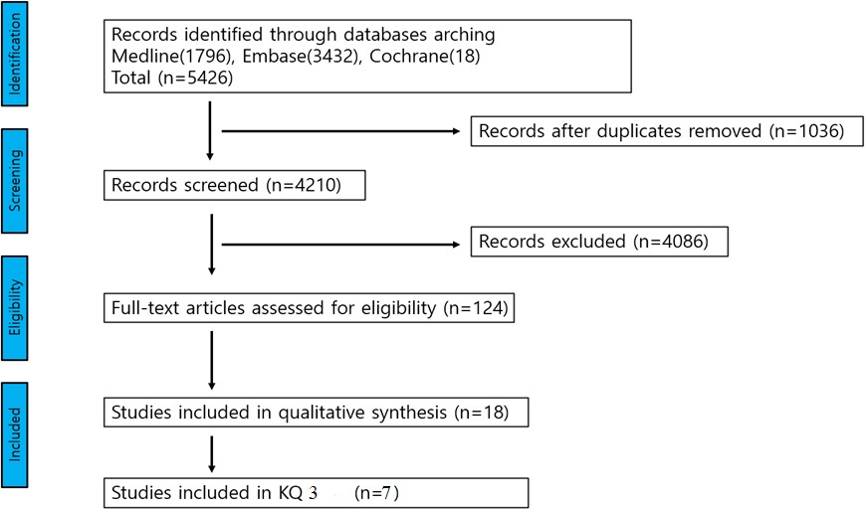

C. Surgery for invasion into the strap muscles, RLN, laryngeal framework and esophagus

C1. What is the appropriate surgical margin for thyroid cancer with invasion into the strap muscles or soft tissue?

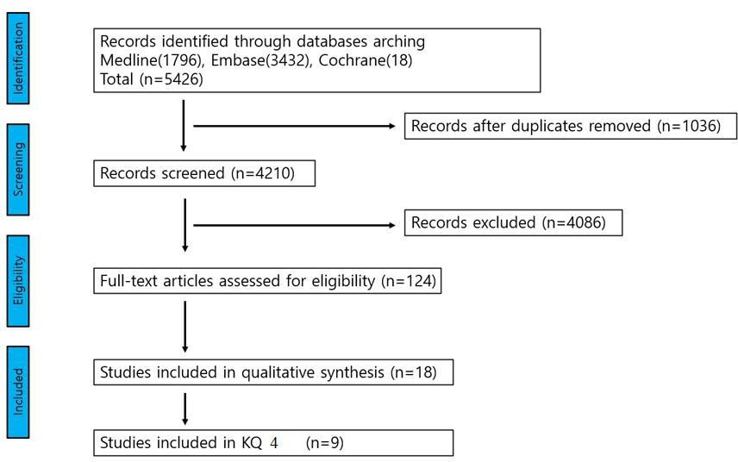

C2. What is the appropriate surgical procedure for DTC with recurrent laryngeal nerve invasion?

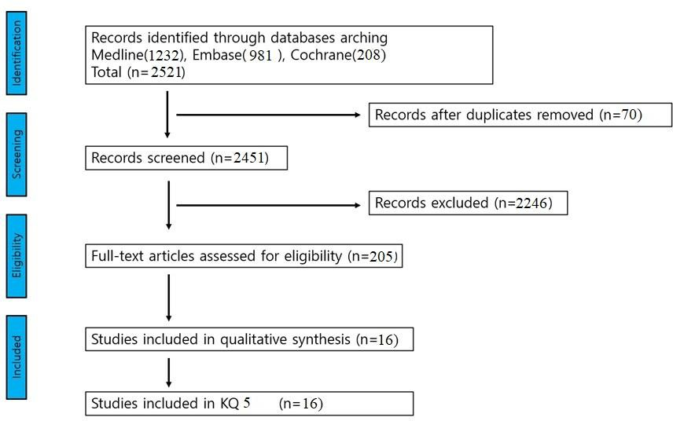

C3. What is the appropriate surgical procedure for DTC with laryngeal invasion?

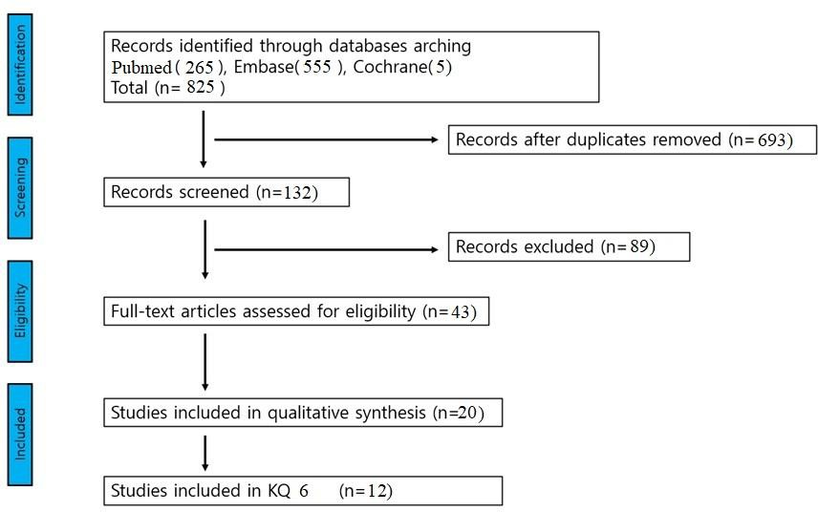

D. Surgery for invasion of the trachea

D1. What is the appropriate surgical procedure for DTC with tracheal invasion?

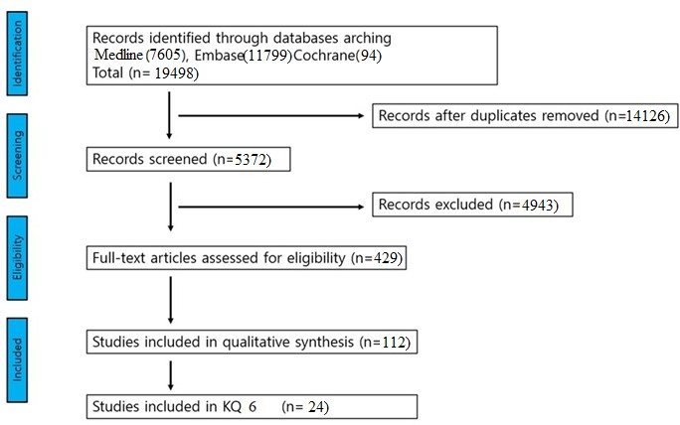

E. Surgery for esophageal invasion

E1. What is the appropriate surgical procedure for DTC with esophageal invasion?

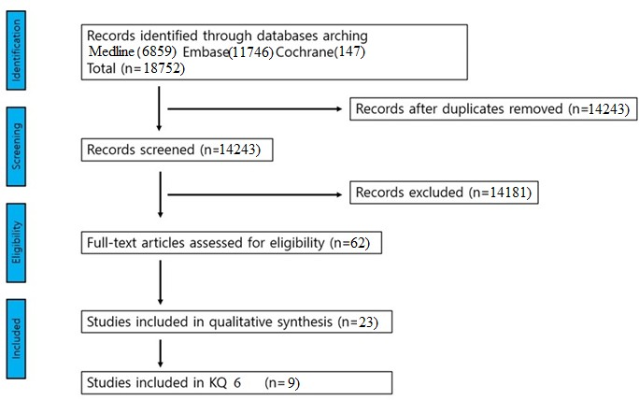

F. Surgery for central and lateral cervical lymph node involvement

F1. Is prophylactic neck dissection necessary for clinically N0 locally invasive DTC?

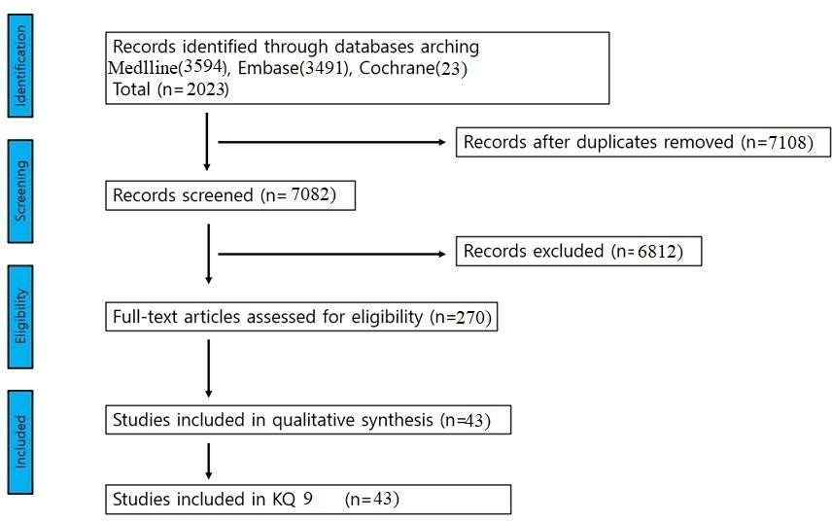

F2. What extent of neck dissection is appropriate for DTC patients with clinically positive neck nodes?

F3. What is the appropriate extent of neck dissection for DTC patients with recurrent/ persistent neck node involvement?

