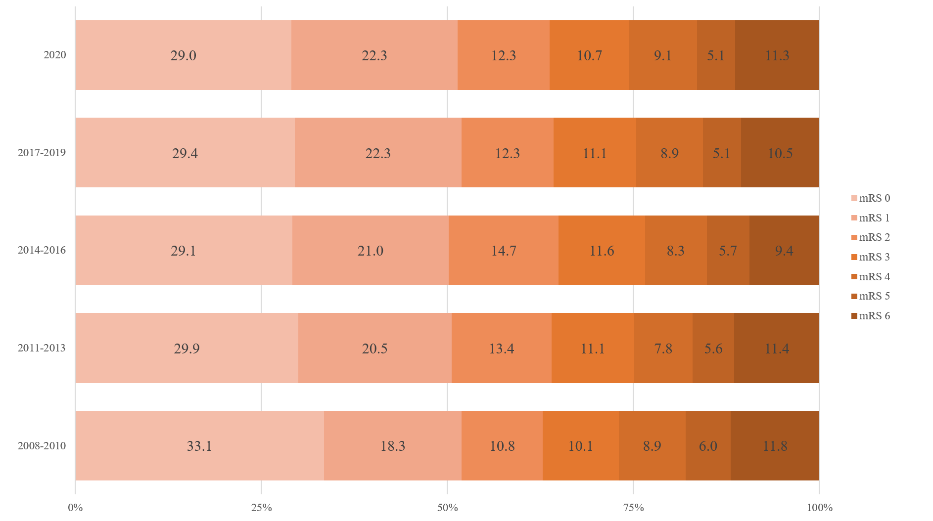
Supplementary Fig. 8. Proportions of mRS score at 1 year after stroke.
mRS = modified Rankin Scale.

