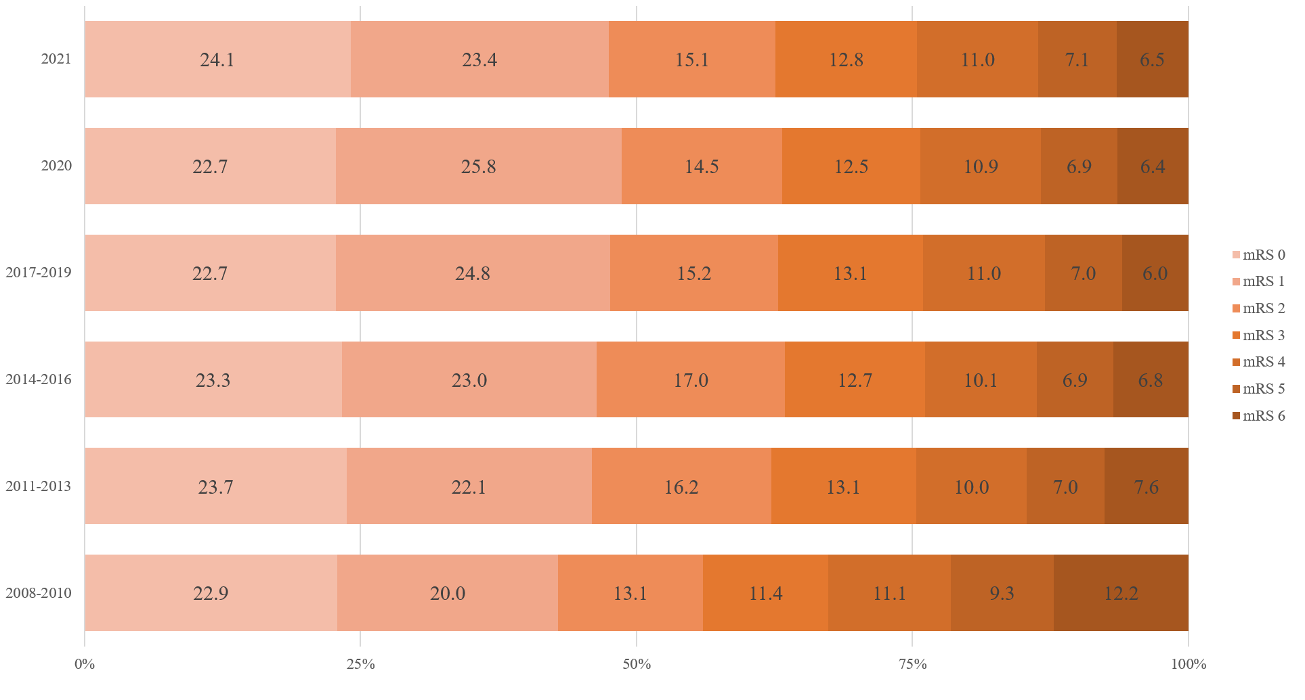
Supplementary Fig. 7. Proportions of mRS score at 3 months after stroke.
mRS = modified Rankin Scale.

