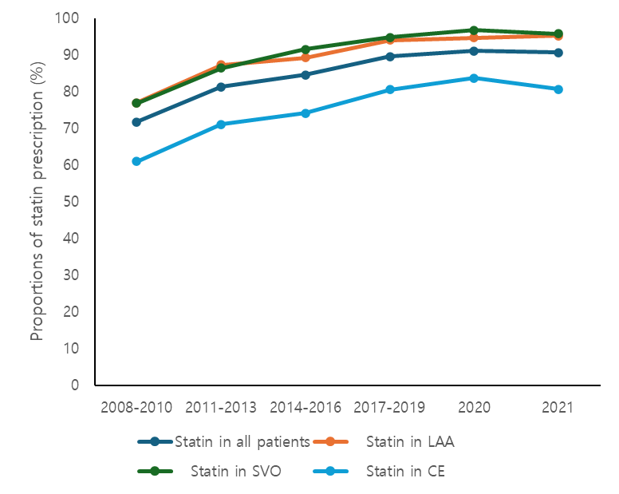
Supplementary Fig. 6. The prescription of statin at discharge among LAA, SVO, CE subtypes and all patients.
LAA = large artery atherosclerosis, SVO = small vessel occlusion, CE = cardioembolism.

