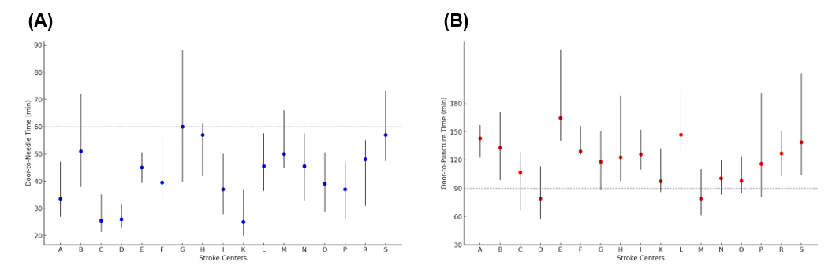
Supplementary Fig. 5. Center disparities in door-to-needle time (A), and door-to-puncture time (B) in 2021.

