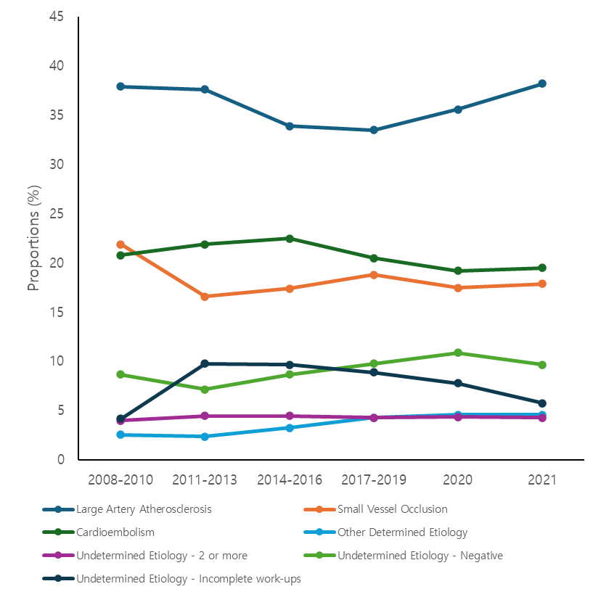
Supplementary Fig. 4. Proportion of TOAST classification between 2008 and 2021.
TOAST = Trial of ORG 10172 in Acute Stroke Treatment.

