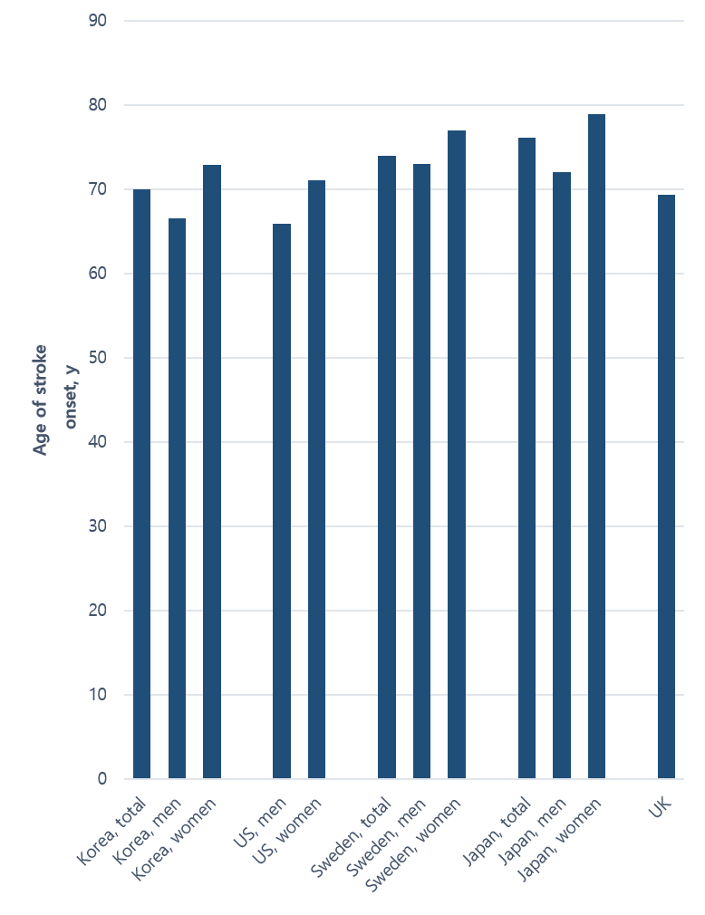
Supplementary Fig. 3. The average age of stroke onset among countries.

