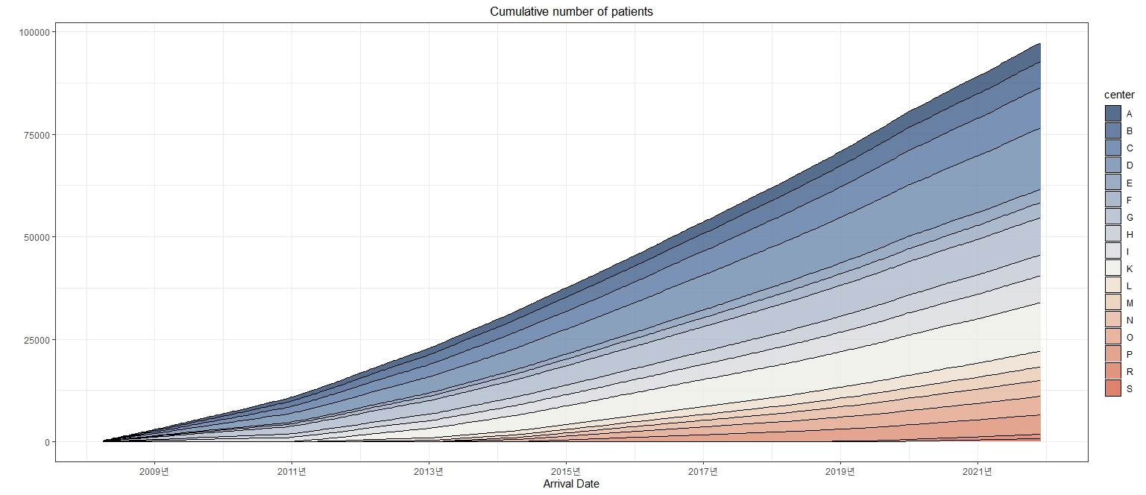
Supplementary Fig. 2. Cumulative number of acute stroke patients since April 2008.

