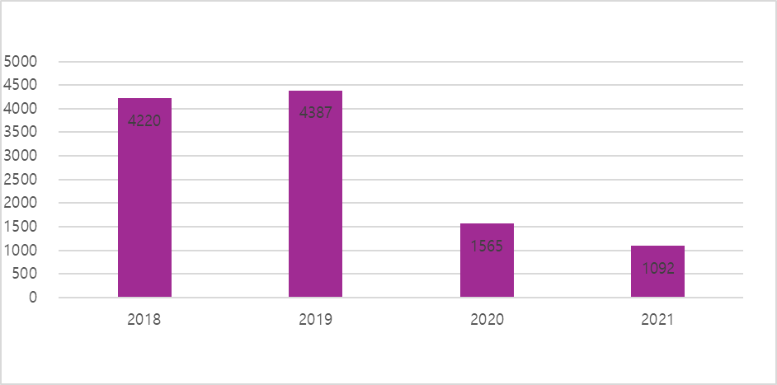
Supplementary Fig. 1. Monthly query volumes of the CRCS-K registry from 2018 to 2021.
CRCS-K = Clinical Research Collaboration for Stroke in Korea.

