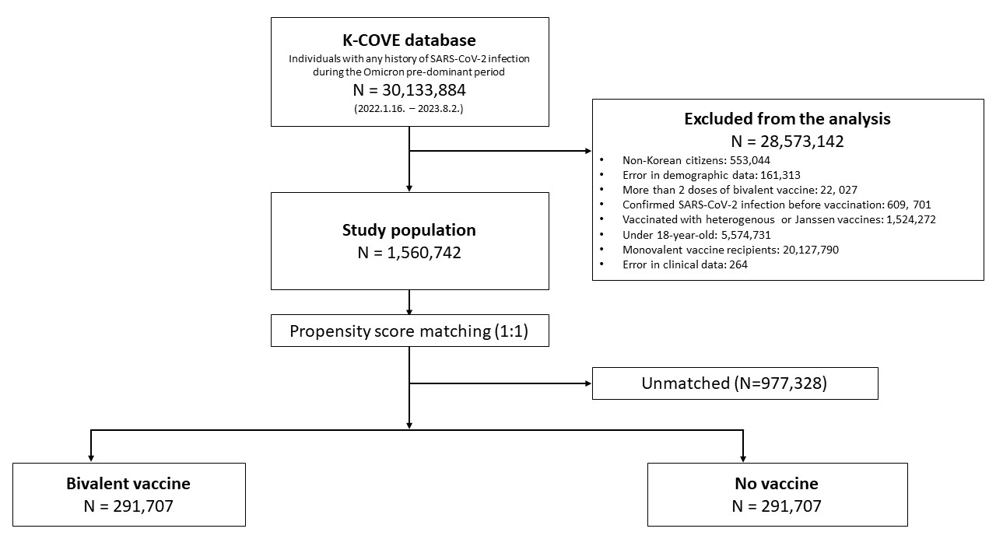
Supplementary Fig. 1. Participant selection process.
K-COVE = Korean COVID-19 Vaccine Effectiveness, SARS-CoV-2 = severe acute respiratory syndrome coronavirus 2.

