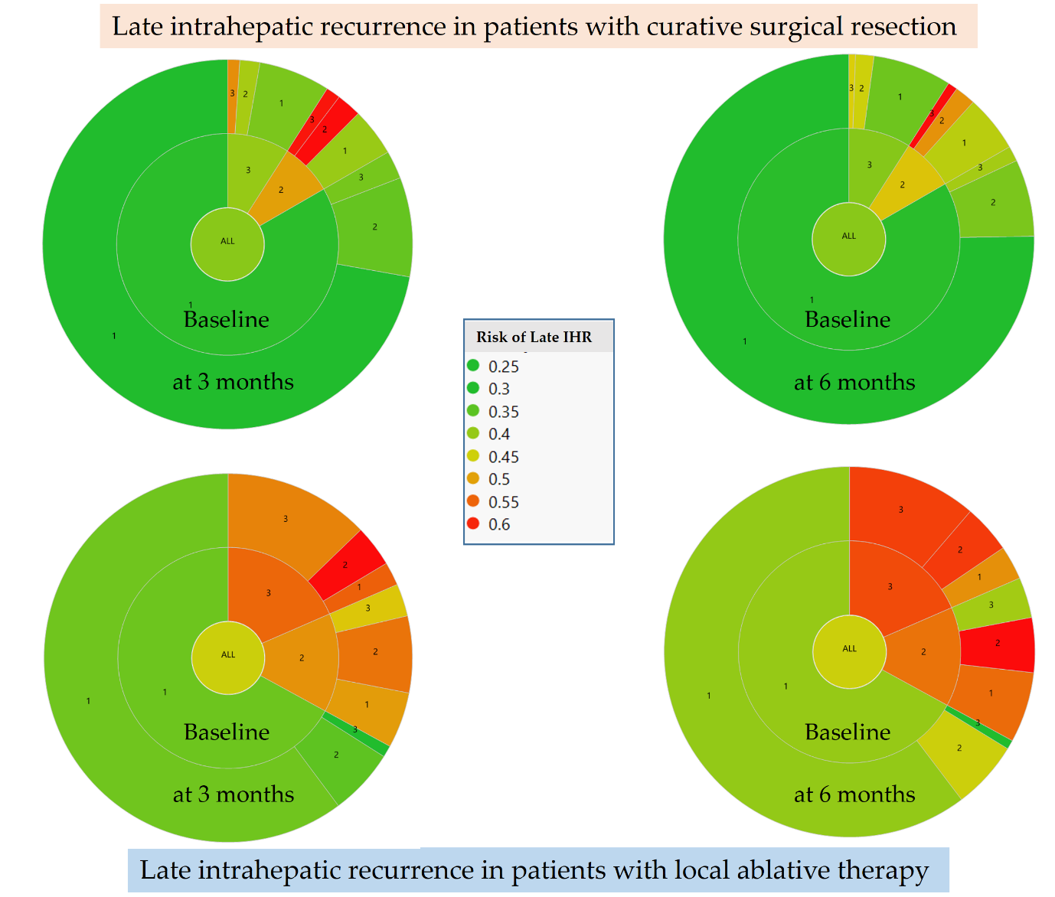
Supplementary Fig. 3. Nested pie plots of late IHR risk according to mALBI grade at baseline, thee months and six months after initial curative surgical resection or local ablative therapy.
IHR = intrahepatic recurrence, mALBI = modified albumin-bilirubin.

