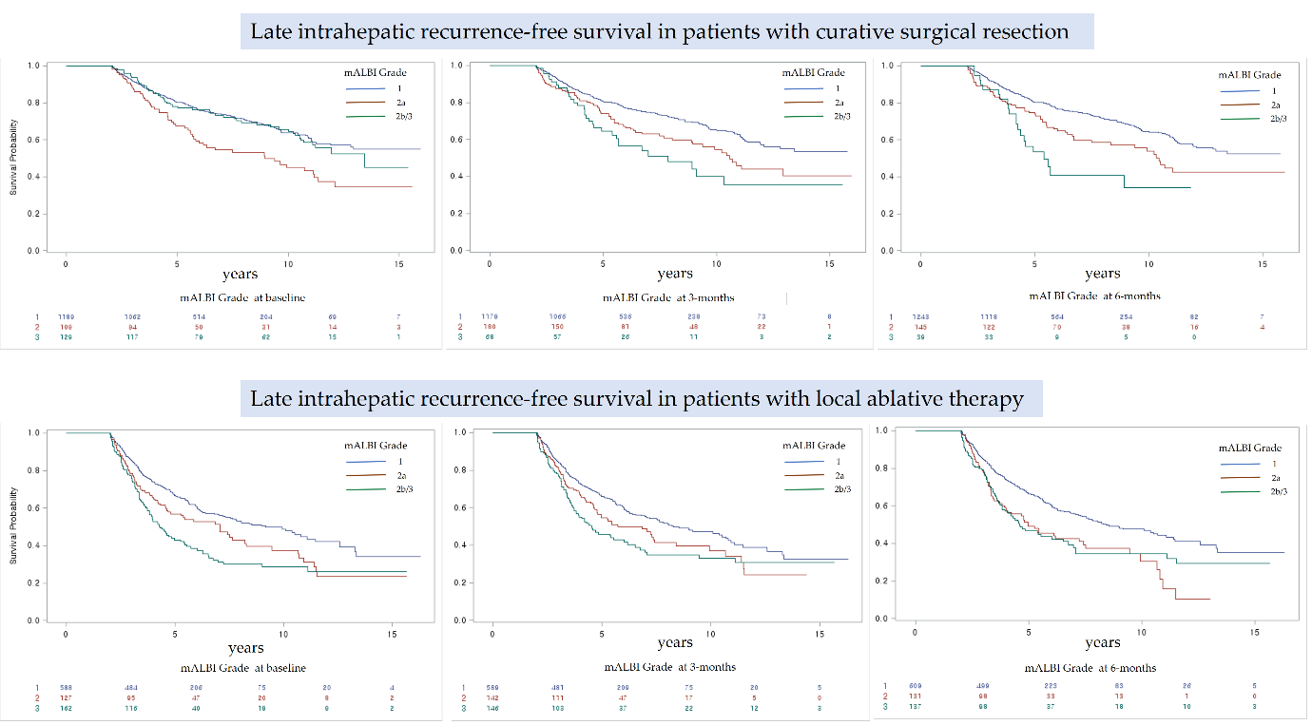
Supplementary Fig. 2. Late IHRFS according to mALBI grade at baseline, thee months and six months after initial curative surgical resection or local ablative therapy.
IHRFS = intrahepatic recurrence-free survival, mALBI = modified albumin-bilirubin.

