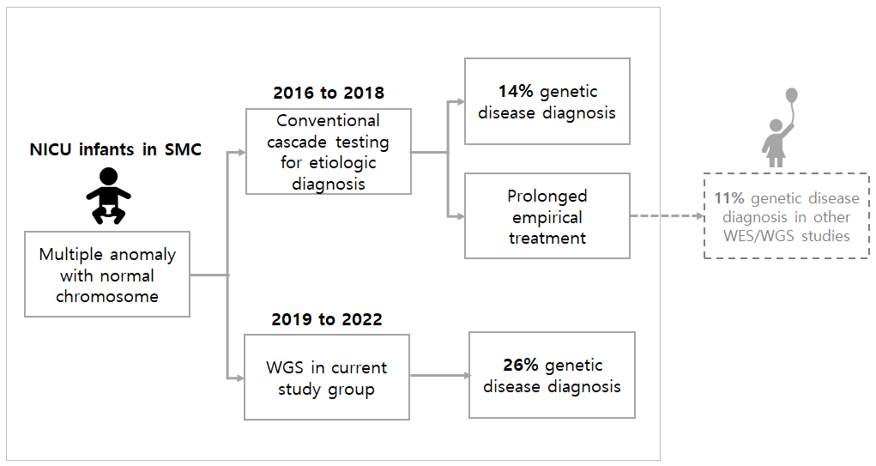
Supplementary Fig. 3. Comparison of the traditional approach to diagnosis of genetic diseases in NICU infants with this study group.
NICU = neonatal intensive care unit, WGS = whole genome sequencing, WES = whole exome sequencing.

