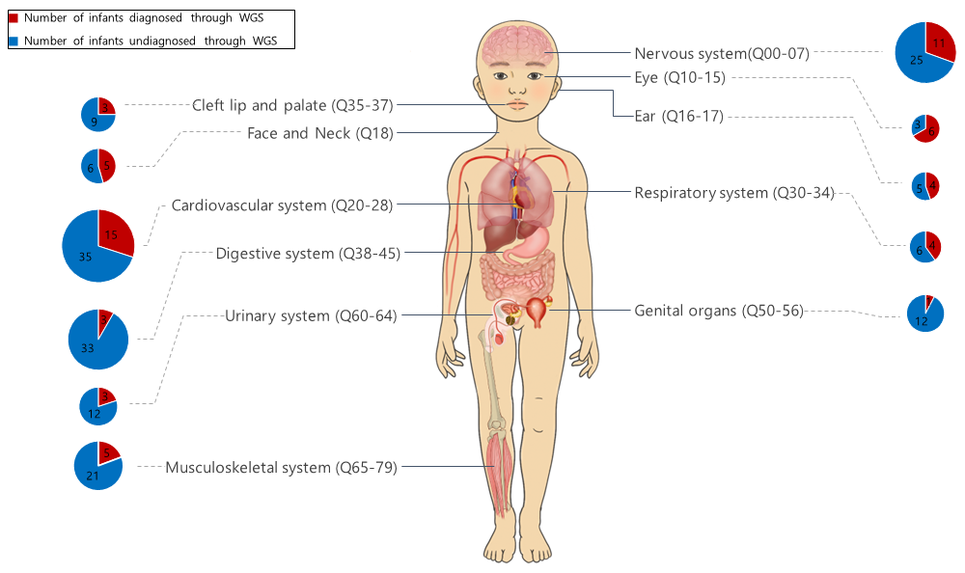
Supplementary Fig. 2. Distribution of infants by organ system based on Q-codes.
WGS = whole genome sequencing.

