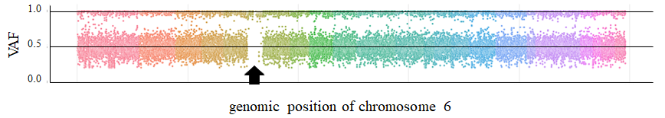
Supplementary Fig. 1. Plotting the variant allele frequencies for the variants across the chromosome 6. The X-axis represents the genomic position of chromosome 6 and the Y-axis represents the variant allele frequencies of the variants found in case No. 21. The arrow indicates a stretch of homozygous pattern of the maternally originated variants on chromosome 6, indicating an isouniparental disomy. This figure was created using Python 3.10.9.

