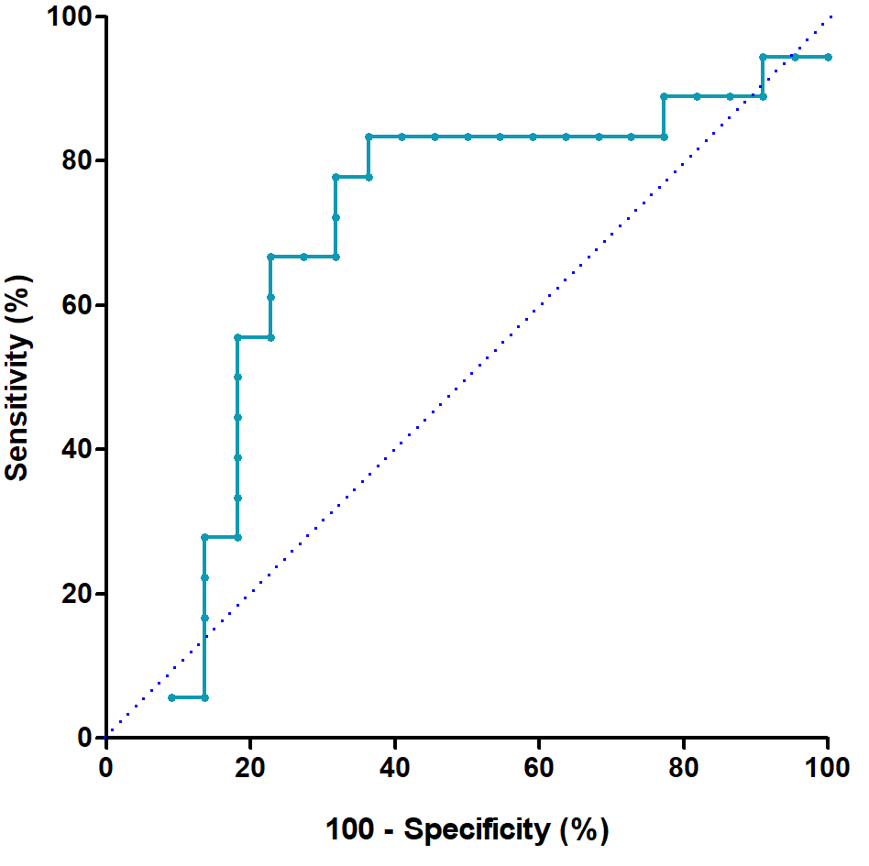
Supplementary Fig. 1. Plotted receiver operating characteristics curve for NP antigen level in the acute phase. The area under the curve was 0.687 (P = 0.044).
NP = nucleocapsid protein.

