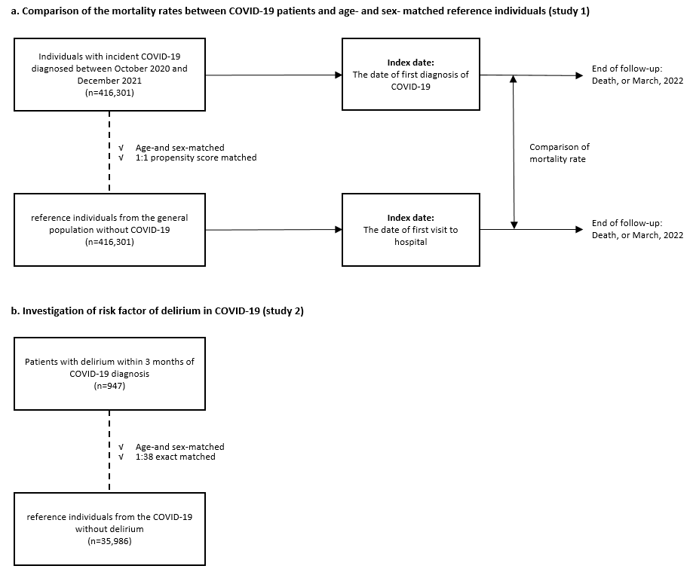
Supplementary Fig. 1. Illustrations of the design: the cohorts used in the follow-up analyses.
COVID-19 = coronavirus disease 2019.

