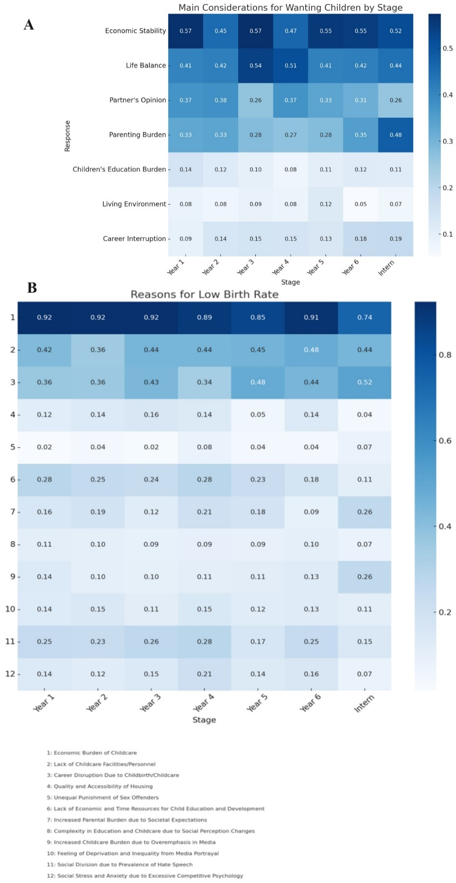
Supplementary Fig. 1. Analysis of medical students’ considerations for family planning and perceived reasons for low birth rate by educational stage. (A) Main considerations for wanting children by stage: economic stability; life balance; partner’s opinion; parenting burden; children’s education burden; living environment; career interruption. (B) Reasons for low birth rate: economic burden of childcare; lack of childcare facilities/personnel; career disruption due to childbirth/childcare; quality and accessibility of housing; unequal punishment of sex offenders; lack of economic and time resources for child education and development; increased parental burden due to societal expectations; complexity in education and childcare due to social perception changes; increased childcare burden due to overemphasis in media; feeling of deprivation and inequality from media portrayal; social division due to prevalence of hate speech; social stress and anxiety due to excessive competitive psychology

