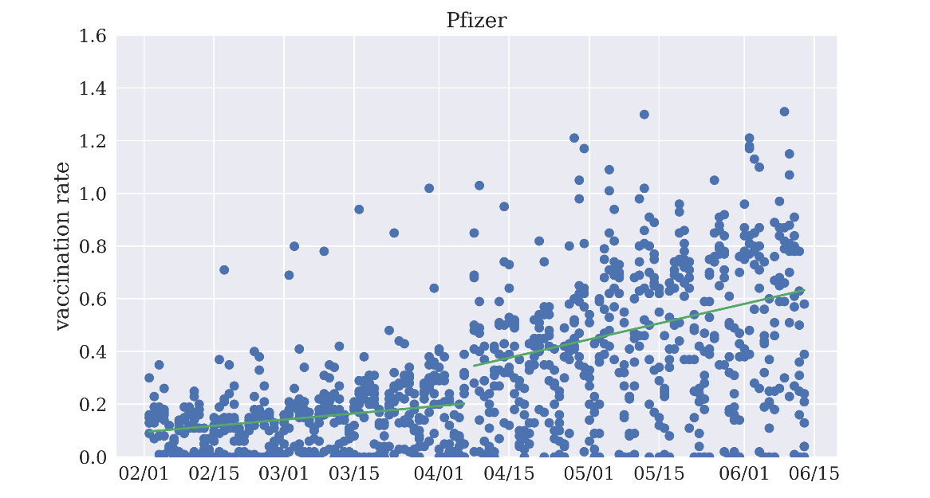
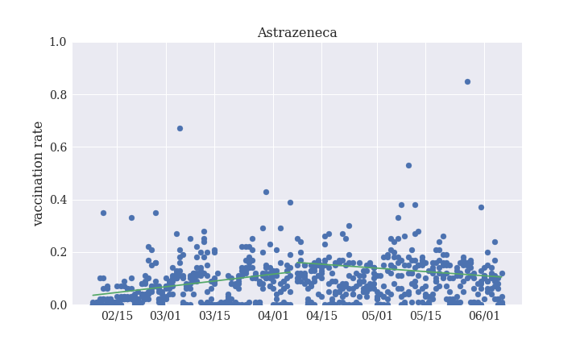
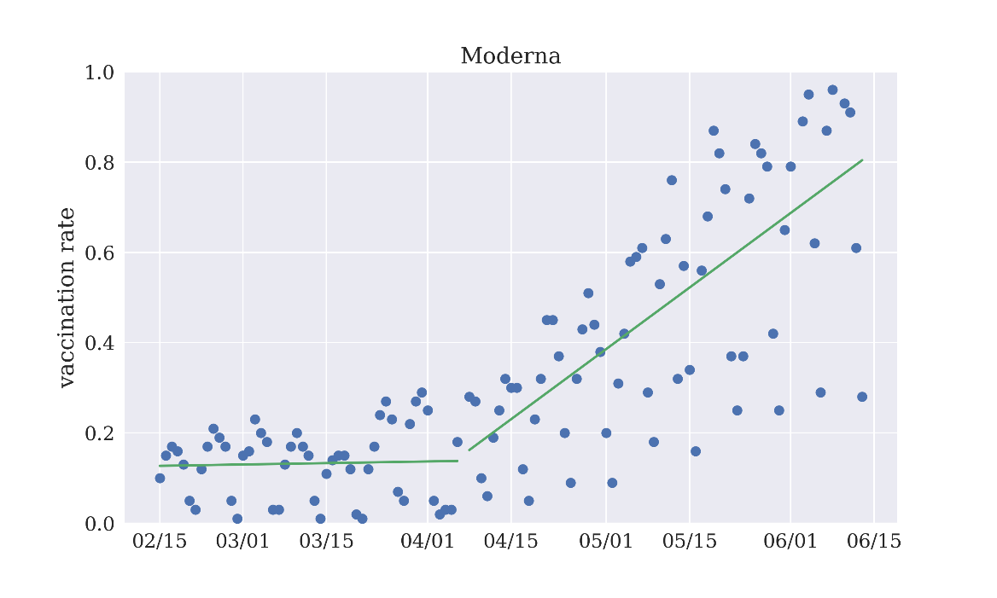
Supplementary Fig. 2. Regression discontinuity on April 7th in Europe, computed with available data on daily vaccination rates.

