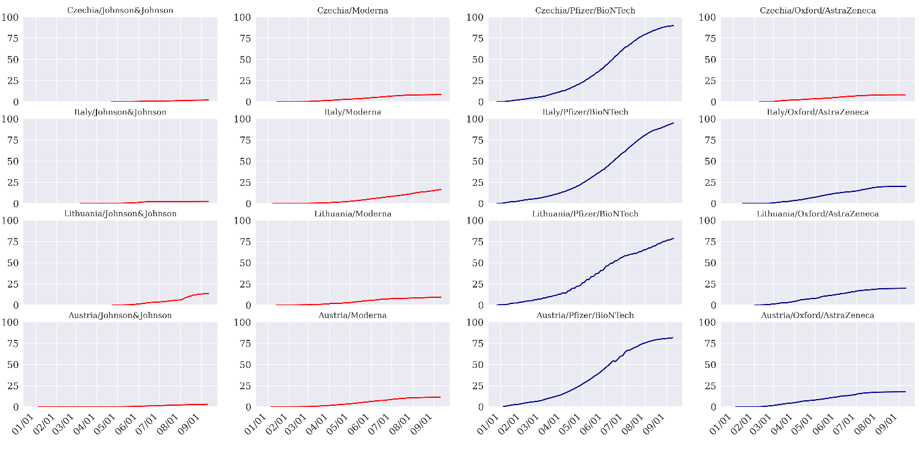
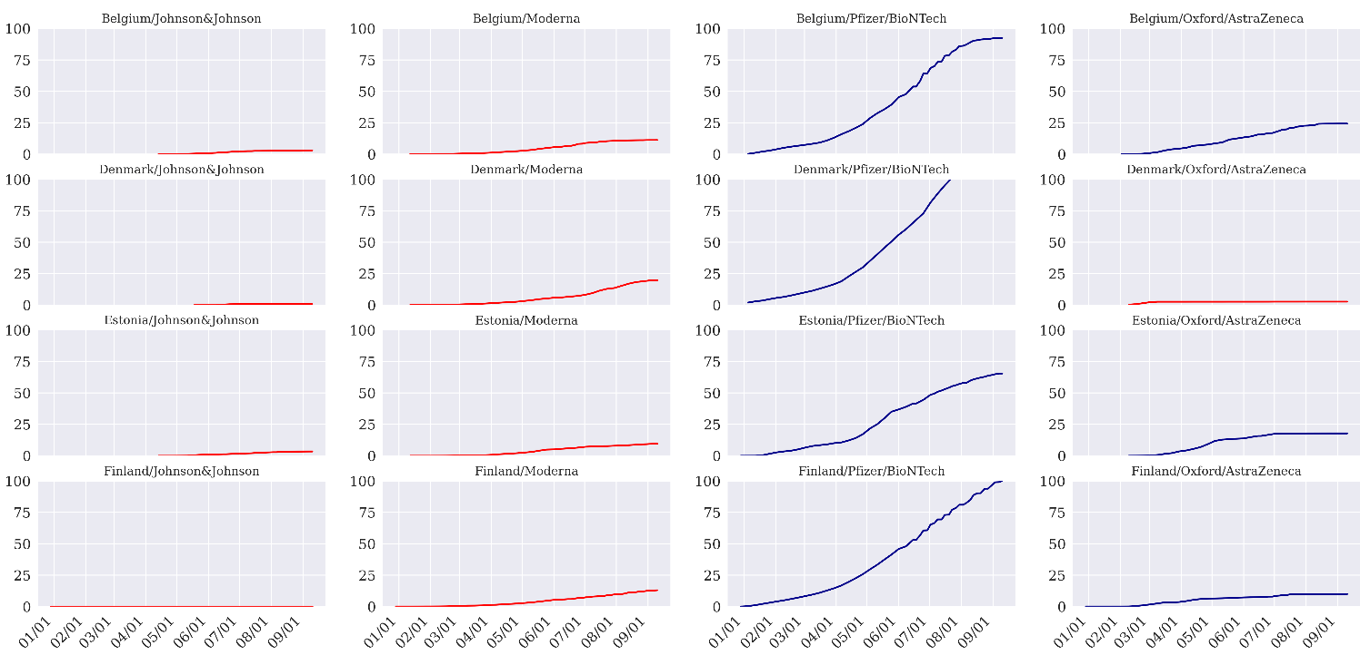
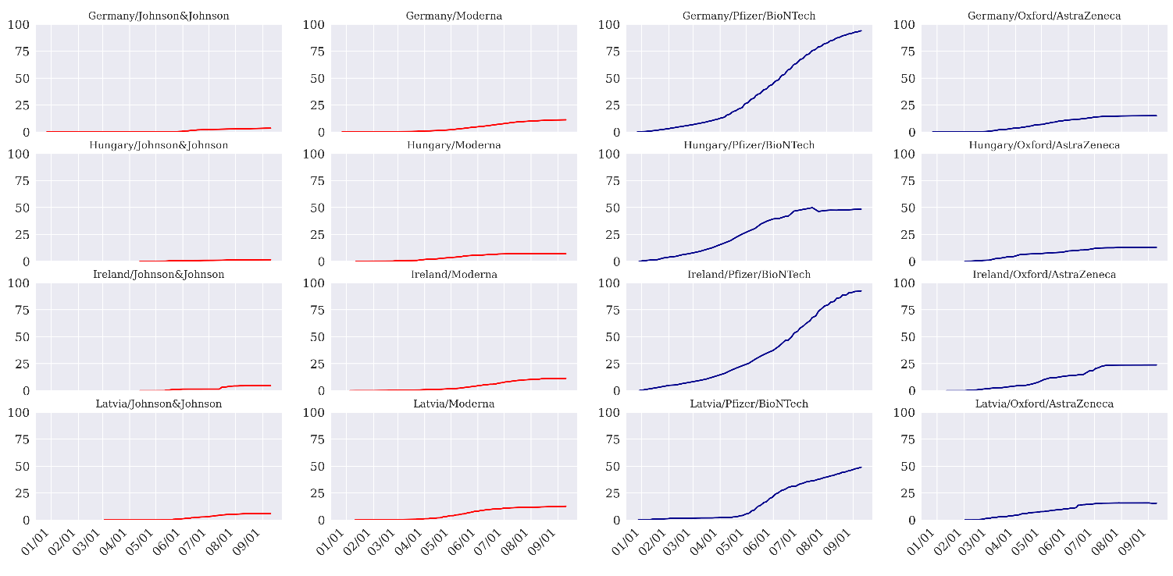
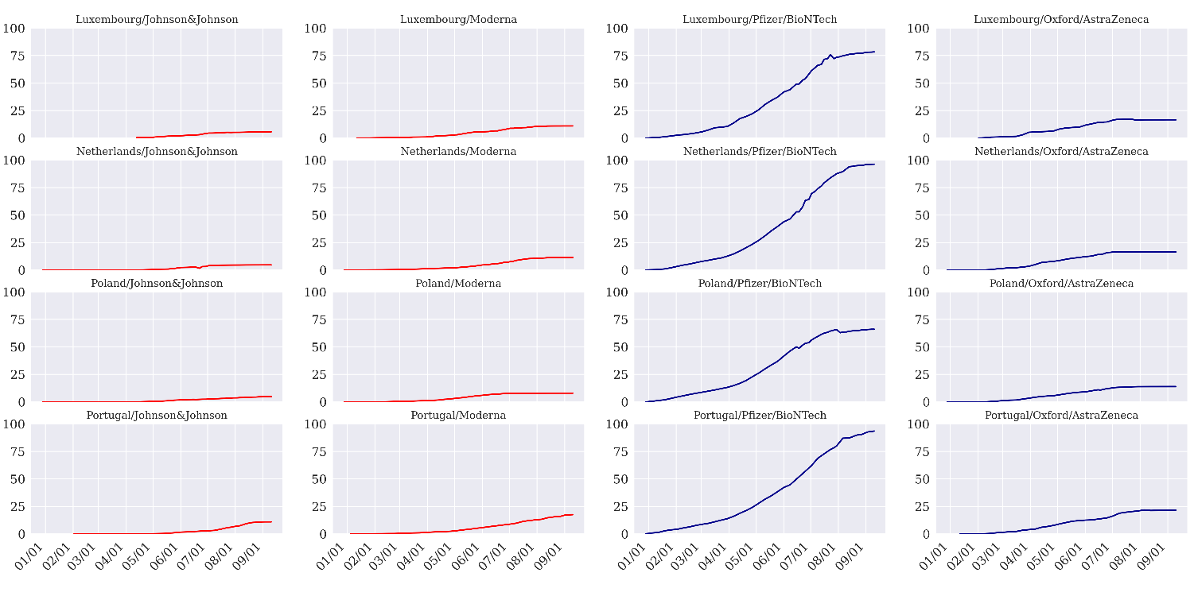
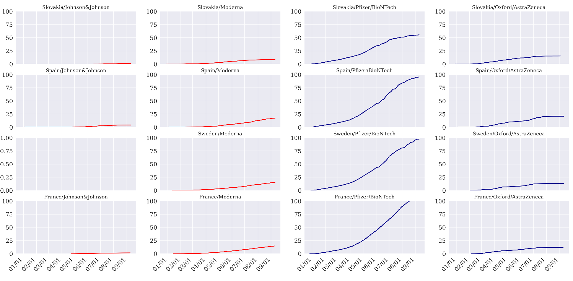
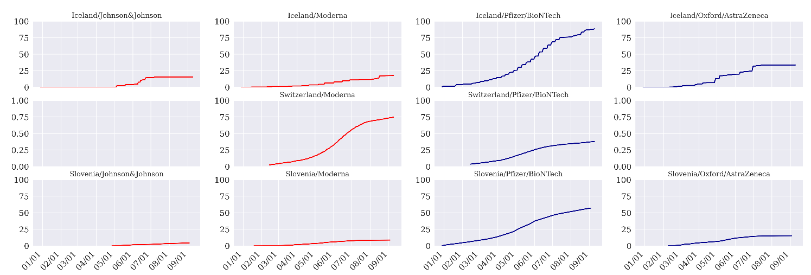
Supplementary Fig. 1. Vaccination rates of European countries during the study period.
The blueline plot indicates the included nation and vaccine type and the red line plot indicates excluded nation and vaccine type. Nations were included in our analysis if the cumulative vaccine rate was more than 5% on the day of four weeks after April 7th. And Switzerland is the only country that has more than 5% of Moderna vaccination, so we did not conduct RDiT analysis for Moderna in Europe.
RDiT = regression discontinuity in time.

