A. Korea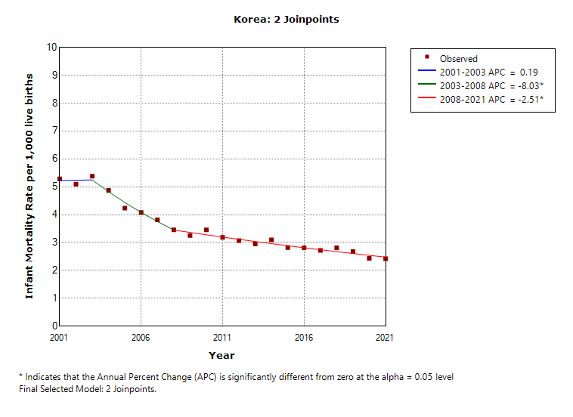
A. Seoul 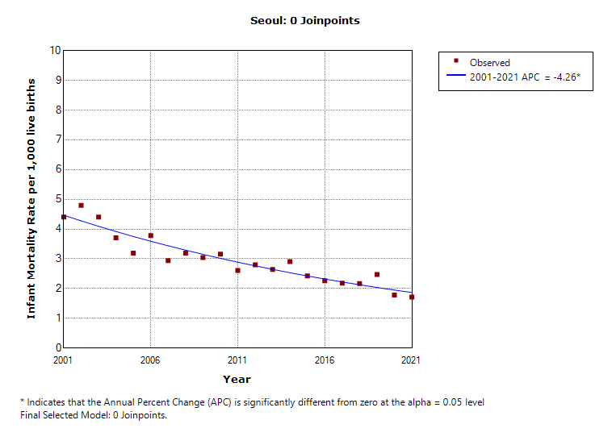
B. Busan 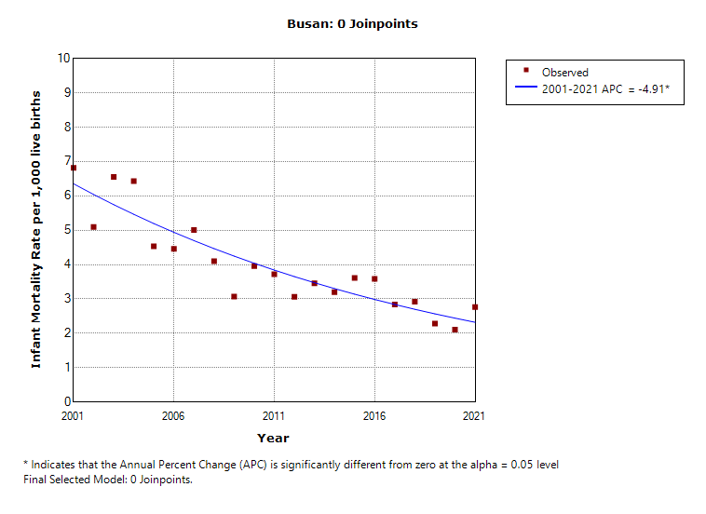
C. Daegu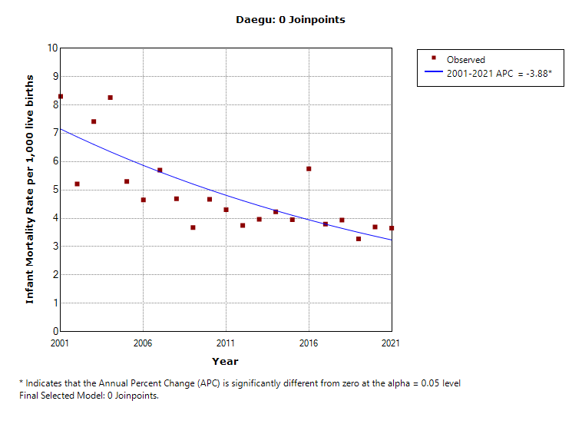
D. Incheon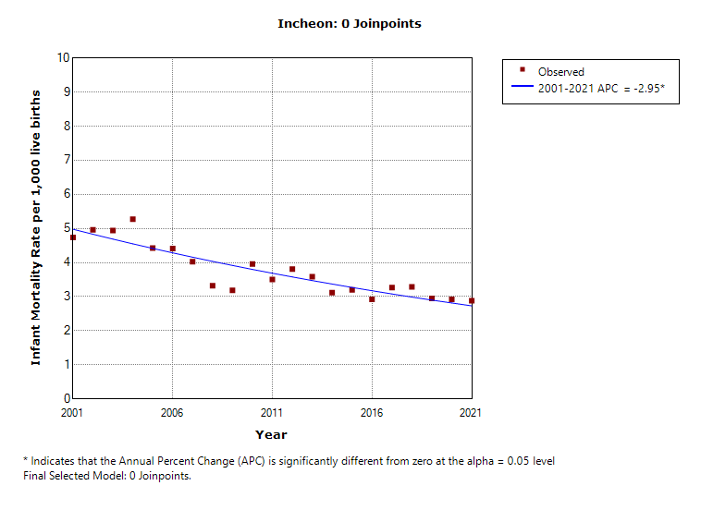
E. Gwangju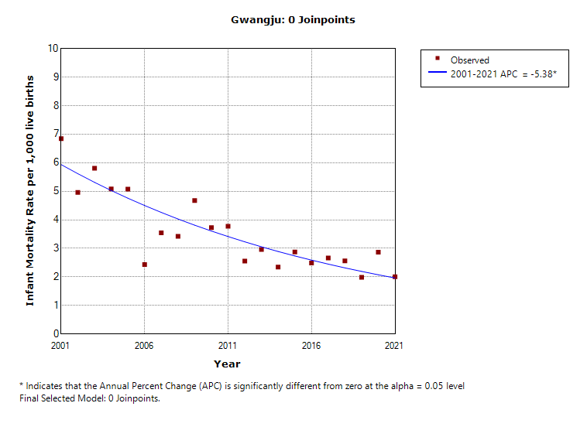
F. Daejeon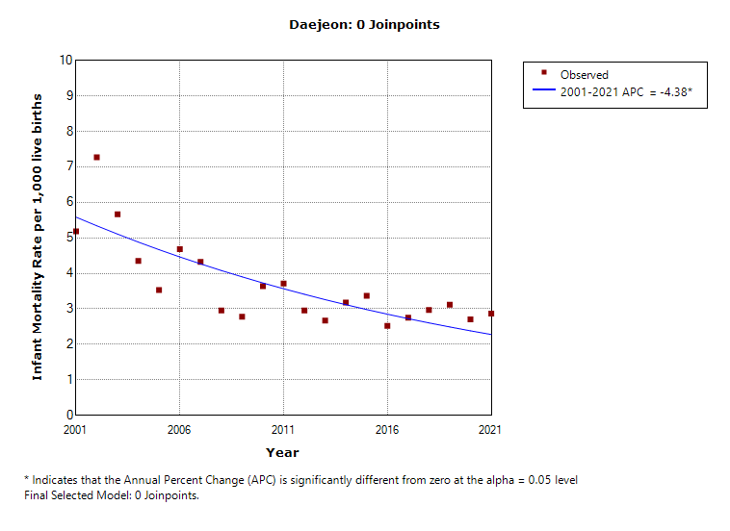
G. Ulsan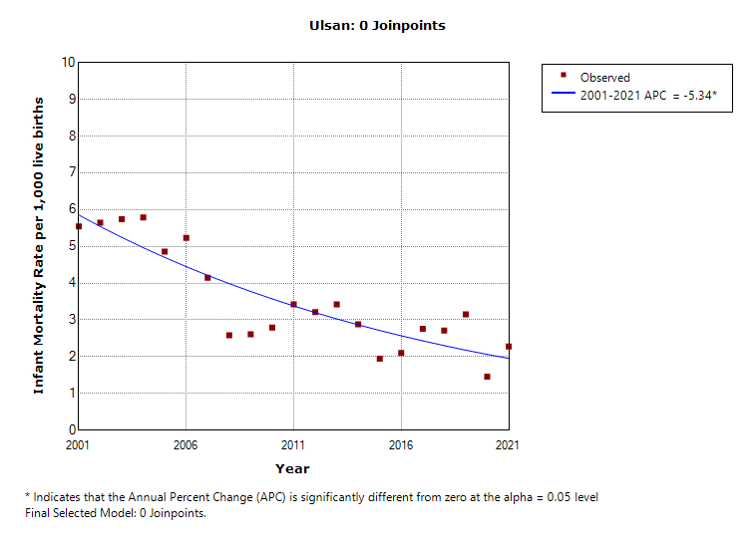
I. Gyeonggi-do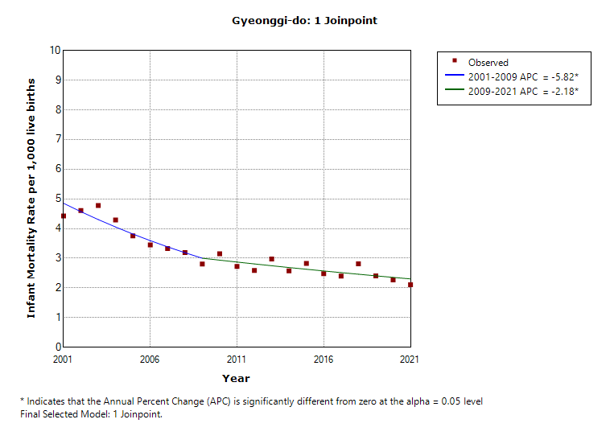
J. Gangwon-do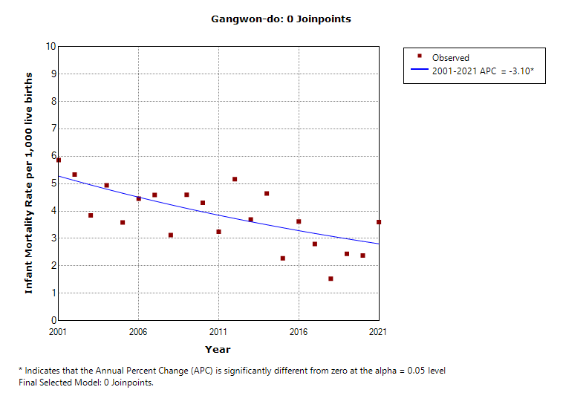
H. Chungcheongbuk-do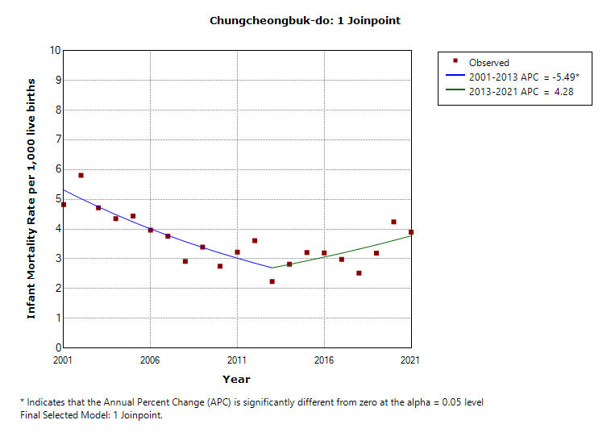
I. Chungcheongnam-do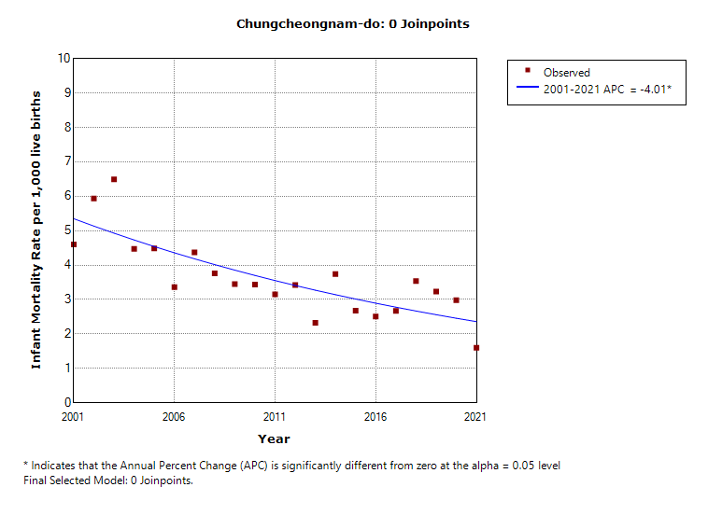
M. Jeollabuk-do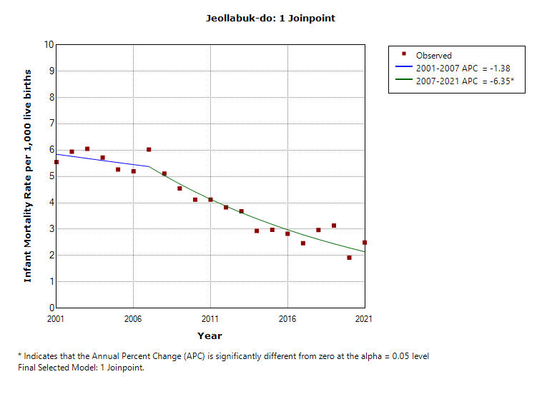
N. Jeollanam-do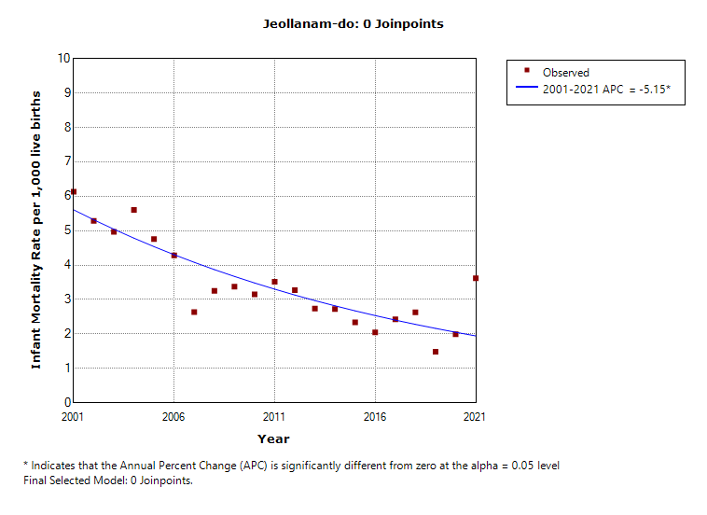
O. Gyeongsangbuk-do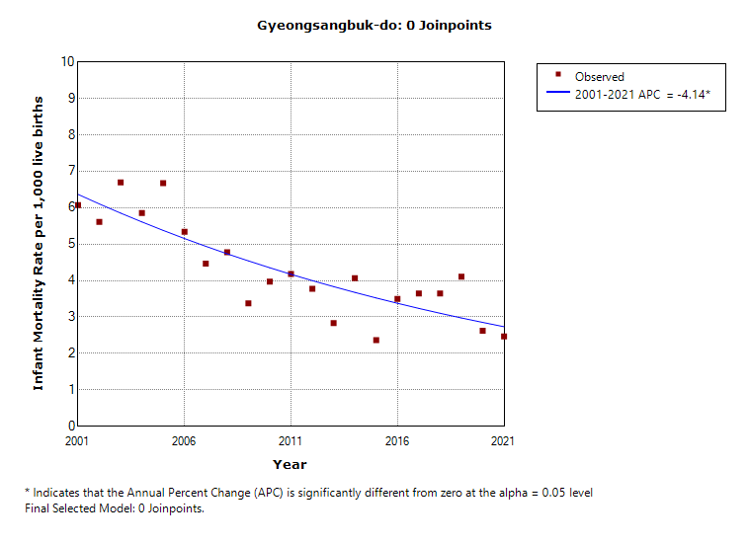
P. Gyeongsangnam-do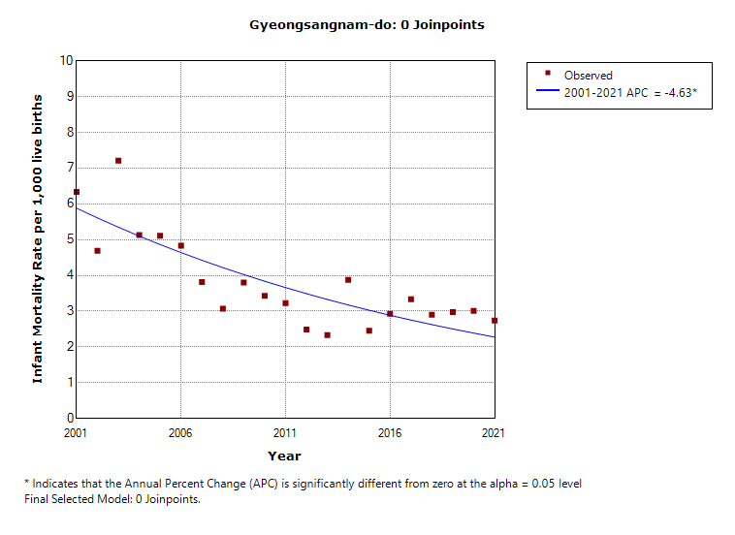
J. Jeju-do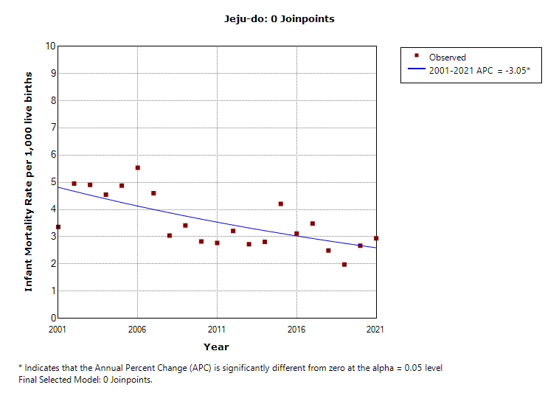
Supplementary Fig. 2. Trends of infant mortality rates between 2001 and 2021. (A) Korea, (B) Seoul, (C) Busan, (D) Daegu, (E) Incheon, (F) Gwangju, (G) Daejeon, (H) Ulsan, (I) Gyeonggi-do, (J) Gangwon-do, (K) Chungcheongbuk-do, (L) Chungcheongnam-do, (M) Jeollabuk-do, (N) Jellanam-do, (O) Gyeongsangbuk-do, (P) Gyeongsangnam-do, (Q) Jeju-do.
ªIndicates that the annual percent change is significantly different from zero at the alpha = 0.05 level.

