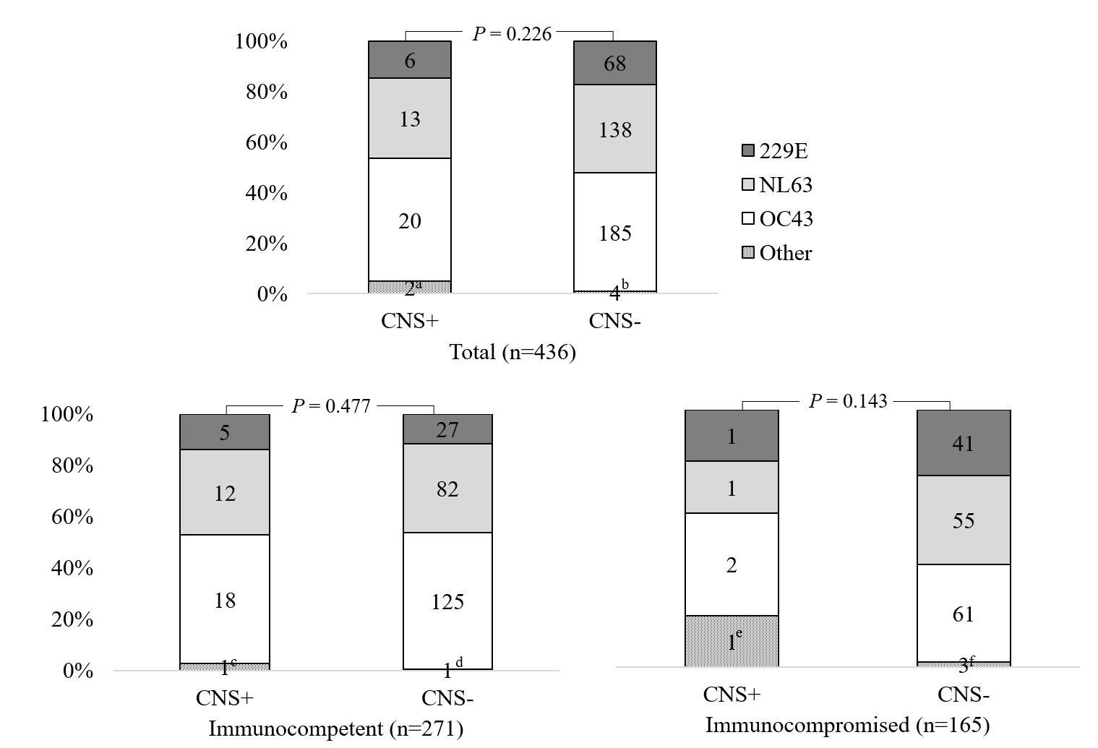

Supplementary Fig. 3. Subtype of common cold coronavirus by presence of the CNS complications.
CNS = central nervous system.
ªOC43/NL63 (n = 2).
^{b}OC43/NL63 (n = 2), 229E/OC43 (n = 1), OC43/HKU1 (n = 1).
^{c}OC43/NL63 (n = 1).
^{d}OC43/HKU1 (n = 1).
^{e}OC43/NL63 (n = 1).
^{f}OC43/NL63 (n = 2), 229E/OC43 (n = 1).

