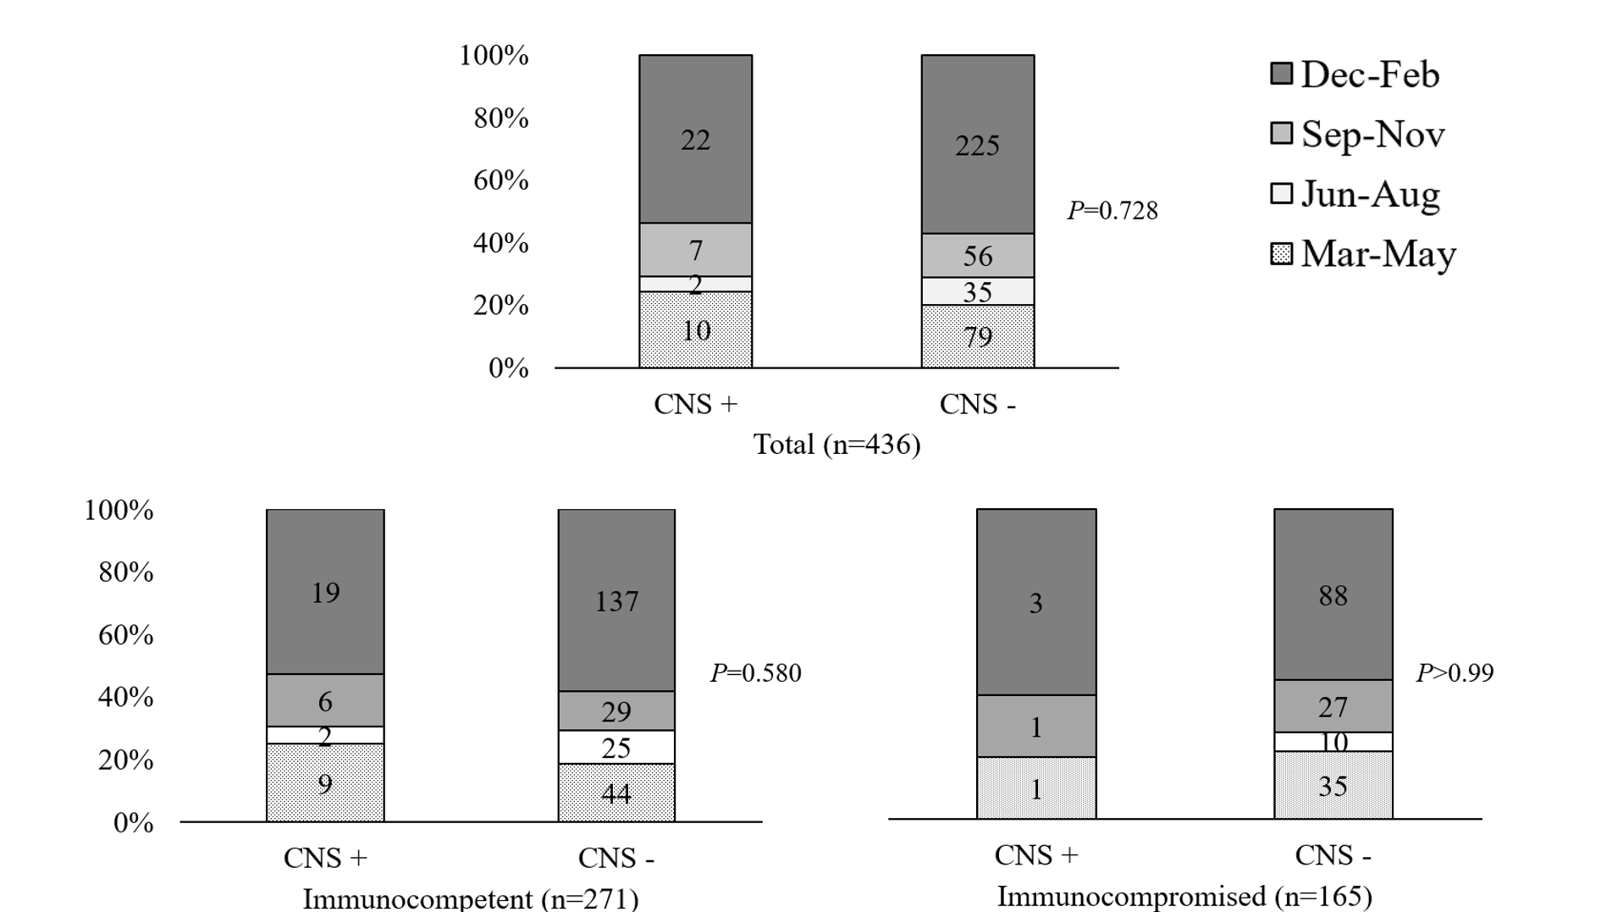
Supplementary Fig. 2. Seasonality by the presence of CNS complications.
CNS = central nervous system.

