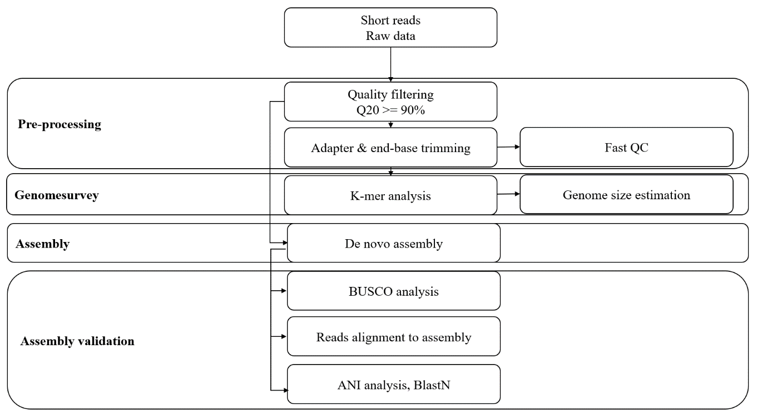
Supplementary Fig. 1. Next generation sequencing analysis workflow overview.
BUSCO = Benchmarking Universal Single-Copy Orthologs, ANI = average nucleotide identity, QC = quality control.

