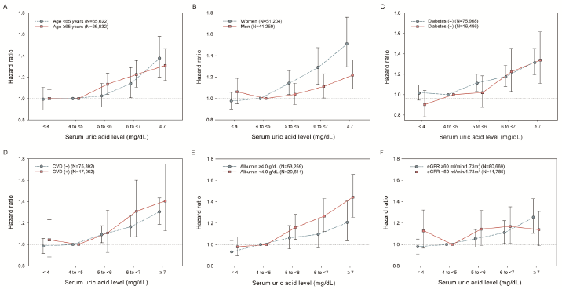
Supplementary Fig. 5. Subgroup analyses of the association between serum uric levels and risk of CVD. All models were adjusted for age, sex, comorbidities, use of angiotensin-converting enzyme inhibitors or angiotensin-receptor blockers, use of diuretics, and use of uric acid-lowering drugs.
CVD = cardiovascular disease, eGFR = estimated glomerular filtration rate.

