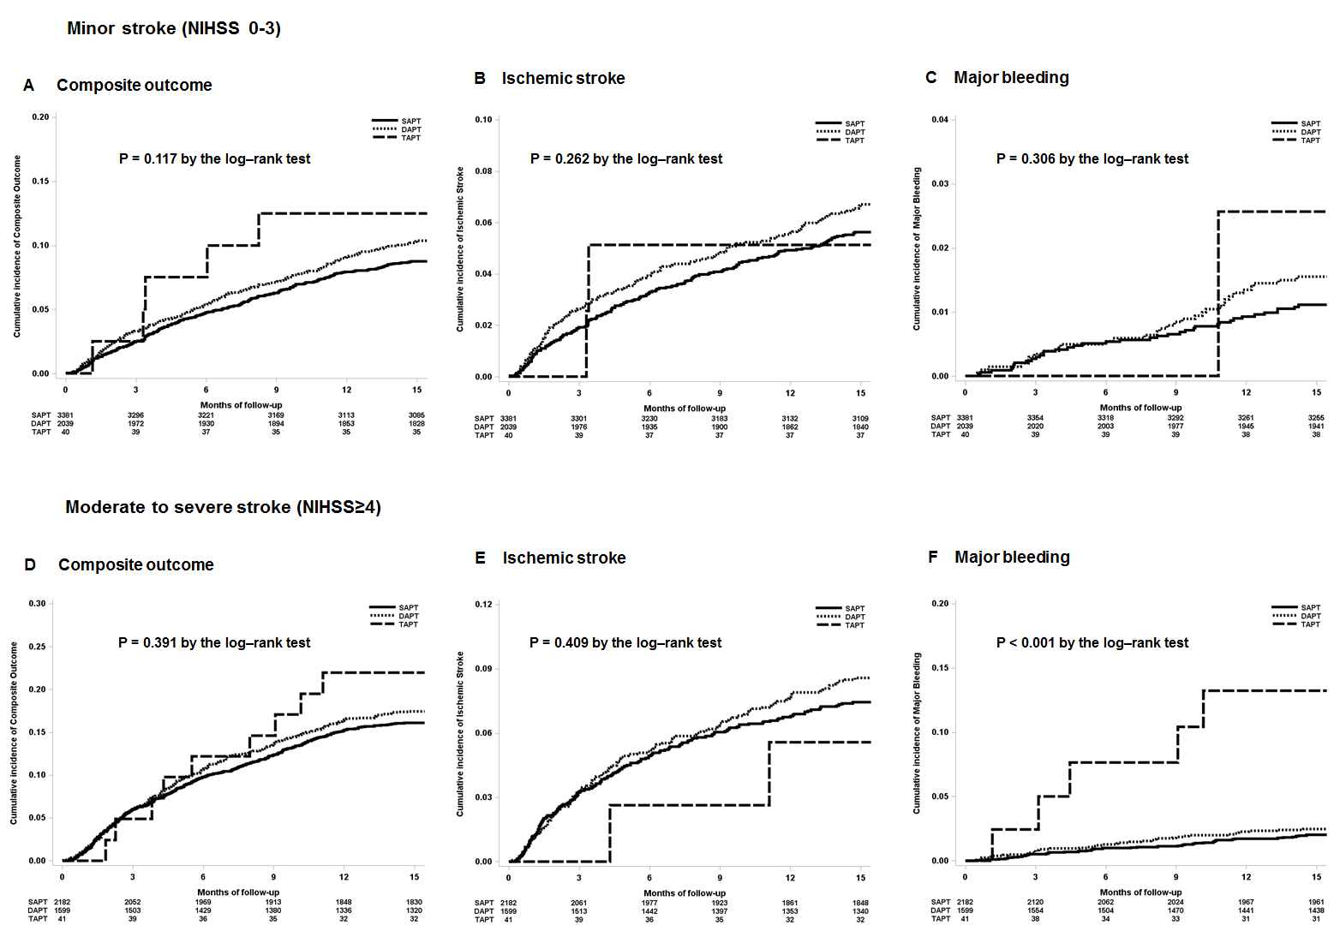
Supplementary Fig. 1. Kaplan-Meier analysis of primary outcome and secondary outcome according to stroke severity. (A) Cumulative incidence of the composite outcome in minor stroke patients. (B) Cumulative incidence of the ischemic stroke in minor stroke patients. (C) Cumulative incidence of major bleeding in minor stroke patients. (D) Cumulative incidence of the composite outcome in moderate to severe stroke patients. (E) Cumulative incidence of the ischemic stroke in moderate to severe stroke patients. (F) Cumulative incidence of major bleeding in moderate to severe stroke patients.
SAPT = single antiplatelet therapy, DAPT = dual antiplatelet therapy, TAPT = triple antiplatelet therapy, NIHSS = National Institute of Health Stroke Scale.

