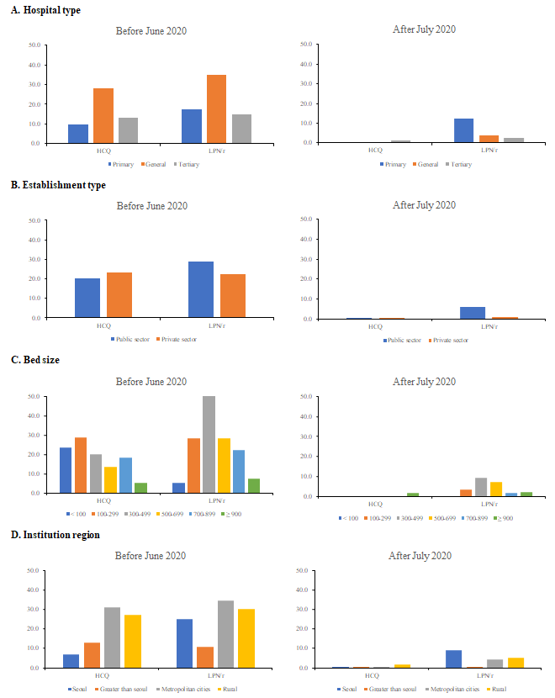
Supplementary Fig. 2. Proportion of patients prescribed HCQ and LPN/r according to hospital factors.
HCQ = hydroxychloroquine, LPN/r = lopinavir/ritonavir.

