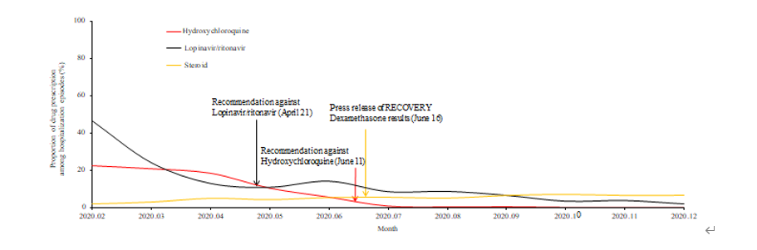
Supplementary Fig. 1. Chronological presentation of antiviral candidates and steroid prescriptions for coronavirus disease 2019 treatment in patients not receiving oxygen therapy in Korea.

