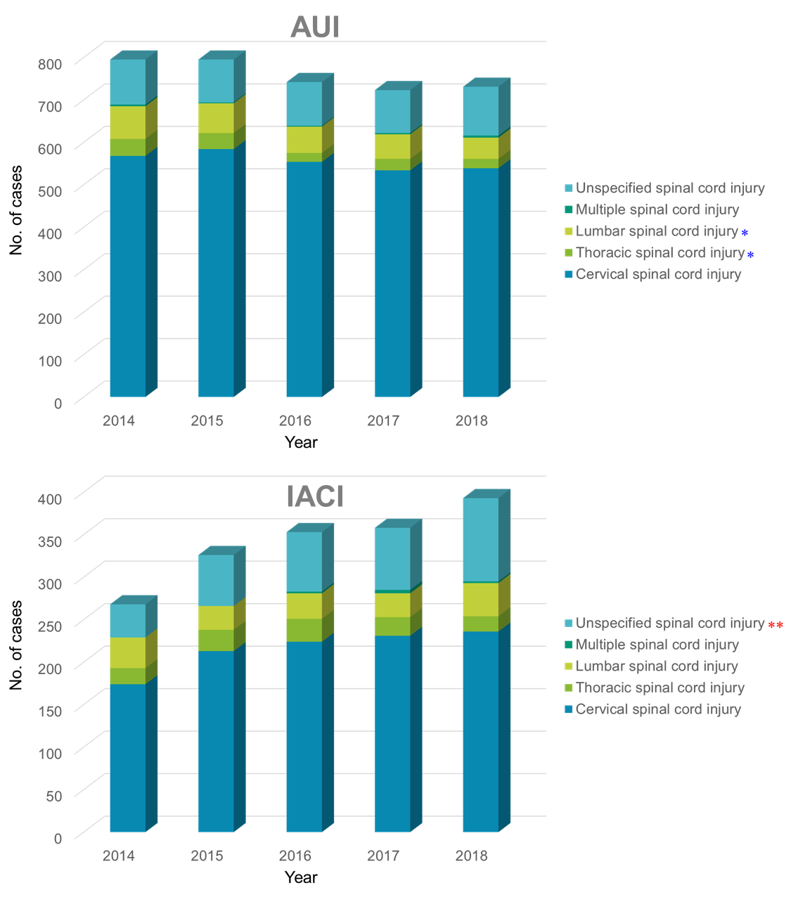
Supplementary Fig. 3. Distribution of injured body regions in patients with traumatic spinal cord injury in AUI and IACI database between 2014 and 2018.
AUI = automobile insurance, IACI = Industrial Accident Compensation Insurance.
*P for trend < 0.05; **P for trend < 0.01; ***P for trend < 0.001.
Red asterisk indicates increased trend; Blue asterisk indicates decreased trend.

