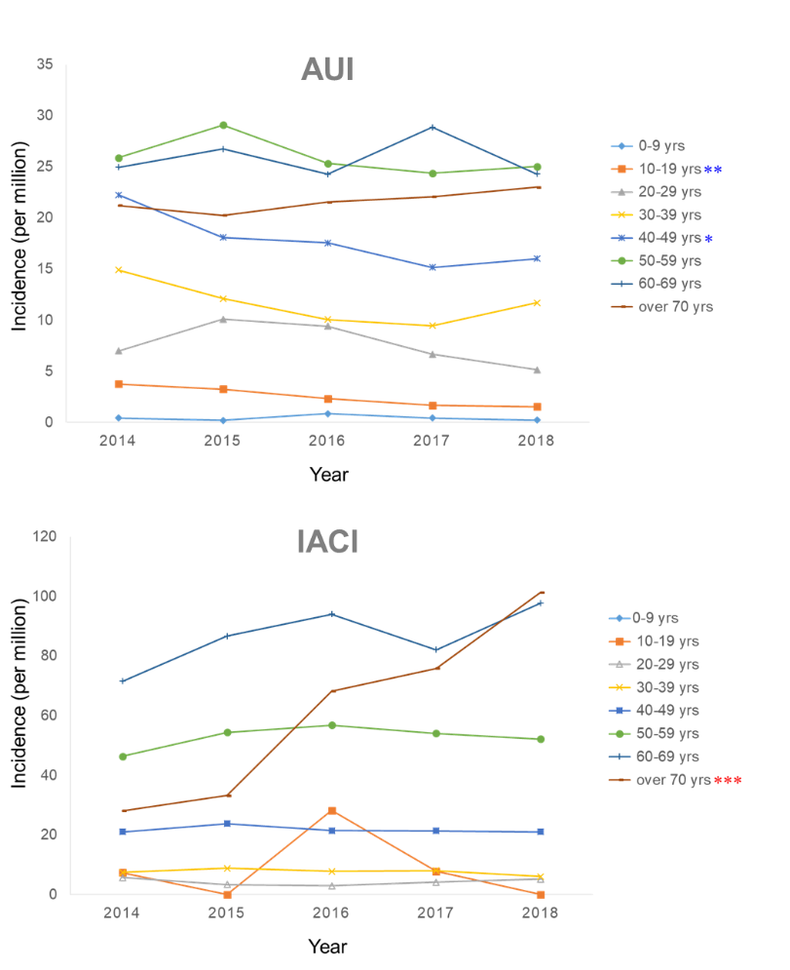
Supplementary Fig. 1. Age-specific incidence of traumatic spinal cord injury in AUI and IACI databases.
AUI = automobile insurance, IACI = Industrial Accident Compensation Insurance.
*P for trend < 0.05; **P for trend < 0.01; ***P for trend < 0.001.
Red asterisk indicates increased the annual percentage changes; Blue asterisk indicates decreased the annual percentage changes.

