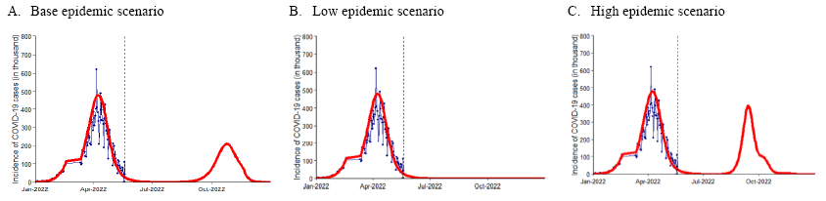
Supplementary Fig. 3. Health impact and incremental cost-effectiveness in deterministic analyses.
COVID-19 = coronavirus disease 2019.

