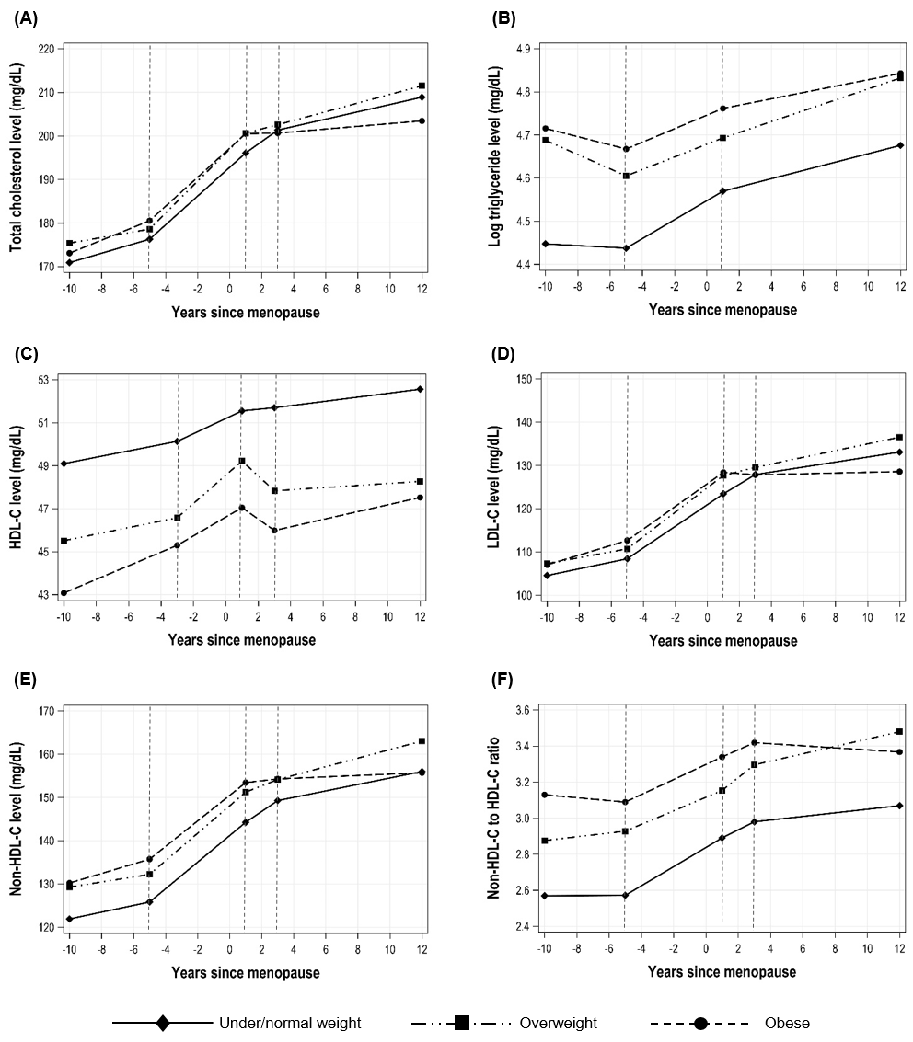
Supplementary Fig. 4. Patterns of lipid changes according to premenopausal body mass index among participants not on lipid-lowering treatment (n = 1,143). Estimated values from piecewise linear mixed-effects models of (A) total cholesterol, (B) triglyceride, (C) HDL-C, (D) LDL-C, (E) non-HDL-C, and (F) non-HDL-C to HDL-C ratio over time since menopause by body mass index among women who did not report using lipid-lowering medication.
HDL-C = high-density lipoprotein-cholesterol, LDL-C = low-density lipoprotein-cholesterol.

