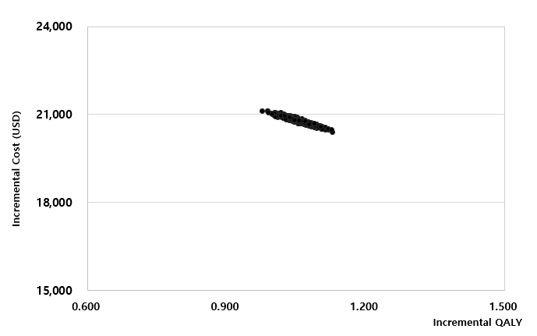

Supplementary Fig. 3. Cost-effectiveness plane. Assumption of exchange rate: 1,200 Korean Won/USD.
QALY = quality-adjusted life year.

