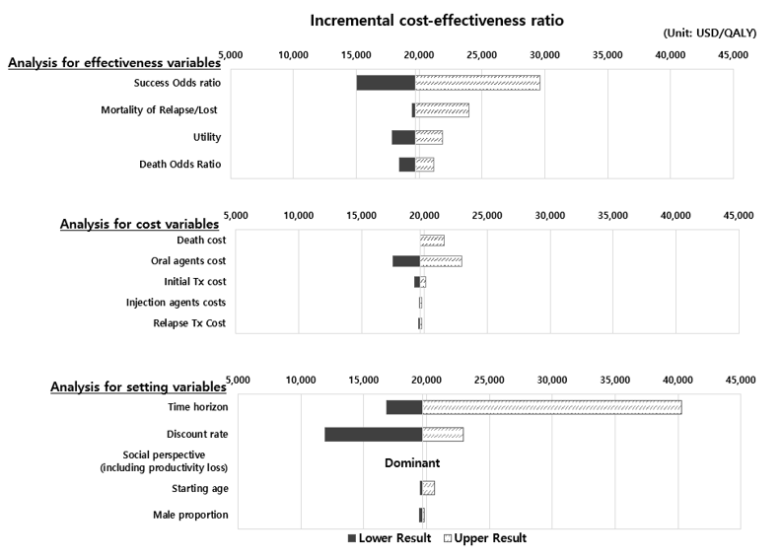

Supplementary Fig. 2. Results of deterministic sensitivity analyses.

