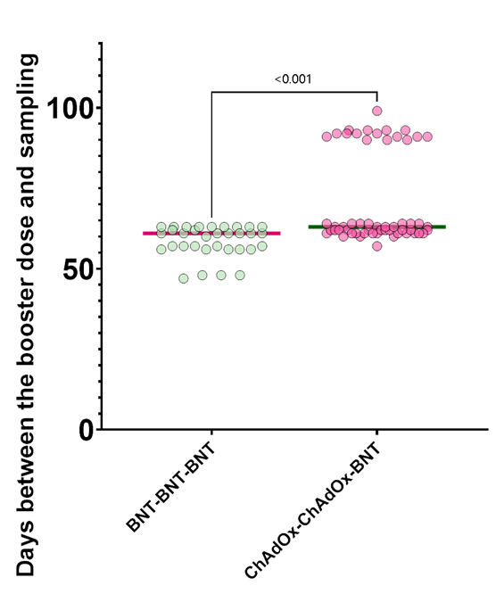
Supplementary Fig. 1. Comparison of time from the booster dose of vaccination to blood sampling by vaccination type. The horizontal bar is the median value. P values according to group comparisons are presented.
BNT = BNT162b2, ChAdOx = ChAdOx1 nCoV-19.

