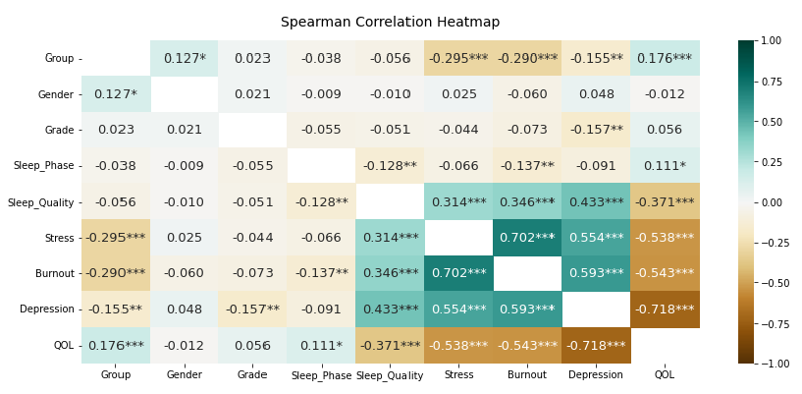
Supplementary Fig. 1. Correlation heatmap between assessment group, gender, school year, 5 factors and quality of life. Numbers represent Spearman correlation coefficients. Group is coded as: 0 = norm-referenced assessment, 1 = criterion-referenced assessment; and gender is coded as: 0 = male, 1 = female. Hence, positive correlation values indicate higher values in criterion-referenced assessment group students and female students, respectively.
QOL = quality of life.
*P < 0.05; **P < 0.01; ***P < 0.001.

