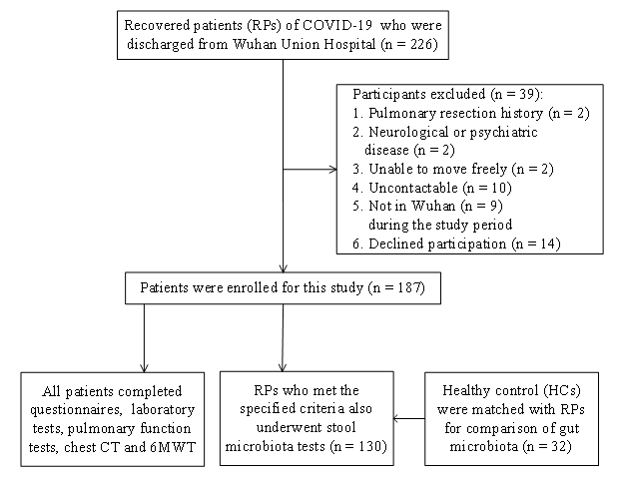
Supplementary Fig. 1. Study design and flow chart.
RPs = recovered patients, COVID-19 = coronavirus disease 2019, CT = computed tomography, 6MWT = 6-minute walk tests, HC = healthy control.

