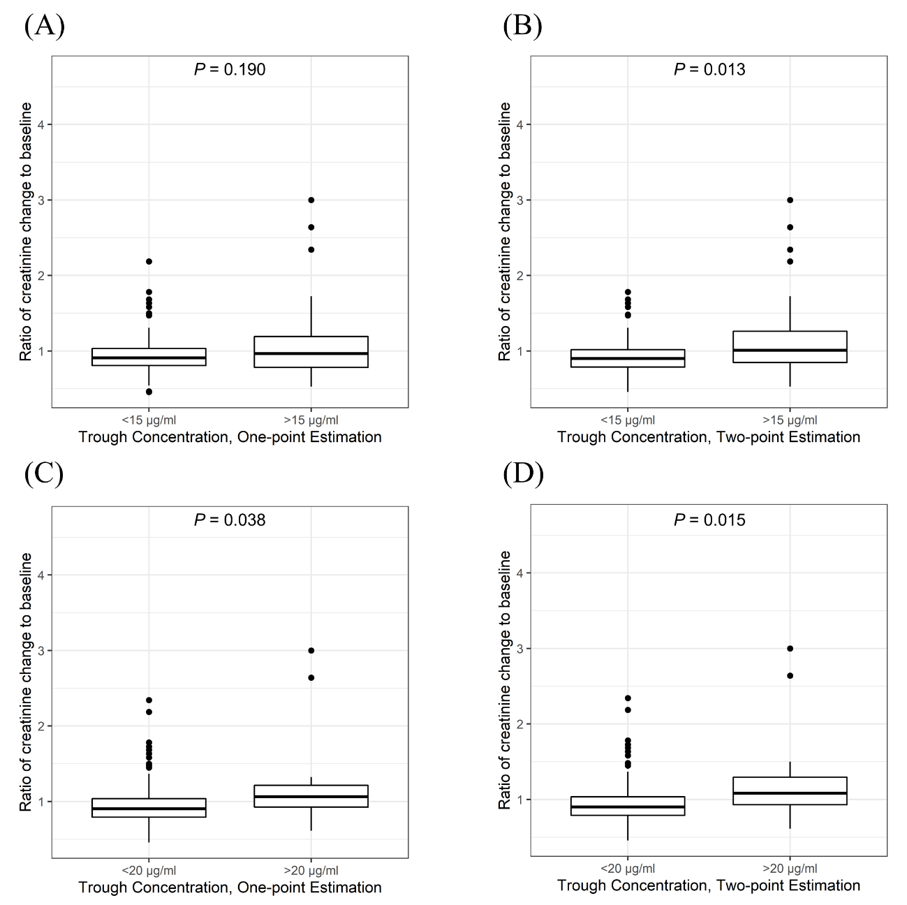
Supplementary Fig. 5. Vancomycin trough concentration and the ratio of creatinine change to baseline calculated by one- and two-point estimation. Each plot was stratified by vancomycin trough levels of (A, B) 15 and (C, D) 20 μg/mL. The P values represent Mann–Whitney U test results.

