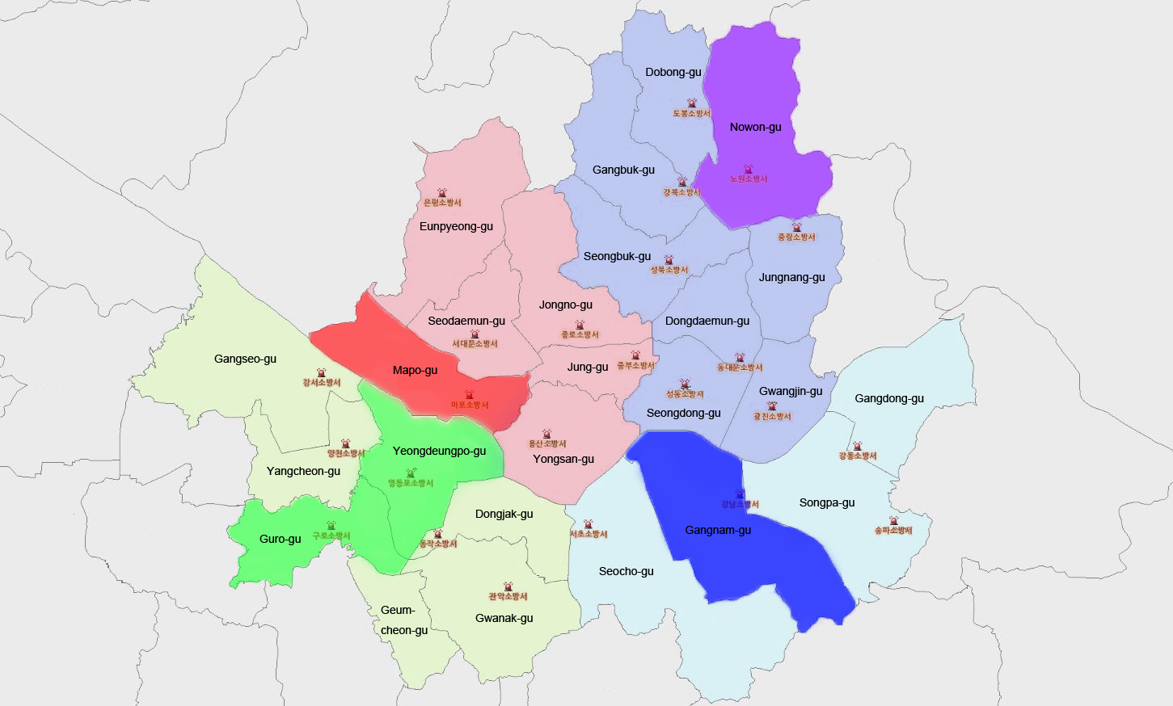
Supplementary Fig. 1. Locations of the five fire stations included in the study.

