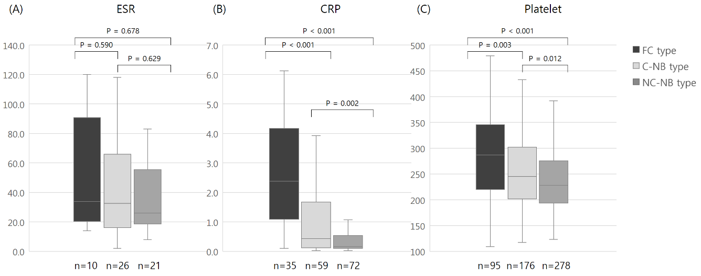
Supplementary Fig. 2. ESR, CRP, and platelet count according to the radiologic classification of patients with Mycobacterium avium complex pulmonary disease. Notably, the number of patients was lower than 549 patients whose neutrophil-lymphocyte ratio and monocyte-lymphocyte ratio were assessed in the main analysis, because only some patients underwent laboratory tests for ESR and CRP. (A) No statistical difference in ESR was noted among the three radiologic types with 34.0 (20.5–90.8), 32.5 (16.0–66.6), and 26.0 (18.5–55.5) in the FC, C-NB, and NC-NB types, respectively. (B) CRP was significantly higher in the FC type (2.38 [IQR, 1.09–4.17]), followed by that in the C-NB type (0.43 [IQR, 0.12–1.68]), and significantly lower in the NC-NB type (0.16 [IQR, 0.10–0.54]). (C) Platelet count was significantly higher in the FC type (287,000 [IQR, 220,000–346,000]), followed by that in the C-NB type (245,000 [IQR, 202,000–302,000]), and significantly lower in the NC-NB type (229,000 [IQR, 193,000–275,000]).
ESR = erythrocyte sedimentation rate, CRP = C-reactive protein, IQR = interquartile range, FC = fibrocavitary, C-NB = cavitary nodular bronchiectatic, NC-NB = non-cavitary nodular bronchiectatic.

