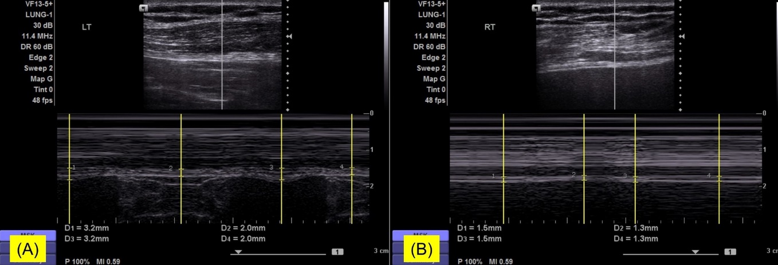
Supplementary Fig. 2. Diaphragm ultrasound measuring diaphragm thickening fraction. (A) The thickness of the left hemidiaphragm was 3.2 mm at end-inspiration, and 2.0 mm at end-expiration (thickening fraction 60%). (B) The thickness of the diaphragm on the right was 1.5 mm at end-inspiration, and 1.3 mm at end-expiration (thickening fraction 15%). In normal subjects, the thickening fraction is usually 20% or greater.

