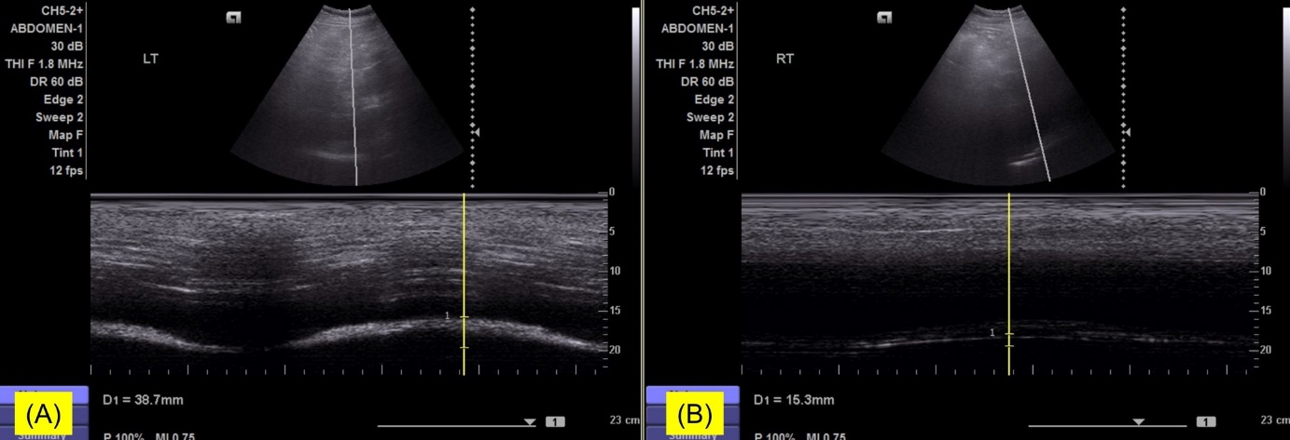
Supplementary Fig. 1. Diaphragm ultrasound measuring diaphragmatic excursion. (A) In the left hemidiaphragm, the diaphragmatic excursion was 38.7 mm. (B) In the right side, the diaphragmatic excursion was reduced to 15.3 mm during forceful breathing. In male subjects without diaphragm dysfunction, the diaphragmatic excursion is usually > 47 mm.

