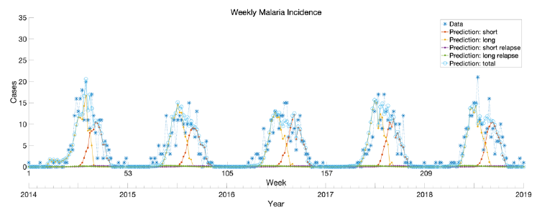
Supplementary Fig. 2. Weekly malaria incidence data between 2014 and 2018 and model prediction using the estimated parameters.

