Supplementary Table 1. Descriptions, values, and references for the model parameters
Parameters | Description | Values | Reference
 | Birth rate of humans | 0.0081 | [1]
 | Death rate of humans | 0.0052 | [1]
 | Probability of having short latency period | 0.4244  95% confidence interval  (0.4101, 0.4383) | Estimated
 | Average short latency period | 14 days | [2]
 | Average long latency period | 314 days | [2]
 | Average short latency period for relapse | 14 days | [3]
 | Average long latency period for relapse | 274 days | [3]
 | Treatment starting rate = 1/Average infectious period | 1/4 1/days | [2]
 | Recovery rate = 1/Average duration of drug action | 1/35 1/days | [4]
 | Probability of relapse | 0.04 | [2,5]
 | Vector carrying capacity | 165 | [6,7]
* | Egg deposition rate per adult mosquito  : temperature(°C) |  | [6-8]
* | Death rate of immature mosquitoes  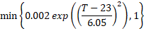 |  | [6,7,9]
* | Maturation rate  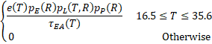  - : Lifetime number of eggs laid by adult mosquitoes.  - : Total number of eggs laid per day.  - ): Average adult mosquito lifespan.  - : Daily survival probability of eggs. and denote rainfall (mm) and rainfall threshold (mm), and fixed to 3mm and 76mm, respectively.  - : Daily survival probability of larvae.  - : Daily survival probability of pupae.  : Total development time from egg to adult mosquito. |  | [6,7,10]
* | Death rate of adult mosquitoes  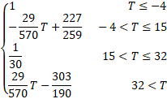 |  | [2,6–8]
 | Progression rate of mosquitoes to the infectious state = 1/Average latency period of mosquitoes | 1/10 1/days | [2,11]
* | Force of infection from mosquitoes to humans  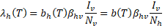 |  | [12]
* | Force of infection from humans to mosquitoes  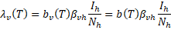 |  | [12]
* | Biting rate for humans is defined as the number of mosquito bites per human per unit time  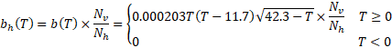 |  | [6-8,12]
* | Biting rate for mosquitoes refers to the number of human bites for one mosquito per unit time  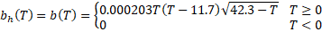 |  | [6-8,12]
 | Probability of transmission of infection from an infectious mosquito to a susceptible human | 0.1184  95% confidence interval  (0.1175, 0.1195) | Estimated
 | Probability of transmission of infection from an infectious human to a susceptible mosquito | 0.02802  95% confidence interval  (0.02774, 0.02828) | Estimated
Citations are listed in Supplementary References.
ªTemperature-dependent parameters. Three parameters, p, β_{hv}, β_{vh}, were estimated based on maximum likelihood estimation assuming Poisson distribution on the data, and their confidence intervals were estimated assuming χ² distribution.

